The extracurricular activity on the topic: “English speaking countries”

**Внеклассное мероприятие – викторина по английскому языку на тему«Англо-говорящие страны» среди обучающихся 8 классов**

Aimsandobjectives:/  **Цели:**

1. Мотивировать учащихся изучать английский язык и правильно пользоваться им при живом общении;
2. Подвести к осознанию необходимости и важности изучения английского языка, как одного из самих распространённых языков в мире;

**Задачи:**

***Образовательная***

- повышать познавательный интерес учащихся к языку через использование игровых моментов;

-обобщение страноведческих знаний учащихся, полученных на уроках английского языка;

-обогащение словарного запаса и развитие устной речи обучающихся.

***Развивающая***

-развивать умение работать в группе.

-развивать внимание, воображение, творческие, актёрские способности и познавательный интерес

-расширение кругозора, развитие и тренировка внимания, памяти, мышления.

***Воспитательная***

-воспитывать уважительное отношение к другой культуре.

-воспитывать взаимопонимание и совершенствовать умение работать в коллективе,

-прививать интерес к изучению английского языка.

**Тип мероприятия:** внеклассное мероприятие - викторина

**Форма проведения мероприятия**: игровая

**Оборудование, материалы:**ноутбук,музыкальная аппаратура, проектор/ интерактивная доска , постеры по теме “English speaking countries”

Procedure of the activity /**Ход мероприятия**

1. Org. moment /**Организационныймомент.**

Greeting / **Приветствие**

**Ведущий :** Good afternoon, Dear guests! We are glad to see you today!

Welcome to our extracurricular activity “English speaking countries”

English is the language of world economics, trade, science and education. It is also the language of international communication in Kazakhstan.

There are questions for 10, 20, 30, 40, 50, 60 points

**Categories:**

1.Capitals

2.Sightseeing

3. Customs and traditions, holidays

4.Famous people

5.Music and cinematography

6.Literature

**Обучающиеся в группах выбирают категории и отвечают на вопросы по выбранным баллам: 10, 20, 30, 40, 50, 60**

**Категории:**

1.Столицы англо-говорящих стран

2.Достопримечательности

3. Праздники, обычаи и традиции англо-говорящих стран

4.Известные личности

5.Музыка и кинематограф

6. Литература

**Students answer the questions and get points**

**Capitals**

**10-** What is the capital of India? **Answer:** Delhi/ New Delhi

**20**- What is the capital of Canada? **Answer:** Ottawa

**30**  - What is the capital of Australia? **Answer:** Canberra

**40**- What is the capital of Hawaii? **Answer:**  Honolulu

**50**- What is the capital of Kenia? **Answer:** Nairobi

**60**- What is the capital of Nigeria? **Answer:** Abuja

**Sightseeing**

**10-** 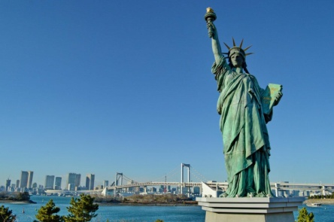

Where is the Statue of Liberty situated? **Answer**: It is in New York (the USA)

**20-**

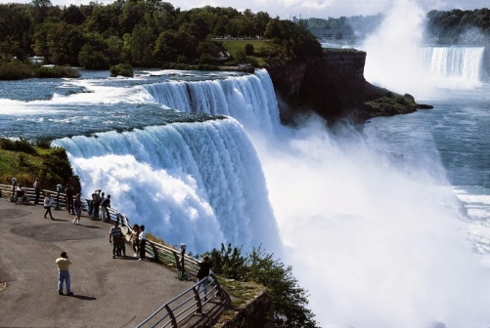

This waterfall is in Canada. What is its name?

**Answer**: Niagara

**30-**

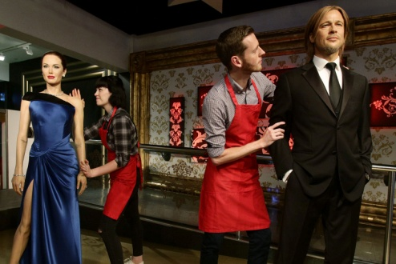 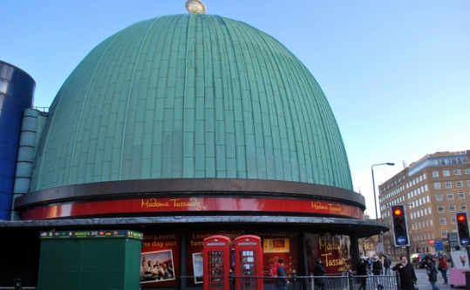

What museum is it?

**Answer:** Museum of Madame Tussauds

**40**-

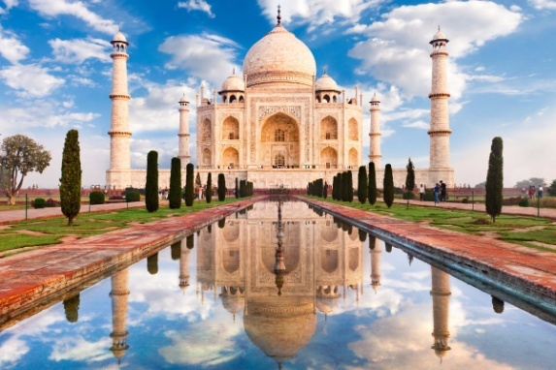

The Taj Mahal was built by order of the emperor Shah Jahan in memory of his favourite wife. It is in ……….. Name the city.

**Answer:** Agra (India)

**50-**

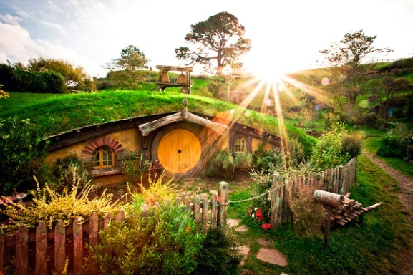

It is the house from “Hobbit “ film. Where is it? Name the country.

**Answer:** New Zealand

**60-**

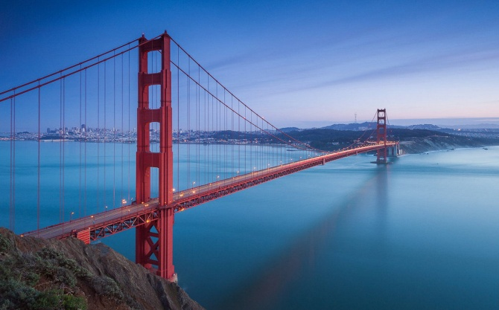

It’s the biggest bridge in the USA (San Francisco). What is its name?

**Answer:** Golden gate bridge

**Holidays, customs and traditions**

**10**- When is New Year celebrated? **Answer:** the 1 st of January

**20**- When is St.Valentine’s Day celebrated? **Answer:** the 14 th of February

**30**- When is Christmas celebrated? **Answer:** the 25 th of December

**40**- When do we celebrate Halloween? **Answer:** the 31 st of October

**50**- Thanksgiving Day is celebrated …. (say the date)

**Answer:** on the fourth Thursday of November

**60**- Guy Fawkes night is celebrated …. (say the date)

**Answer:** the 5 th November nigh

**Famous people**

10.

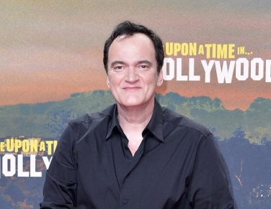

 This is Quentin Jerome Tarantino. What is his job? **Answer:** a producer

**20.**

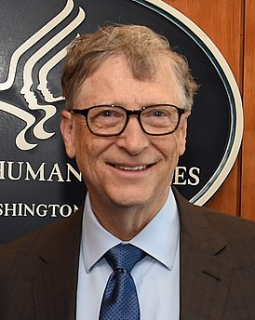

**This is Bill Gates.** What is his job? **Answer:** a businessman and a public figure

**30**

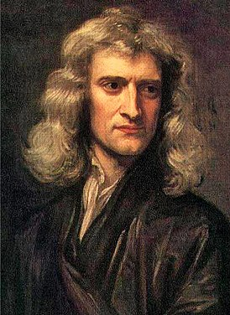

**This is Isaac Newton. Why is he famous?**

**Answer:**

He is best know for his theory about the law of gravity

**40**

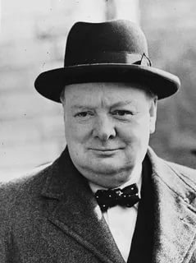

**Winston Churchill was a ….(job). Answer: He** was a British politician, army officer, and writer.

**50**

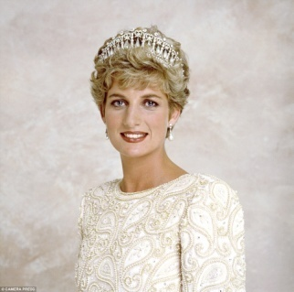

**Princess Diana was married to... . Who was her husband?**  **Answer:** [Prince](https://en.wikipedia.org/wiki/Charles,_Prince_of_Wales) Charles

**60.**

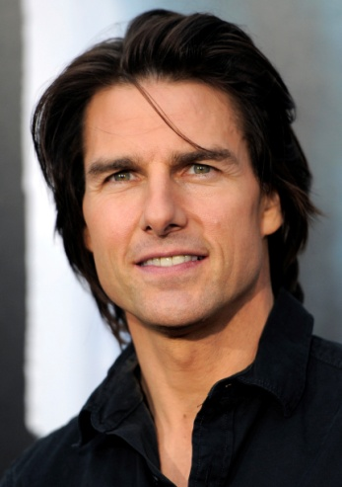

Which actor is it? What’s his name and surname?

**Answer:**   Tom Cruise

**English literature**

**10.Who is the author of “Romeo and Juliet”?**

**Answer:** William Shakespeare

**20. Who is the author of “Sherlock Holmes stories” ?**

**Answer: Arthur Conan Doyle**

**30. Who is the author of “Oliwer Twist”? Answer:**  Charles Dickens

**40. . Who is the author of “Pride and prejudice “? Answer:** Jane Austen

**50.** **Who is the author of** “[The Picture of Dorian Gray](https://en.wikipedia.org/wiki/The_Picture_of_Dorian_Gray)”?  **Answer**:Oscar Wilde

**60.** **Who is the author of “**[Tom Sawyer and Huckleberry Finn](https://en.wikipedia.org/wiki/Mark_Twain#Tom_Sawyer_and_Huckleberry_Finn)”?

**Answer:** Mark Twain

Подсчет баллов и объявление победителей.

Ведущий: Dear students, thanks for your participation! You worked hard. It’s time for announcing the winners. There are 5 classes (5 group), so there are 5 places: the first, second, third, fourth and fifth. There are presents for all of you.

Dear students, have a nice day! See you soon!