Smart friends

Form: 5  
Theme: “Smart friends”  
The aims of the lesson:  
- To revise a new words, to develop the pupil’s habit’s of reading, speaking, writing, to support an interest to the English lesson and promote interpersonal relationship of pupils.  
Visual aids: interactive board, pictures, cards etc.  
The type of the lesson: competition lesson  
Method of teaching: question - answer, multiple choice, matching  
Leading: Good morning children, teachers and guests. We are glad to see you. Welcome to our “Smart friends” competition. Well, today’s competition we have three teams. They are: girls and boys. We will introduce today’s competition’s rounds.  
  
They are called:  
I. Introduction  
II. Who is the best?  
III. Reading the text and translated.

IV. Polyglot  
V. Fairy tale

VI. Test  
VII. The competition for captains  
Well, let me introduce the member of juries:  
_____________________________________  
_____________________________________  
_____________________________________  
  
Ok, let’s begin competition 1st round introduction.  
  
Boys:  
We are boys,  
We did not play toys.  
We are read English  
To develop the knowledge.

Girls:  
We are girls  
We are clever  
We will be  
A nice pupil ever.  
  
Thank you, very much. The next round “Who is the best?”. Pupils, look at the interactive board, there are six books. Each books has got one questions. You must choice one book and answer the question.  
One, two, three, let’s go!

2. Second round: “Who is the best?”

1st team captain:  
1. How many seasons in a year? (four)  
2. The epic novel “Abai” is the work of ……….(Mukhtar Auezov)  
3. What’s the capital of America? (Washington)  
4. What colors are on Kazakhstan Flag? (blue and yellow)  
5. When do we pick fruits? (in autumn)  
6. The great Kazakh poet? (Abai)  
7. What month is it now? (September)

2 nd team captain:  
1. What’ the capital of Kazakhstan? (Astana)  
2. Eating in the evening is called what? (Supper)  
3. The first capital of Kazakhstan? (Kyzylorda)  
4. How many months in a year? (Twelve)  
5. What is the state language of Kazakhstan? (Kazakh)  
6. What’s the capital of England? (London)  
7. How many days in a week? (Seven)

3 rd team captain:  
1. What country do you live in? (Kazakhstan)  
2. When is Nauryz celebrating? (The 22nd of March)  
3. What’s the season now? (Autumn)  
4. What color are the leaves in autumn? (Yellow)  
5. Eating in the morning is called what? (Breakfast)  
6. What’s the official language of the United Kingdom? (English)

7. A little child? (baby)

III. Reading the text and translated.

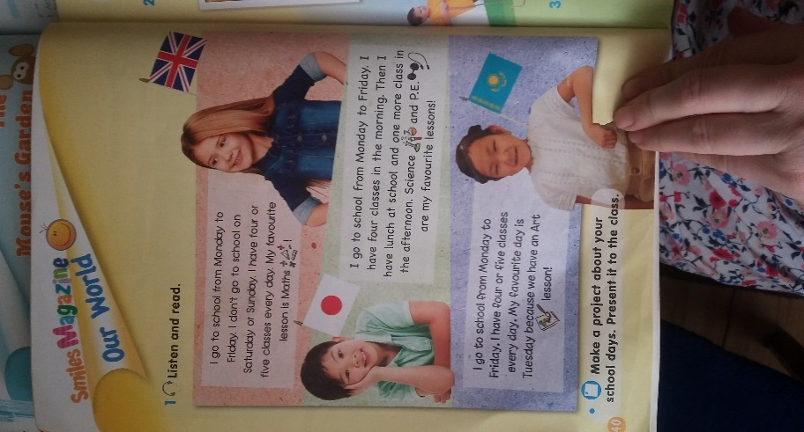 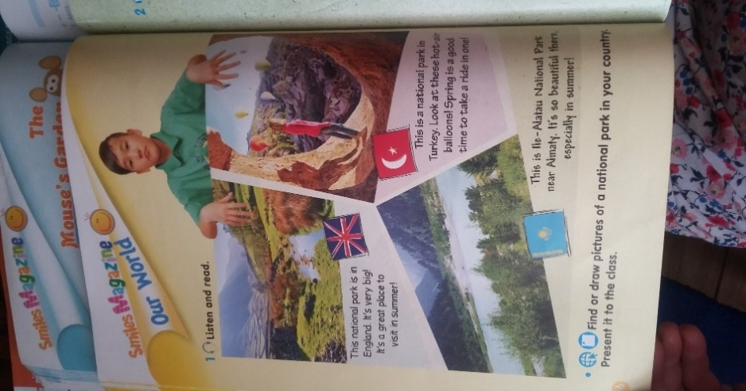 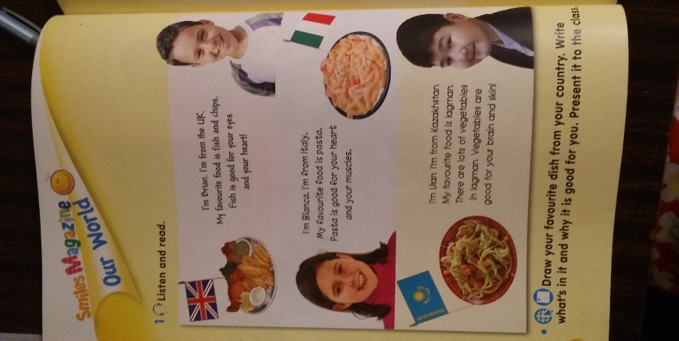

Ok, pupils the 4th round called “Polyglot”. That is there are a lot of balloons. Each balloon has got Kazakh riddles. You must find its answer and translate into Russian and English.

1. Қабақ - қабат қаптама,  
Ақылың болса аттама. (Кітап - Книга - Book)

2. Жазу жазып жалықпаған,  
Жаза - жаза арықтаған. (Бор - Мель - Chock)

3. Ашылып, жабылады,  
Әр үйден табылады. (Есіk - дверь - Door)

4. Гүл ұшып, гүлге қонады,  
Гүл бақшам гүлге толады. (Көбелек - Бабочка - Butterfly)

5. Төрт қарны бар,  
Бір аузы бар. (Үй - Дом - House)

6. Ұшында бір тамшы,  
Уы бар сұр қамшы. (Жылан - Змея - Snake)  
  
7. Қалқиған ұзын құлағы  
Елеңдеп қорқып тұрады. (Қоян - Зайц - Rabbit)

8. Күші десе, күші бар  
Тісі десең, тісі бар.  
Торуылдап ауылды  
Түнде жортар ісі бар.(Қасқыр - Волк - Wolf)

V. Fairy tale

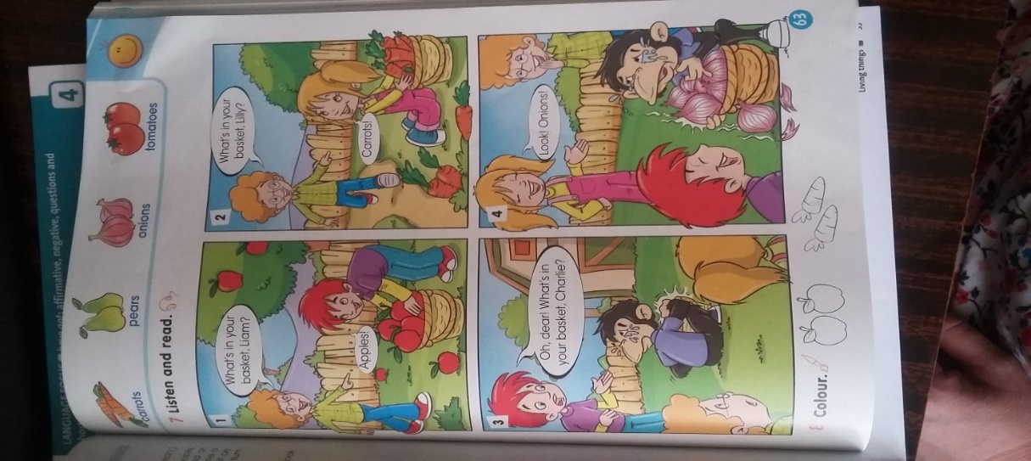 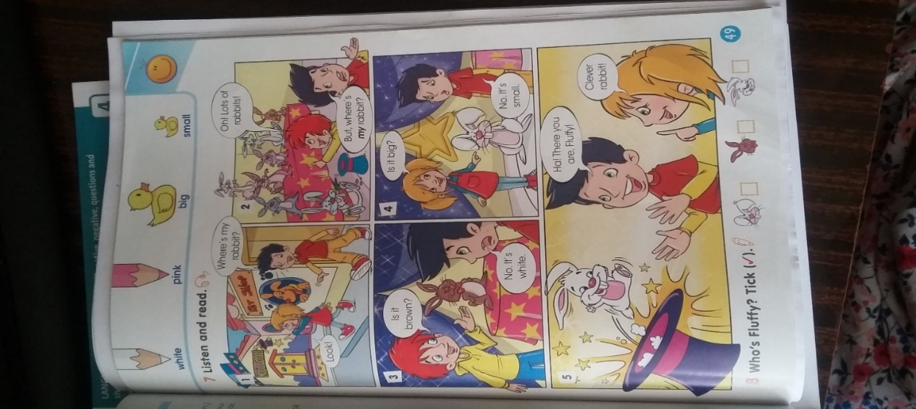 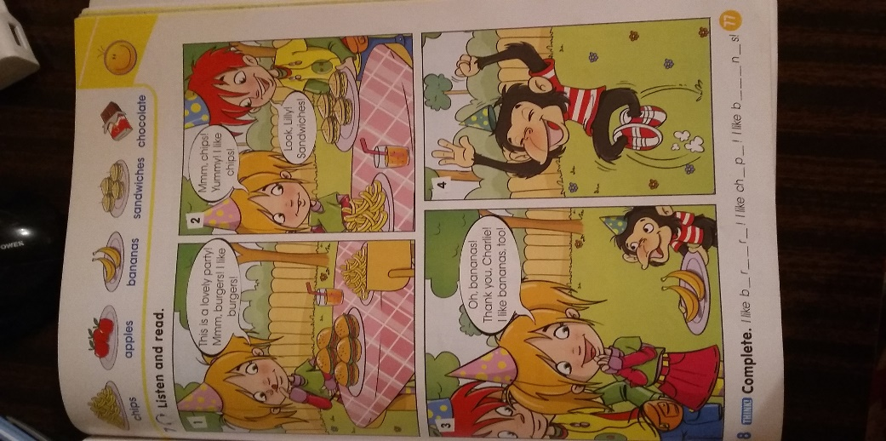

The 6th round “Test”.  
Test  
1. Болымсыз сөйлемді толықтырыңыз.  
I___ not play football  
A) does  
B) was  
C) did  
  
2. Сөйлемді ағылшын тіліне аударыңыз.  
Мен теннис ойнаған жоқпын  
A) He does not play tennis  
B) I do not play tennis  
C) You do not play tennis  
  
3. Болымсыз сөйлем құрастырыңыз.  
Does, watch, she, not, TV  
A) She does not watch TV  
B) Does she not watch TV  
C) Not does she watch TV

4. Осы шақтағы сұраулы сөйлемнен, болымды сөйлем жазыңыз.  
Do you walk?  
A) I walk  
B) I did not walk  
C) I do not walk  
  
5. Сan модаль етістігін дұрыс қолданыңыз  
A) Swim can I  
B) I swim can  
C) I can swim

The 7th round “The competition for captains”  
Translate these words into in English.

1) Ана - mother  
Ата - grandfather  
Мектеп - school  
Мұғалім - teacher  
Кіруге болама - may I come in?  
Рахмет - thank you  
Отбасы - family  
Ақша - money  
Жолбарыс - tiger  
Қарбыз – watermelon

2) Осы шақ - present simple  
Қарындаш - pencil  
Көгершін - dove  
Үй жұмысы - home work  
Әже - grandmother  
Әке - father  
Кітап - book  
Оқушы - pupil  
Шығуға болама?- May I go out?  
Мезгіл – season

3) Маймыл - monkey  
Жылан - snake  
Пенал - pencil - case  
Қауын - melon  
Өткен шақ - past simple  
Қалам - pen  
Қоян - rabbit  
Сынып жұмысы - class work  
Сызғыш – ruler

Сөмке - bag

- Teacher: dear juries, please, conclude all points of rounds. If juries to come a conclusion, make winners public, please.  
Dear teachers, pupils thank you for your attention we are pleased very

Dora wanted to buy a card for her mother. Her mother's birthday was next week. Dora loved her mom. She wanted to get a nice birthday card. She wanted a card that was pretty. She wanted a card that said the right thing. What was the right thing? The card must say, "I love you, Mom." It must say, "Mom, you are the best mother in the world." It must say, "I'm so happy that you are my Mom." Those are all the right things for the card to say. But there was one more thing the card must say. It must say, "Happy Birthday!"