Unit of a long term plan  Holidays and Travel. |  |  | School:
Date: |  |  | Teacher name:
CLASS: 7 |  |  | Number present: | absent:
Lesson title: |  | Sightseeing in Kazakhstan.
Learning objectives |  | 7 C.2 Use speaking and listening skills to provide sensitive feedback to peers.  7R.1 Understand the main points in texts on a limited range of unfamiliar general curricular topics.
Level of thinking skills |  | Application, understanding, evaluating.
Lesson objectives |  | All learners will able to:  -understand the general idea of the text; Name the picturesque places of the city  Most learners will able to:  -understand details of the text and describe the picturesque places ;  Some learners will able to:  -retell the given text;
Assessment criteria |  | - Practice students giving feedback according to speaking and listening skills.  - Identify the core idea of the text on a limited range of unfamiliar general and curricular topics.
Values links |  | -Teach pupils to love and know about our country;
Cross-curricular links |  | History, Geography, Kazakh.
Previous learning |  | Free time Activity
Plan.
Planned timings | Planned activities (replace the notes below with your planned activities) |  |  |  | Resources
Start  7min  WH | I. Org. moment  a) Greeting  b)Checking the attendance  II. Psychological spirit: “Wishes by plane”  Pupils stand in a circle. T takes a plane and say: “I wish you to visit Astana and see the Baiterek” then T gives the plane to pupil standing next to her, who must continue .  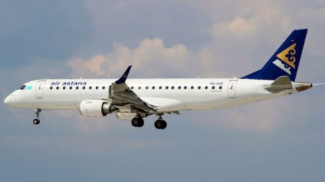  III. Divide class into two groups by “Puzzle” strategy ( Astana, Almaty).  Give them parts of pictures of “Baiterek” and “Apple” and they have to join them.  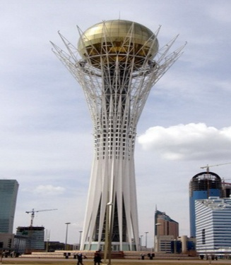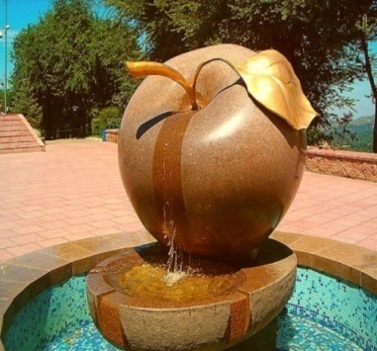  I group-Astana  II group-Almaty |  |  |  | Taken from https://t.co/xWULiV4rutwitter.com  https://yvisio.kz  https://earthflax.ru.net
(WH)  Middle  20 min  (GW)  (I)  5 min  (G)  5 min  End  3 min | Pre-reading. Elicting  Watching video.  I.Brainstorming.  -What can you say about this video?  -How do you think what is the theme of our lesson is?  T: ok ,very good. Today`s our theme is Sightseeing in Kz.  The Teacher assesses students with smiles.  While – reading. By “Gigsaw” strategy.  Ss read and discuss the text in groups and explain it to other group by “Gigsaw” strategy.  I group – Almaty  Almaty is a sunny, immersed in the green city with wide streets, beautiful buildings, numerous parks, gardens and fountains. Magnificent city at the foot of the emerald ridges of the Tien Shan is called «garden city». Luxurious green grass and magnificent mountains make Almaty unlike other cities.  There are a plenty of attracting sights for visitors and guests in Almaty such as  the 28 heroes-panfilovs park, Zenkov Cathedral in Panfilov Park 28 heroes, Islamic Cultural Centre, Independence Monument, Museums, Chimbulak ski resort.  Koktobe is a hilly terrain bordering the city in the south. Koktobe reaches a height of 1,070 m. There is an observation deck at the top of Koktobe. Koktobe is the best place to review the city at night.  Medeo is the world-famous alpine Medeo ice rink was built in 1972 in a picturesque valley located at a distance of 15 km. from the city. The mild climate, the optimal level of solar radiation, low pressure, favorable weather and ice made of crystal clear water make Medeo one of the best rinks in the world.  II group – Astana  Astana is the capital of the Republic of Kazakhstan. It is the third largest city in the country with population over 8 000 000. Astana is a beautiful modern city. The author of Master plan of Astana is the famous Japanese architect Kisho Kurokawa. If you go to this city you will see a lot of modern futuristic buildings as Museum of the First President of Kazakhstan, The Palace of Peace and Reconciliation, Ak Orda, Atameken, Duman, Khasret Sultan Cathedral Mosque, parks e.t.c  “Baiterek” memorial is the symbol of Astana , it is also the geographical centre of all Eurasia. Bayterek, the capital’s symbol. The monument embodies the Kazakh people’s idea of the universe. The tower construction symbolizes three universe bases – underground, earthly and heavenly worlds. At the depth of 4.5 meter, there is the lower level housing café, aquariums and mini-gallery “Bayterek”.  Khasret Sultan Cathedral Mosque  One of the most modern attractions of Astana, the young Kazakhstan capital, is the Khasret Sultan Cathedral Mosque. The colossal building resembles an oriental palace, whose construction involved over 1,500 builders and masters, who with joint efforts created the most beautiful landmark of Astana.  Descriptor:  A learner:  -reads a text understandable;  -discusses in the group;  -explains it to other group;  -list sentences according to the text;  Assessment: Peer assessment by “Stars” strategy. Give stars to each other.    Differentiation: More able learners help to less able learners.  Post reading task. “Magic box” strategy  Pick up a card with sentence from the Magic box and define what city is it?  Almaty Astana  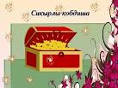  Assessment: by group leaders  Project work. “Advertising” strategy.  They must introduce their city, telling about sights and invite to visit it. Make a poster.  Descriptor  A learner:  -creates their ideal poster (creative, colorful, understandable e.t.c)  Assessment  Group leaders assess another group using “2 stars and a wish” strategy.  Feedback by method 3:2:1  3- facts known from the lesson  2- interesting things learned from the lesson  1 -question for the lesson |  |  |  | https://youtu.be/xqkSnqcdI0s  Handout    www.almaty-info.net  https://wwwadvantour.com  Handout

