|  |  |  |  |  |  |
| --- | --- | --- | --- | --- | --- |
| Short-term plan:  Unit 3: Treasure and Heritage  Lesson : 4 | | **School: “Tortkol” general secondary school**  **English** | | | |
| **Date: 07.11.18** | | **Teacher’s name: Saparbay Nurallah** | | | |
| **Grade 4** | | **Number present:** | | **absent:** | |
| **Learning objectives(s) that this lesson is contributing to** | | **4.L4** understand a limited range of short supported questions on general and some curricular topics  **4.W1** plan, write and check short sentences with considerable support on a limited range of personal and some curricular topics  **4.W2** write words and phrases of regular shape and size  **4.UE2** use cardinal numbers 1 - 100 to count and ordinal numbers 1 - 10 | | | |
| **Lesson objectives** | | **All learners will be able to:**   * Understand how to form ordinal numbers; * Count ordinal numbers from 1-10; * Write a treasure problem with support; * Write 2-3 ordinal numbers correctly; * **Most learners will be able to:** * Write a treasure problem with little support; * Make up cardinal numbers; * Write 4 ordinal numbers correctly;   **Some learners will be able to:**   * Write a treasure problem without support; * Write 5 ordinal numbers correctly | | | |
| **Language objectives** | | **Learner has achieved learning objectives if:**  **4.UE2** use cardinal numbers 1 - 100 to count and ordinal numbers 1 - 10 | | | |
| **Previous learning** | | Treasure map 2 | | | |
| **Values links** | | Competition, functional literacy | | | |
| **Cross-Curricular Link** | | Geography, Mathematics | | | |
| **Use of ICT** | | PPT teacher uses | | | |
| **Intercultural awareness** | | Global citizenship through exploration of the numbers in English | | | |
| **Kazakh culture** | | Comparison of numbers formation in L1 and L2 | | | |
| **Pastoral Care** | | Assure you met all learners’ needs | | | |
| **Health and Safety** | | Make sure power cords are not a tripping hazard  Everyday classroom precautions | | | |
| **Planned timings** | **Planned activities** | | | | **Resources** |
| **Start**  **7 min**  **(W)** | **Lesson Opening & Warm-Up**   * Greet learners. Introduce the lesson objectives. Make sure they understand lesson objectives.   *Treasure and numbers*  *Today we will:*   * *Solve and make treasure problems* * *Learn how to form ordinal numbers*   **Ordinals Buzz Fizz**  Buzz Fizz is a common numbers game can be played with ordinal numbers as easily as with cardinal numbers. Students take turns counting up one number at a time, but instead of any multiple of three they have to say “Buzz”, so going around the class or a group you get “One” “Two” “Buzz” “Four” “Five” “Buzz” “Seven” etc. People who make a mistake can be made to sit out that round if you like. | | | | Board, markers  Slide 1  Slide 2 |
| **Middle**  **5 min**  **(W/P)** | * Ask learners to take their seats and draw learners’ attention to Slide. Explain that in this task learners should solve treasure problems. Give learners some time to think of their answers. Have some learners from the class give their answers.   *Answer key*  *A pirate has got a treasure chest. There are 20 gold coins and 17 silver coins in it. How many coins are there? (There are 37 coins)*  *Another pirate comes and takes 12 coins. How many coins are in the treasure chest now?* (There are 25 coins)  *A treasure island has got 16 rocks on the beach. It’s got 7 rocks near the mountain. It’s got 5 rocks outside the cave. How many rocks are on the island? (There are 38 rocks)* | | | | Slides 3-5 |
| **10 min**  **(I/P)** | * Divide learners into pairs. Explain that each pair should agree on number of coins and rocks to use in their treasure problems. They should write and check their problems before giving them to another pair to answer. After they finish tell them to read their problems aloud and ask other learners to suggest their answers. | | | | Learners’ copybooks |
| **5 min**  **(I/W)** | * Draw learners’ attention to Slide. Tell them that another type of numbers is ordinal numbers. Explain that ordinal numbers show order, position. Give out Handout 1 and Worksheet 2 and have learners glue them into their copybooks. Explain that in Worksheet 2 they should write the numbers in words. Show answers on the Slide | | | | Slides 6,7  Didactic material 1  Didactic material 2  Slide 8 |
| **End**  **3 min**  **(I/W)** | **Revisit lesson objectives**   * Draw learners’ attention to the “Reflection” slide and ask them to say:   ***What did you learn today?***  ***What was the easiest thing for you today?***  ***What was the most difficult thing?*** | | | | Slide 9 |
| End  1min | Feedback: Teacher asks students what task was difficult to them and which pair worked well. | | | |  |
| **Additional information** | | | | | |
| **Differentiation – how do you plan to give more support? How do you plan to challenge the more able learners?** | | | **Assessment – how are you planning to check learners’ learning?** | | |
| **More support:**   * Peer support * Teacher’s support through the whole lesson. | | | Formative assessment  Teacher assesses learners’ progress by observing their work during the class and peer assessment | | |
| **Summary evaluation**  What two things went really well (consider both teaching and learning)?  1:  2:  What two things would have improved the lesson (consider both teaching and learning)?  1:  2:  What have I learned from this lesson about the class or individuals that will inform my next lesson? | | | | | |

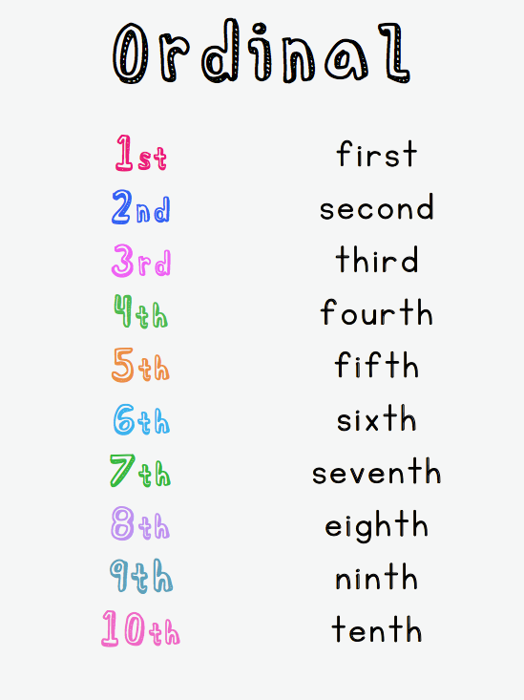

**Name: ______________________________________ Grade: ___________**

**Task. Write an ordinal number to complete the sentences. Use the numbers in brackets.**

1. March is the ___________________________ month in the year. (3)
2. My brother’s birthday is on the ______________________ of July. (9)
3. Сaptain Goldtooth is the ___________________ pirate in his family. (5)
4. Our class is on the __________________________ floor. (2)
5. My mother bought me my _________________________ parrot. (1)

**Name: ______________________________________ Grade: ___________**

**Task. Write an ordinal number to complete the sentences. Use the numbers in brackets.**

1. March is the ___________________________ month in the year. (3)
2. My brother’s birthday is on the ______________________ of July. (9)
3. Сaptain Goldtooth is the ___________________ pirate in his family. (5)
4. Our class is on the __________________________ floor. (2)
5. My mother bought me my _________________________ parrot. (1)

**Name: ______________________________________ Grade: ___________**

**Task. Write an ordinal number to complete the sentences. Use the numbers in brackets.**

1. March is the ___________________________ month in the year. (3)
2. My brother’s birthday is on the ______________________ of July. (9)
3. Сaptain Goldtooth is the ___________________ pirate in his family. (5)
4. Our class is on the __________________________ floor. (2)
5. My mother bought me my _________________________ parrot. (1)

**Name: ______________________________________ Grade: ___________**

**Task. Write an ordinal number to complete the sentences. Use the numbers in brackets.**

1. March is the ___________________________ month in the year. (3)
2. My brother’s birthday is on the ______________________ of July. (9)
3. Сaptain Goldtooth is the ___________________ pirate in his family. (5)
4. Our class is on the __________________________ floor. (2)
5. My mother bought me my _________________________ parrot. (1)