Lesson plan

Long-term plan unit:5 Our health |  |  |  |  | School: №20 A.Pushkin school – lyceium
Date: |  |  |  |  | Teacher name: Salamatova Gulim
Grade: |  |  |  |  | Number present: | absent:
Theme of the lesson: |  |  |  |  | Takeaway food
Learning objectives(s) |  |  |  |  | 6.1.8.1. develop intercultural awareness through reading and discussion;  6.3.3.1. give an opinion at sentence and discourse level on an increasing range of general and curricular topics;  6.6.13.1. use modal forms including must / mustn’t (prohibition), should (for advice) on a range of familiar general and curricular topics.
Lesson objectives |  |  |  | All learners will be able to:  - Read for main ideas of the text by supporting  - Make sentences  Most learners will be able to:  - Edit and proofread the specific information with modal verbs  Some learners will be able to  - Give own opinion about text  - Make and confirm predictions and references
Assessment criteria |  |  |  | - Ask question  - Pronunciation  - Use modal verbs  - Describe benefits of takeaway food
Value links |  |  |  | Healthy habits
Cross curricular links |  |  |  | Kazakh and Russian
ICT skills
Previous learning |  |  |  | Past Simple. Was / were
Plan
Planned timings | Planned activities |  |  |  |  |  |  | Resources
Beginning  5 min | - Warm – up  Strategy “Musical basket”  Teacher writes down new words on pieces of paper, put them in a basket and turn on some music. Ask the learners to sit in a circle and hand this basket over to each other until you stop the music. The learner who is holding the basket at that moment should take a piece of paper out of the basket and make true sentences with the new word. |  |  |  |  |  |  | Appendix 1.
Middle  25 min | - Differentiation by task. Strategy “Use task cards”  Teacher gives out cards with an inscription “healthy food” , “takeaway food” and “junk food” according to the use task cards strategies and divides into 3 groups.  Task 1. 1st group. Read the text and fill in the gaps with the words from the list.  - popular  - England  - served  - home  - eat  2nd group. Read the text and answer the question.  - What is the traditional national food in England?  - When did it become popular?  - In traditionally, the fish and chips are covered with what?  - With what often served fish and chips in the north of England?  - What do British people do at the pub?  3rd group. There is a menu. Learners circle the odd– one–out.  - Side dishes: boiled rice – pancakes – fries – vegetable soup.  - Main meals: noodles with bean sprouts – kebab – fruit salad – pasta  - Desserts: ice-cream – chocolate cake – fruit salad – fish and chips  - Drinks: mineral water – cola – sandwich – lemonade  Descriptors:  - Read carefully  - Pronounce and complete sentence  - Asks questions for clarification  - Evaluates partner’s answer  Formative Assessment: Peer and self assessment.  With peer assessment learners begin to check each others answer. The learners must identify two things that did well (stars) and one specific suggestion for improvement (the wish)  Task 2. Strategy “Find word combination”  According to this strategy learners match the words to form phrases. Learners 1st and 2nd group choose the words and match them. 3rd group make short dialogue use these phrases and modal verbs.  1) mineral a) sandwich  2) healthy b) chips  3) takeaway c) food  4) fish d) water  5) chicken e) meals  Short dialogue  L1: Hi Almat!  L2: Hi Ainur!  L1: Where are you going?  L2: I go to the Colin’s fast food with my friends.  L1: Why fast food? Fast food is unhealthier for you. You mustn’t eat fast food like a chips, sandwich, cola. You should eat more fruits and vegetables.  L2: Yes, you are right. I must eat a lot of healthy food.  L1: Yes, it is important to eat healthy foods.  Descriptors:  - Work in pairs, then in a group  - Match the words using topical vocabulary  - Make short dialogue  Formative Assessment: Response log.  Teacher gives to learners paper achievement with coloured circle. If the learners need help tick the blue circle. If the learners need more information but can do it tick green circle. If the learners can do it all tick red circle. |  |  |  |  |  |  | Appendix 2
End  10 mins | Project work.  - Differentiation by outcome.  Teacher gives poster to draw healthy and unhealthy food and write sentence that you should, must / mustn’t eat. Give own opinion about text according to this poster. Teacher provides multiple tasks according to the learners level.  Descriptors:  - Work in a group  - Make true sentences using modal verbs  - Draw the picture according to the description.  - Present the information to class  Feedback  Write an email  Teacher asks students to imagine they have to write an email to a friend or family member and tell them what they did today in their lesson. Learners have a chance to summarize what they’ve learned in written form with the new vocabulary. |  |  |  |  |  |  | Appendix 3
Additional information
Differentiation – how do you plan to give more support? How do you plan to challenge the more able learners? |  |  | Assessment – how are you planning to check learners’ learning? |  |  |  | Health and safety check  ICT links
Task 1 is Differentiation by task can be achieved through all learners learned new vocabulary, most learners make dialogue using modal verbs, some learners give own opinion.  Differentiation by outcome for more able and less able learners. |  |  | - Peer and self assessment  - Response log  - Write an email
Reflection  Were the lesson objectives/learning objectives realistic? Did all learners achieve the LO?  If not, why?  Did my planned differentiation work well?  Did I stick to timings?  What changes did I make from my plan and why? |  | Use the space below to reflect on your lesson. Answer the most relevant questions from the box on the left about your lesson.
Summary evaluation

What two things went really well (consider both teaching and learning)?
1:

2:

What two things would have improved the lesson (consider both teaching and learning)?
1:

2:

What have I learned from this lesson about the class orachievements/difficulties of individuals that will inform my next lesson?

Appendix 1.
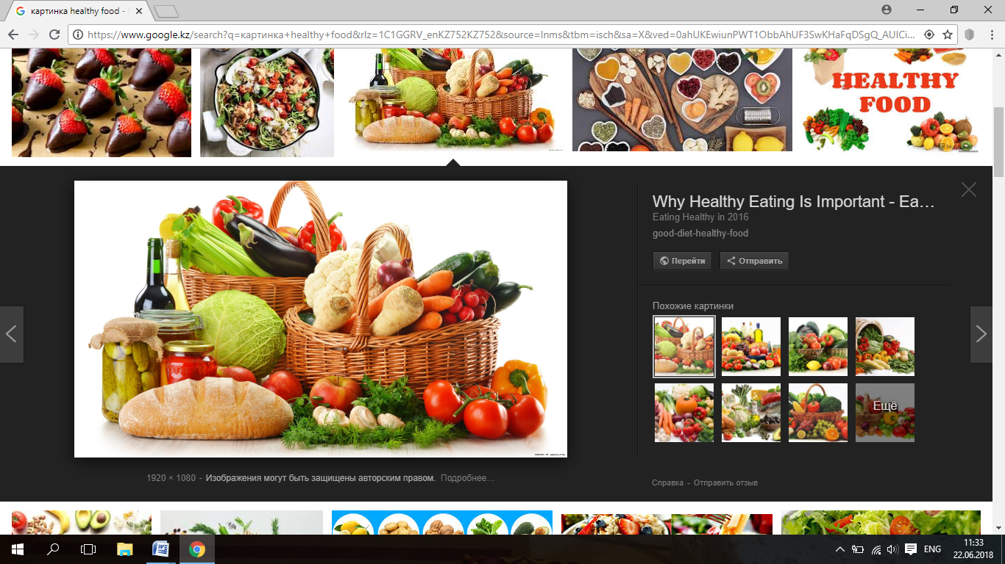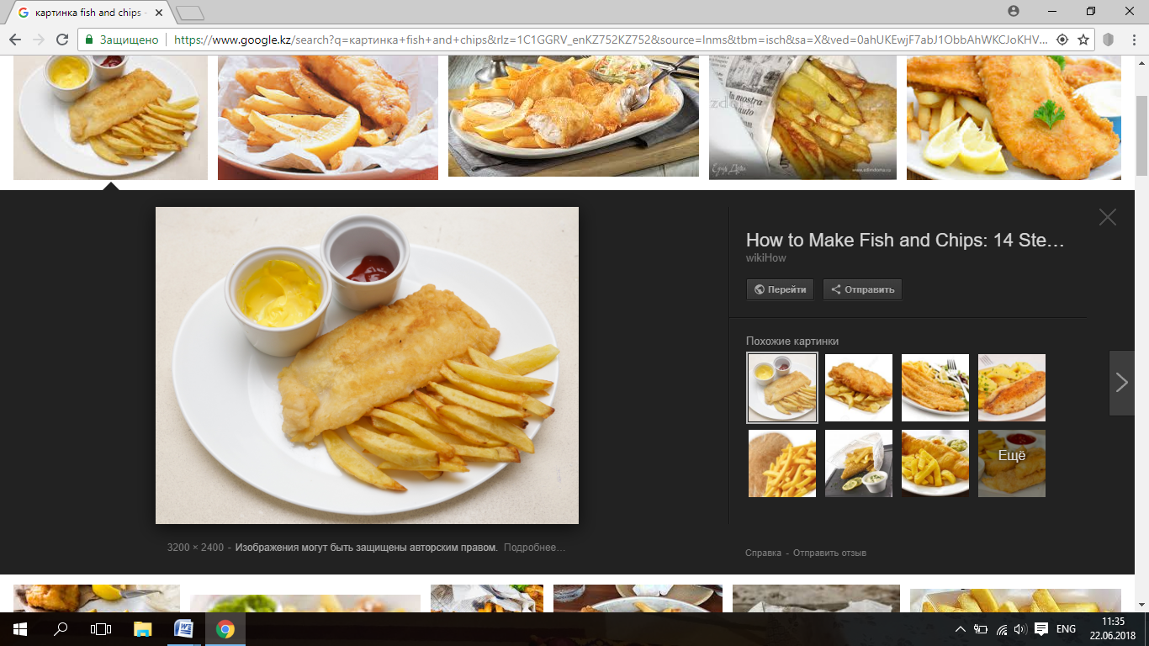

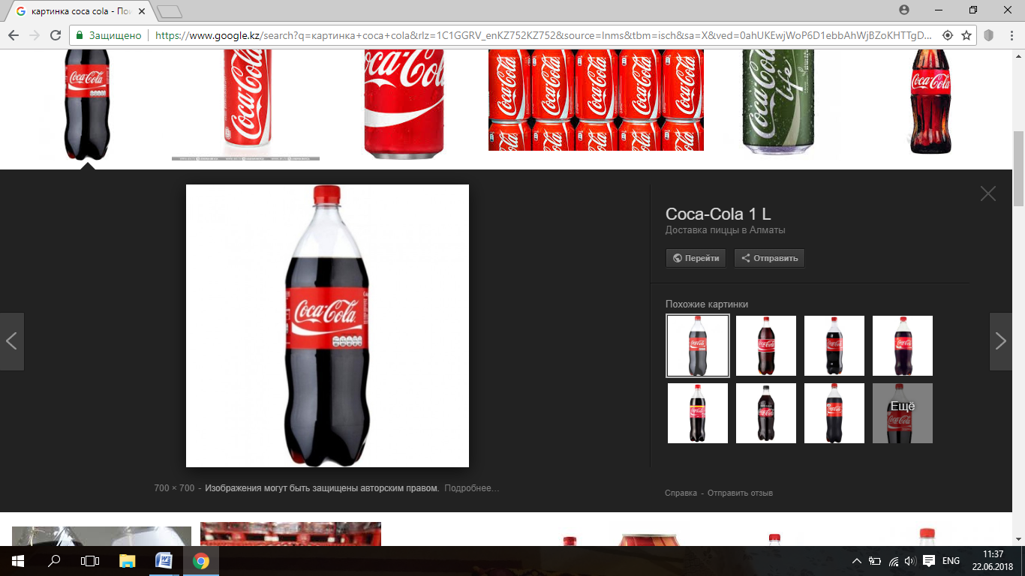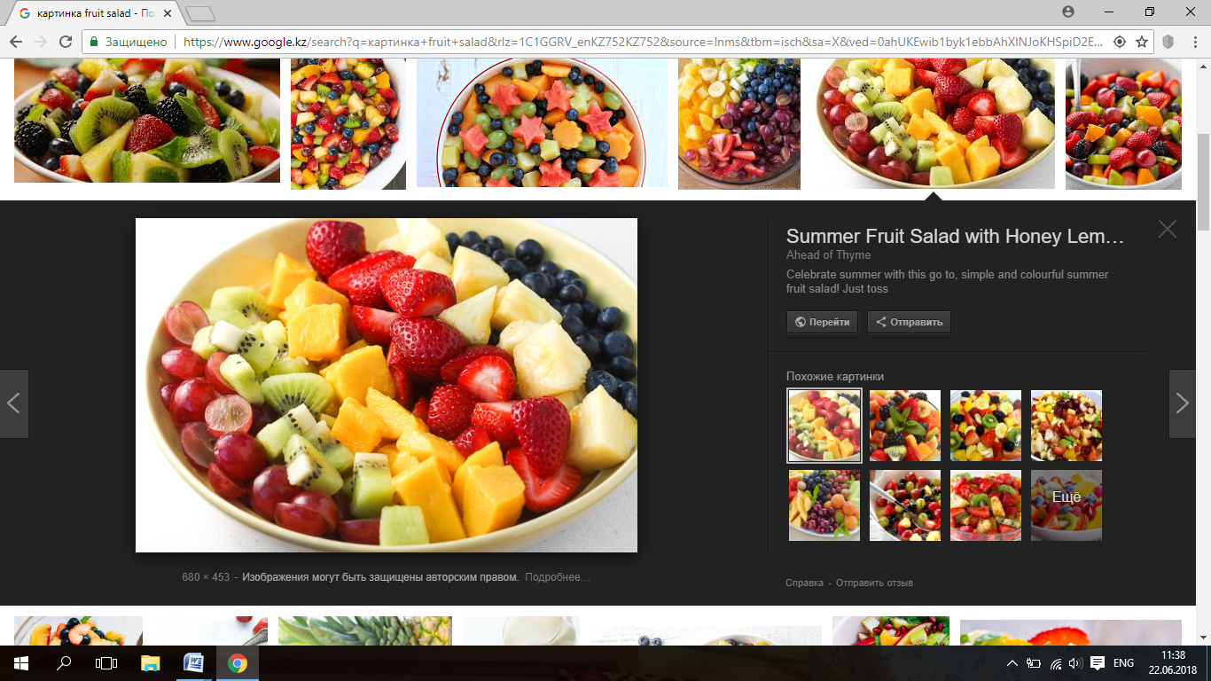

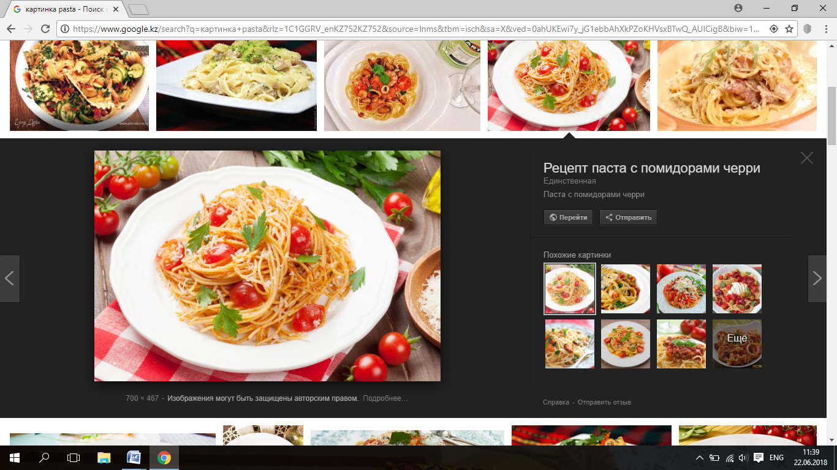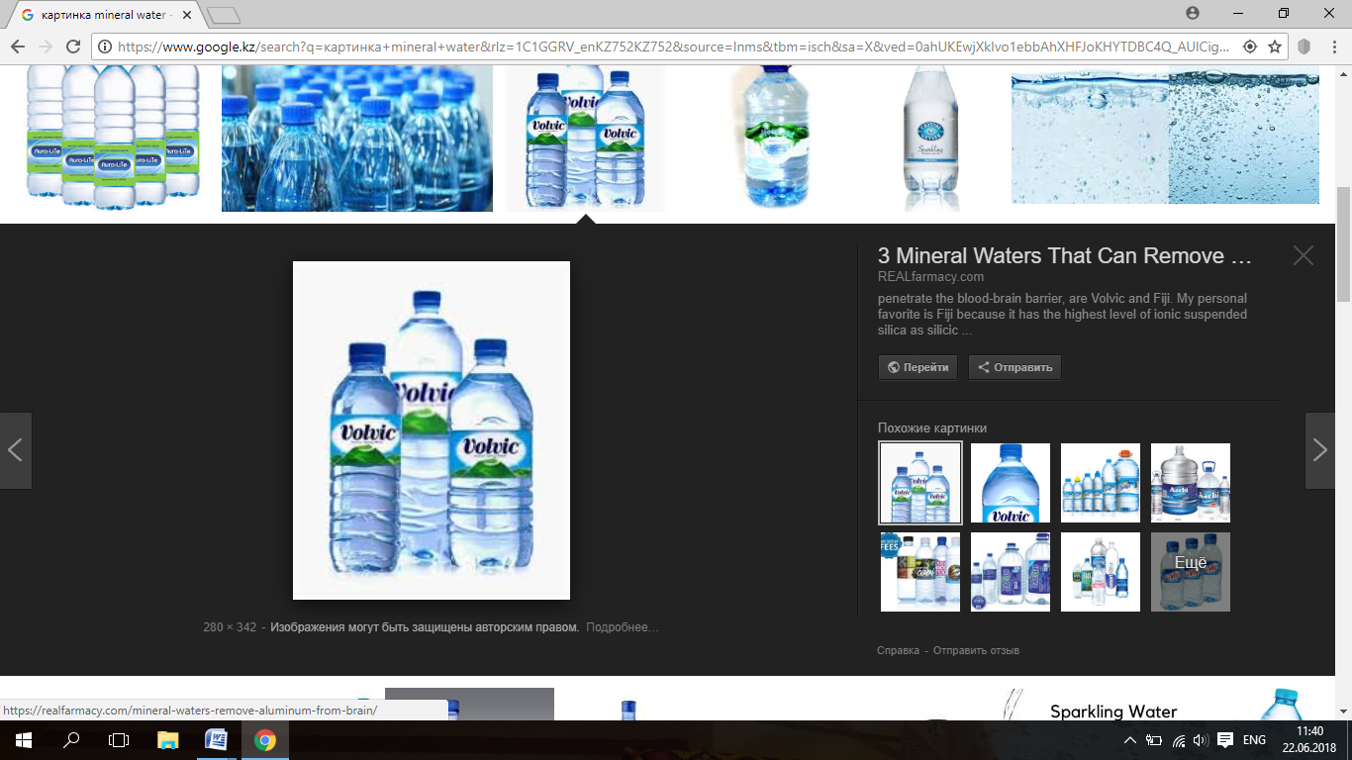

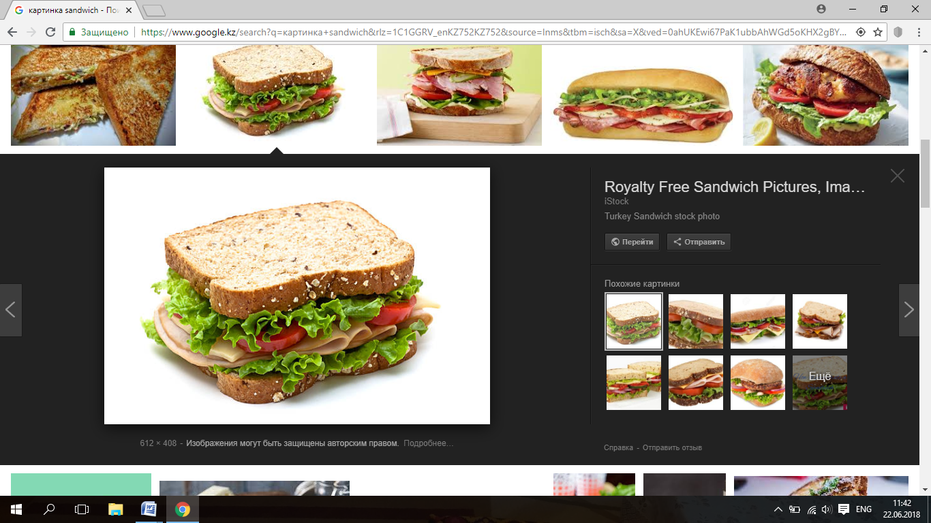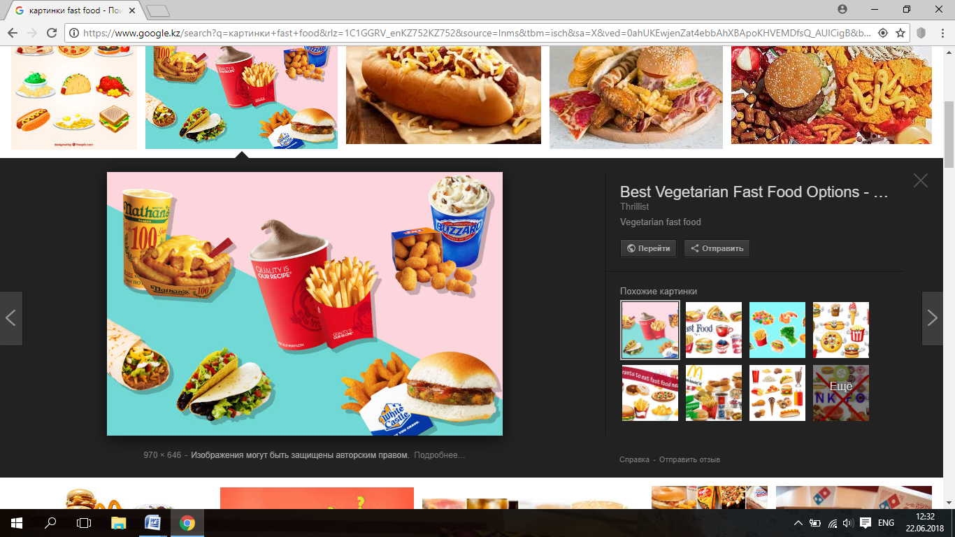

Appendix 2
Takeaway food
Takeaway meals are very popular and most towns have a selection of Indian, Italian, Chinese and Greek Restaurants. You will also find Macdonalds, Burger King and Subway. Fish and chips is the classic English takeaway food and is the traditional national food of England. It became popular in the 1860’s when railways began to bring fresh fish straight from the east coast to the our cities over night. The fish (cod, haddock, huss, plaice) is deep fried in flour batter and is eaten with chips. Traditionally, the fish and chips are covered with salt and malt vinegar and using your fingers, eaten straight out of the newspaper which they were wrapped in. Nowadays small wooden forks are provided and the fish and chips are wrapped in more hygienic paper. In the north of England, fish and chips is often served with “mushy peas” (mashed processed peas). Where can you eat in Britain apart from at home and in a restaurant? Pubs are an important part of British life. People talk, eat, drink, meet their friends and relax there.

Appendix 3
Project work

