LESSON PLAN
Long-term plan: |  |  |  | School: № 40
Date: 26.07.2019 |  |  |  | Teacher’s name: Berdigalieva Shynar
CLASS: 4 |  |  |  | Number present: 12 |  | absent: 0
Theme of the lesson: Weather-season
Learning objectives |  | 4.S.2. express basic likes and dislikes, recount short, basic stories and events on a limited range of general and some curricular topics  4.W.3. write with support short sentences which describe people, places and objects  4.UE.13.use can/can’t to make requests and ask permission, use must/mustn’t/have to, to talk about obligation, use have + object+infinitive to talk about obligations
Lesson objectives |  | All learners will be able to:  - Discuss the weather they like and dislike in 1-2 sentences  - Write short sentences with dictionary support  - Use model verb can/can’t according to the prompt.
Most learners will be able to:
- Discuss the weather they like and dislike in 2-3 sentences
- Write dialogue using no less than 3-4 sentences without any support
- Use model verb can/can’t in their own sentences
Some learners will be able to:
- Discuss the weather they like and dislike in 3-4 sentences
- Write dialogue using no less than 4-5 sentences without any support
- Use model verb can/can’t in own dialogues.
Assessment criteria |  | - Discuss the weather they like and dislike in class  - Write sentences using new vocabulary to describe weather  - Use the model verb can/can’t expressing ability
Value links |  | Love and care to nature
Cross-curricular links |  | Geography
ICT links |  | White board
Previous learning |  | Vocabulary words sunny, rainy, cloudy, windy
Plan
Planned timings | Planned activities |  |  |  |  |  | Resources
0-1 min | Greating : Teacher greats
Start  2-3 min  4-5 min  6-9 min  10-16 min  16-18min | (W) Lead in  - Teacher points the picture weather on the white board and asks the learners what they see, what kinds of weather they know, what weather they like/dislike.  Teacher gives, example; weather, a sunny day, I like/dislike sunny day,  FA with words: good, well done, excellent  Pre –teaching  Teacher tells the students to look at the screen and listen the new words.  Thunder and lightning-  Flood  Tornado  Hail  Avalanche  Storm  The Teacher tells the word and point to the picture to explain the SS the meaning of the words.  Drilling (W)(G)(P)(I)  Matching  - Teacher divides class into 2 groups by pictures (teacher gives students the pictures of hail and storm).  The 1st is hail, the 2nd is storm  Match the words with the suitable pictures:  CCQ: what should they match?  1.Thunder and lightning  2.Flood  3.Tornado  4.Hail  5.Avalanche  6.Storm  After doing the task groups change their works to check. Teacher shows the right answers on the screen and asks how many mistakes each group has  Answers:  1-6, 2-3, 3-2, 4-1, 5-5, 6-4  Teacher’s oral feedback  What’s missing?  (P) Teacher puts 4 pictures on the board and gives 4 dialogues to each group. Students should match the dialogue with suitable picture and find out what natural disaster is described in the dialogue.  - A: What was that light and noise?  B: Don’t worry, dear! Go back to sleep.  - A:We couldn’t get out of the house.  B: Why not?  A: There was water everywhere.  - A: What did you see?  B:I saw a big ball of snow railing down the mountain !\  - A: And then? What happened?  B: Small balls of ice fell from the sky?  Each pair reads a dialogue other students check them with a teacher.  FA with words good, nice, be try  Descriptor students:  - Use new dictionary  - Correct students mistakes  Energizer  Listen to the weather song sing along and dance |  |  |  |  |  |   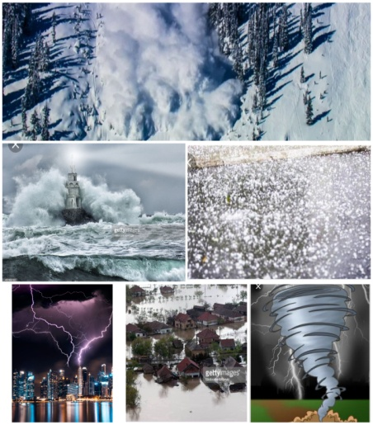    http:youtu.be/rD6FRDd9Hew
Middle  19-24 min  25-30min  31-34 min  35-37 min | Use of English  Teacher says to look at the screen and name what the students see (2 mice) and suggests to give the mice names (eg. Tom and Jerry )  Teacher wants students to describe the mice  The 1st is hardworking  So that he always says I can  foto  The 2nd is lazy  And he always says I can’t  Teacher points to the screen and engages students to say what mice can/can’t do  - CAN + V (RUN, SWIM)  - CAN’T + V (DRAW,JUMP)  Differentiation  Division into 3 groups,  The 1st groups makes up sentences using the example  The 2 nd group makes up their own sentences  The 3rd group makes up the dialogue  (I) Writing Make up sentences: teacher gives a card to both group should make sentences.CCQ: What should they do?  1. 2. 3. 4. 5. 6.  1.house?/Can/your/stay/we/at  Our house is full of water after the flood.  1. 2. 3. 4. 5. 6.  2. email/ you/an/Can/send/for me please?  We haven’t got electricity at home after the tornado.  1. 2. 3. 4. 5. 6.  3. all/ Can/close/you/windows, please?/the  I’m afraid of thunder and lighting.  1. 2. 3. 4.  4.leave/ Can/ early?/we  There’s a storm coming  Keys 2.5.4.6.3.1.  4.2.5.3.1.6  2.4.3.1.6.5.  2.4.1.3.  FA self checking  (P) Writing: complete sentences and discuss views. CCQ: What should they complete?  1. A: Can I go skiing at the weekend, Dad?  B: _1_____. There was an avalanche in that area this morning.  2. A: Miss, can I leave early?  B:___2_____  But only if the rain stops.  3. A: Mum,can I go out tonight?  B: _____3____. It’s snowing  The roads are dangerous.  4.A: Can I stay in the tree house?  B: ______4____________.  There’s thunder and lightning outside  answers:  - No you can’t  - Yes, you can  - No you can’t  - No you can’t  Students read one by one and check each other.
End  38-40 | Reflection “colored balloons”  Teacher says students to raise  - green balloon if students like the lesson  - yellow balloon if they are not sure  - red balloon if they don’t like it at all |  |  |  |  |  | 
Additional information
Differentiation – how do you plan to give more support? How do you plan to challenge the more able learners? |  |  | Assessment – how are you planning to check learners’ learning? |  | Health and safety check
- by objective  - by support  - by resources  - by instruction |  |  | - Self assessment  - Peer assessment  - Group assessment  - Criteria –based assessment  - Teacher assessment |  | - Links to the L1: Do learners know  this story in the L1 and do the know any other Aesop’s fables?  - Make sure learners have sufficient  space to act out the role-play.  - As the unit is on the topic of  values, it is very important to leave time to discuss the end two questions with the  whole class.
Summary evaluation
What two things went really well (consider both teaching and learning)?
1. I followed all rules when I gave instructions to the tasks.
2. I used various of interactions.
What two things would have improved the lesson (consider both teaching and learning)?
1.I would manage the time during the tasks.
2.I increase CCQ

