Lesson plan
Unit 2. Helping and Heroes |  |  |  |  | School: by K.Akynov
Date:22.10.2018 year |  |  |  |  | Teacher name: Bidashova
CLASS: 6 |  |  |  |  | Number present: 6 |  | absent:
Lesson title |  |  | Writing biography
Learning objectives(s) that this lesson is contributing to (link to the Subject programme) |  |  | 6.4.6.1 - recognise the attitude or opinion of the writer in short texts on a  growing range of general and curricular topics  6.4.2.1 - understand independently specific information and detail in short,  simple texts on a limited range of general and curricular topics;  6.5.8.1- spell most high-frequency vocabulary accurately for a limited range  of familiar general topics and some curricular topics  6.3.3.1- give an opinion at sentence and discourse level on an increasing  range of general and curricular topics;  6.5.3.1 -write with some support about personal feelings and opinion on a  limited range of familiar general and curricular topics;  6.2.7.1- recognize the opinion of the speaker(s) in supported extended talk  on a limited range of general and curricular topics;  6.3.8.1- recount some extended stories and events on a limited range of  general and curricular topics  6.3.6.1- communicate meaning clearly at sentence and discourse level
Lesson objectives |  |  | - All learners will be able to identify the main idea in the text  - Most learners will be able to make a conversation to each other according to the topics  - Some learners will be able to prepare presentation on the given topic and writing biography
Assessment criteria |  |  | * Identify the main idea in reading passage  * Identify the position of speakers in an extended talk with some support  * Consider different perspectives on the world orally or in a written form  * Interact in a pair, group and a whole class work presenting logically connected information with ideas of other people  * Consider classmates’ advice and set personal learning objectives based on their feedback
Level of thinking skills |  |  | Application, higher order thinking skills
Cross-curricular links |  |  | History, Art
Previous learning |  |  | Learners already know new words about biography, they should know facts about heroes
Plan
Planned timings | Planned activities (replace the notes below with your planned activities) |  |  |  |  |  |  | Resources
Start  5min | Greetings. Good morning my dear pupils!  -Who is on duty today ?  -Who is absent?  -What date and what day is it today?  -What’s is that weather today?  -I wish you be healthy, good luck, be active, be happy and etc.  Take pictures and I will divided into 2 groups  - Abraham Lincoln  - Leonardo do Vinci
Middle  5min  10min  5 min  End  5-min | Task 1  The method “Stop cadre”(Стоп-кадр)  All pupils close your eyes, one pupil come to the black-board look this picture and give some sentences about this person. You must show who is?  (He was Kazakh hero/He died in 1982/ Who is he? B.Momyshuly, M.Curie, Shyngys Khan, Cleopatra)  “ The method Mosaic” (Пазл)  Complete this chart.  Past Simple  Regular verbs Irregular verbs  Affirmative I played football yesterday. We ate pizza yesterday  Question Did you play football yesterday. Did you eat pizza yesterday?  Negative No, I didn’t. Yes, I did.  Time expressions: yesterday, last week, last year  Pre- reading/New words  Admire-таңырқау  Courage-батылдық  Civil War-Азамат соғысы  Elect-сайлау  Farmhouse-фермер үйі  Lawyer-заңгер  Honesty-шындық  Statue-мүсін  Shoot-ату  Artist-суретші  Post- reading The method “Kos zhazba” kundeligi (Қос жазба күнделігі)  You must read the text and translate into group, then write biography fact file.  I group/Name: Abraham Lincoln  Where/when born: farmhouse in Kentucky on 12th February in 1809  Early years: he was lawyer and he was elected 16th president of the USA.  Achievements: his statue in the Lincoln Memorial, to this day people visit to admire “Honest Abe”  Later years: he guided his country through the American Civil War.  When died: in 1836  II group/Name: Leonardo da Vinci  Where/when born: small town near Florence, Italy in 1452  Early years: he was artist  Achievements: people go to see amazing work to museums and galleries  Later years: in 1500 painted The Mona Lisa  When died: in 1519  The method “Jigsaw” (Джигсо әдісі)  Take the biography and go the next group. Then you must explain.  Envelope with questions «Конверттегі сұрақ»  I will give these questions. You must answer.  - Who was Abraham Lincoln?  - Who was an artist and an Italian painter?  - Leonardo da Vinci when\ where born?  Kick the ball then you must translate words and you don’t know klick the next group.  Home task: Work-book ex 3.p19. Look at the fact file about Marie Curie. Write sentences about her biography. The new words learn by heart.  Feedback look at the ship. Todays lesson  -Green The lesson is clear for me  -Yellow I have got some question  -Red I don’t understand anything |  |  |  |  |  |  | Slides, active board  The groups assessment each other by traffic light  Green-excellent yellow-good red-satisfactory  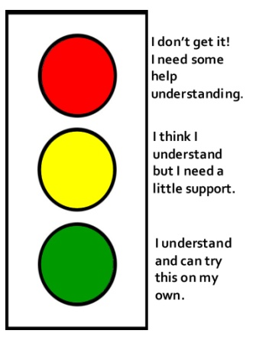  Handout with these words and expressions  Markers and papers  Excel-grade-6-student book and workbook  Page: 27.19  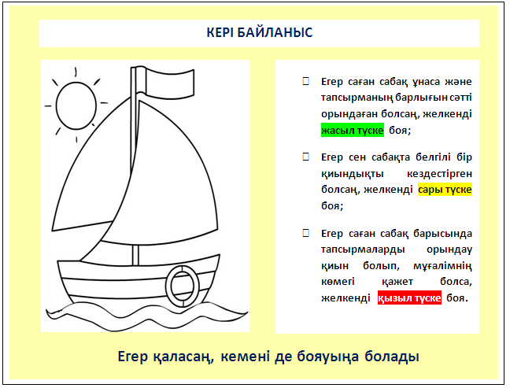
Additional information
Differentiation – how do you plan to give more support? How do you plan to challenge the more able learners? |  |  |  | Assessment – how are you planning to check learners’ learning? |  | Health and safety check
Differentiation can be achievedthroughtheselectionofactivities, identification of learning outcomes for a certain student, provision of individual support to learners, selection of learning materials and resources based on the individual abilities of leaners (Theory of Multiple Intelligences by Gardner). |  |  |  | Use this section to record the techniques that you will use to assess what the learners have learned during the lesson.  I will assess learners by giving oral feedback and explain why they have taken such kind of assessment. |  | Health saving technologies.  Using physical exercises and active activities.  Rules from the Safety Rules book which can be applied in this lesson.
Reflection  Were the lesson objectives/learning objectives realistic?  Did all the learners achieve the lesson objectives/ learning objectives? If not, why?  Did my planned differentiation work well?  Did I stick to timings?  What changes did I make from my plan and why? |  | Use the space below to reflect on your lesson. Answer the most relevant questions from the box on the left about your lesson.
 |  | The lesson was exciting. The atmosphere was very active. Pupils are very good
Summary evaluation
What two things went really well (consider both teaching and learning)?
1: Group work.
2: The method “Mosaic” 3: The method “Stop cadre”
What two things would have improved the lesson (consider both teaching and learning)?
1: Some interesting facts.
2: Be more active students

