Long-term plan unit:  Unit 3 “Holidays and travel” |  |  | School:
Date: |  |  | Teacher’s name:
Grade: 7 |  |  | Number present: |  | absent:
Theme: The best places to visit in Kazakhstan
Learning objectives |  |  | 7.R1 understand the main points in texts on a limited range of unfamiliar general and curricular topics  7.S3 give an opinion at discourse level on a growing range of general and curricular topics  7.C3 respect differing points of view
Level of thinking skills |  |  | 1. Analysis and synthesis  2. Assessment
Lesson objectives |  |  | All learners will be able to:  - analyze and discuss the main points in text on the best places to visit in Kazakhstan with support  - apply an opinion at discourse level on the best places to visit in Kazakhstan.  Most learners will be able to:  - analyze and discuss the main points in texts on the best places to visit in Kazakhstan with some support;  - suggest an opinion at discourse level on the best places to visit in Kazakhstan.  Some learners will be able to:  -explain the main points in texts on the best places to visit in Kazakhstan without support  - give an improvement of an opinion at discourse level on the best places to visit in Kazakhstan
Assessment criteria |  |  | Analyze and discuss the main points in texts on the best places to visit in Kazakhstan  Express and give an improvement of their opinions at discourse level on the best places to visit in Kazakhstan
Value links |  |  | National unity, peace, harmony in our society.
Cross curricular links |  |  | History, geography
ICT skills |  |  | Using internet
Previous learning |  |  | Gathering information about festivals in Kazakhstan and around the world (Food and drink)
Plan
Planned timing | Planned activities |  |  |  |  | Resources
Beginning  5 min | - Greeting  - Warming up (date, weather, season, month, day of the week, feeling)  - Checking absence  - Phonetic drill. Let’s remember some English proverbs:  East or West home is the best!  There is no place like home!  - What do these proverbs mean?  - What is the theme of our lesson?  - Why do you think so?  Concept checking: What should you do? |  |  |  |  | Blackboard, chalk
Middle (30 min)  2 min  6 min  8 min  2 min  7 min  5 min | Students guessed about the theme)  As you guessed, today we’ll talk about our country and the best places to visit in Kazakhstan.  Regrouping :( students are divided into three groups with the help of cards of popular cities of Kazakhstan. Each of them take one card and find another from the famous cities. At the end they should form 3 groups of cities).  Look at your cards. You should form three groups “Astana”, “Almaty”, “Shymkent”.  I group -“ Astana”  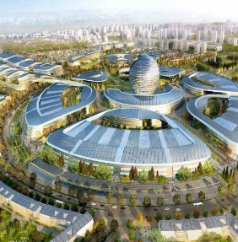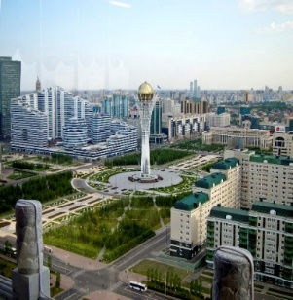  II group – “Almaty”  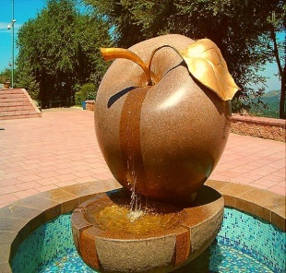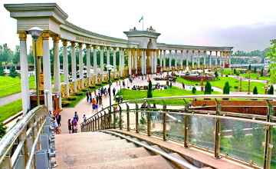  III group – “Shymkent”  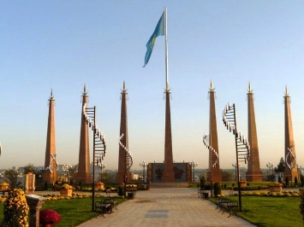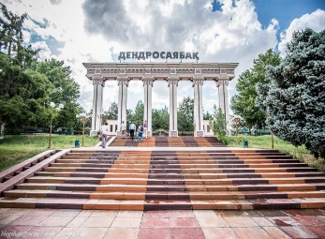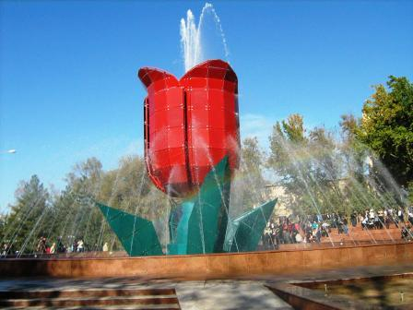  I Task. Answer the questions using internet resources. Each group describe your city. (Group work).  Less able students answer the questions.  More able students give full description of the city.  - Where is this city situated?  - What is this city famous for?  - What places do you like to visit in this city?  - Why do you recommend visiting this city?  Descriptor:  1. Answers the questions using internet;  2. Give the description of the city.  FA by cards:  - Group of Astana –Baiterek  - Group of Almaty- gold apple  - Group of Shymkent- red tulip r   Acquired skills (Bloom’s taxonomy): understanding, researching, presenting.  (Students guessed what they have just done).  II Task. Read the text attentively.  Group “Astana”  Find out in the text the sightseeings of Astana. Name them.  Astana is the capital city of our country. It is beautiful and young. There are many sightseeing in Astana.  Ak Orda is the residence of our president. He works and lives in Ak Orda.  Duman is the biggest oceanarium in the Central Asia. There are many different kinds of fish there.  Baiterek is an observation tower in Astana. It is 105 meters tall. On the top level there is a handprint of the right hand of Nursultan Nazarbayev, the first President of the Independent republic of Kazakhstan.  Group “Almaty”  Make up 10 questions about the text.  Almaty was the capital of Kazakhstan from 1929 to 1997. Now it is big commercial and cultural center of country. There are a lot of sightseeing in Almaty.  Medeu is located in mountain. It is the highest skating rink in the world.  Kok-Tobe mountain. It has a variety of amusement park. There is also 372 metres tall TV Tower.  There is also a ski resort in Almaty- Shymbulak. It is elevated 2200 metres above sea level.  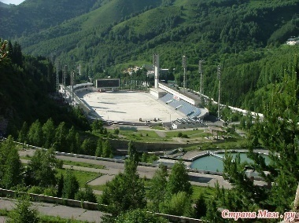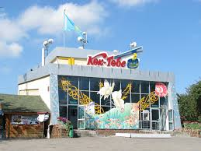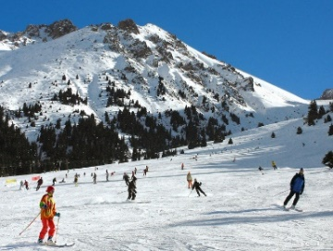  Group “Shymkent”  Make an advertisement using pictures and sentences from the text.  Shymkent  Shymkent-the third largest city in Kazakhstan. There are many anciant cities. Tukestan historical region of central Asia. This city is 1500 years old. It was Khodja Ahmed Yasawi, the poet and Sufi. This place is worshiped by the Muslim community of Kazakhstan and Central Asian Countries.  Arystan Bab Mausoleum it situeted in Sairam. Arystan Bab was a mentor of Khodja Ahmed Yasawi, and his teacher.  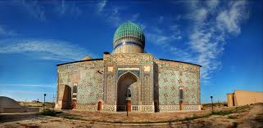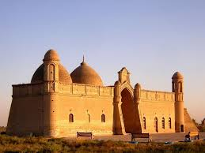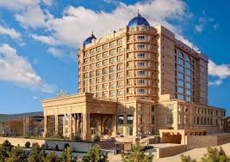  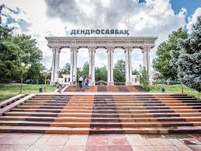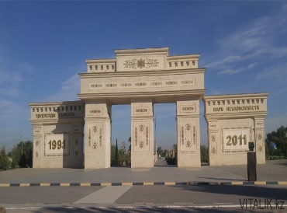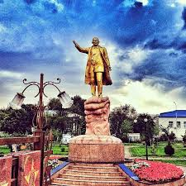  Descriptors:  1. Analyze the text, find out and name the best places to visit in Astana.  2. Analyze the text make up ten questions about the text.  3. Analyze the text and make up advertisement using pictures and sentences from the text.  Regrouping. Take parts of the pictures and form pairs.  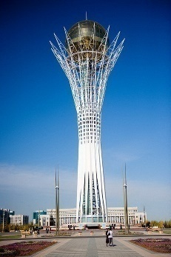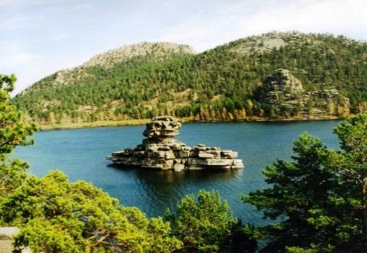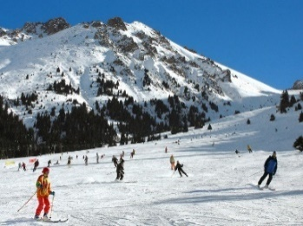  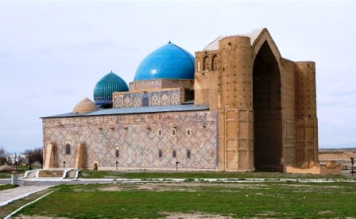  III Task. Look at the pictures. Discuss and make up a dialogue using pictures and Internet resources. Imagine that you are visiting this place.  Descriptors:  1 make up the dialogue in pairs using pictures and Internet resources. |  |  |  |  | Cards of three cities  Copies with questions  Internet resources.  Active board  Texts, pictures  Pictures,Internet resources
End (5 min) | Feedback:  Tree of success  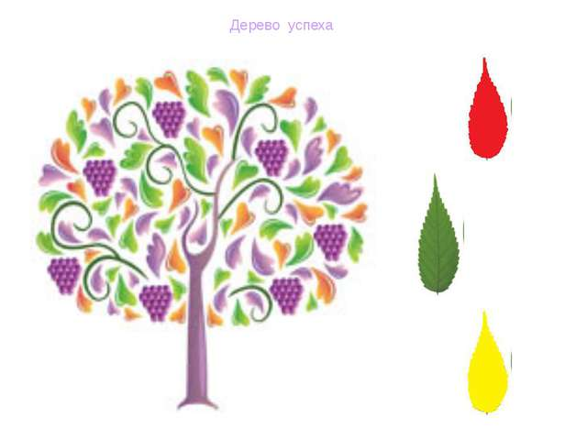  Green leaf - I totally understand  Yellow leaf - I understand the lesson but I need some helps  Red leaf - I don't understand
Homework |  |  | Write a review about your favourite city of Kazakhstan
Additional information
Differentiation – how do you  plan to give more support?  How do you plan to  challenge the more able  learners? |  | Assessment – how are you planning to check learners’  learning? |  | Health and safety check ICT links
Less able students – greater  support by means of prompts,  visuals or writing difficult words  on the cards.  More able students –  independent work on definite  tasks with little/no support. |  | The assessment is held with the help of “Tree of wishes”.  Through the feedback. Students answer the questions by analyzing the lesson and themselves. |  | - Ensure proper ventilation  - Check sockets’ safety

