Theme: |  |  |  | School: № 177
Date: 22.11.2019 |  |  |  | Teacher’s name: Kadiraly.A
CLASS: 9A |  |  |  | Number present: |  | absent:
Theme of the lesson: Do you like living in the city or countryside?
Learning objective (s) that this lesson is contributing to |  |  | 9.4.3.1- understand the detail of an argument in extended texts on a range of familiar general and curricular topics;  9.6.3.1- use a variety of compound adjectives and adjectives as participles and a variety of comparative structures to indicate degree on a range of familiar general and curricular topics;  9.5.3.1- write with moderate grammatical accuracy on a wide range of familiar general and curricular topics;
Lesson objectives |  |  | All learners will be able to:  - understand the text with support  - translate text with support  - write sentences without mistakes with support
Most learners will be able to:
- translate text with little support
- make sentences with modal verb

Some learners will be able to:
- understand the text without support
- Make sentences using modal verb without support
Value links |  |  | Understand about life in city and in countryside
Cross curricular links |  |  | Geography
Plan
Stages of the lesson | Planned activities (replace the notes below with your planned activities) |  |  |  | Teacher’s notes
Greeting  2 min | Greet students; students respond to greeting and take their places.  Hello, boys and girls! How are you?  Explain about life in the city and in the countryside
Grouping  5 min | Pupils take cards with pictures “city” and “countryside”  One group has city pictures. Other group has countryside pictures |  |  |  | Preparation  • Bring photocopies of the videoscript.
Check hometask  2 min | Exercise 2 on page 121
New theme  10 min | Teacher explains new theme about difference between “city” and “countryside”  New words:  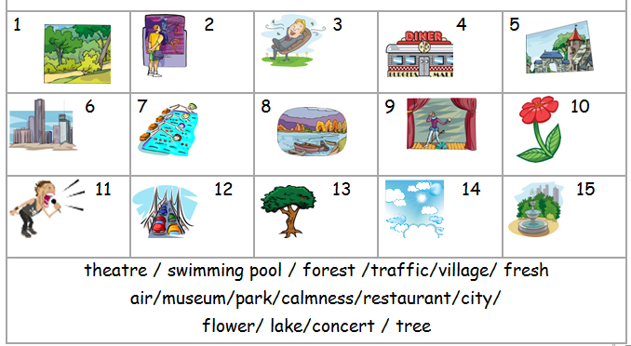  Fun-қызық  Job-жұмыс  Tiring-талпыну  Drive-жүргізу  Difficult-қиын  Crowded-толы  Lonely-жалғыз  Dangerous-қауіпті  Stressed-шаршаған  Pollution-ластану  Secure-күзет |  |  |  | Video from Youtube
5 min | (G)Each group has one text  The first group reads about city  The second group reads about countryside  COUNTRY LIFE: Living in the countryside may be more relaxing, but it can get (1) __________________ as life is slower. There is less to do to have (2) ______________, like going to the cinema or shopping centre. It is also more (3) __________________ to get to places because often there are no good public transport systems. Getting a (4) _________________ in the country may also be harder. Most jobs are in the city so people have to (5) ________________ there every day and this can be (6) _________________.  CITY LIFE: Living in the city may be exciting but it is also (1) ______________________. The crime rate is higher and people may feel less (2) __________________ than in the countryside. Also, there is more (3) _________________ because of the cars. So there are more traffic jams. Cities are bigger and so they are more (4) ______________. City life is faster and people are often so busy and (5) ________________ that they don’t have time to pay much attention to their neighbours. Some people may also feel (6) ____________. |  |  |  | Answers  Countrylife:  fun  job  tiring  boring  drive  difficult  Countryside:  crowded  lonely  dangerous  stressed  pollution  secure
3 min | (UE)  modal verb can/can’t |  |  |  | worksheet
4 min | (G)  What can you do in the …………?  Every group should write what they can do in the city and countryside |  |  |  | worksheet
5 min | (I) Put in correct order
2 min | Feedback  KWL chart  K W L
Additional Information
Differentiation - how do you plan to give more support? How do you plan to challenge the more able learners? |  | Assessment - how are you planning to check learners` learning? |  |  | Health and safety check ICT links
More support will be given to weaker learners by giving them a modified worksheets in some tasks with greater support |  | -through questioning and the redirecting of questioning in feedback activities  -through observation in group and end performance activities  -through formative task |  |  | -Health promoting techniques  -Breaks and physical activities used.  -Points from Safety rules used at this lesson.
REFLECTION |  | Answer the most relevant questions to reflect on your lesson.  Were the lesson objectives/learning objectives realistic?  What did the learners learn? What did/didn’t you like? What was difficult?

