Lesson plan

Unit: 6. Explorers and Inventors |  |  | School: Maitubek secondary school
Date: |  |  | Teacher name: Aizhan Amanzholova
CLASS: 3 |  |  | Number present: | absent:
Lesson title |  |  | Marco Polo
Learning objectives(s) that this lesson is contributing to (link to the Subject programme) |  |  | 3.2.4.1 respond to questions on a limited range of general and some curricular topics  3.3.6.1 understand with considerable support, some specific information and detail in short, simple texts on a limited range of general and some curricular topics  3.4.3.1 write short phrases to identify people, places and objects
Lesson objectives |  |  | Learners will be able to:  - formulate answers to questions on a limited range of topic with support  - recognize the details in short, simple text of «Marco Polo» with support  - describe one of the inventions in short phrases in written form
Assessment criteria |  |  | - answers to questions on general and curricular topics  - identify some detailed information in short simple texts with considerable support  - write short phrases to identify people, places and objects
Values links |  |  | Common history, culture and language
Cross-curricular links |  |  | History, Art
Previous learning |  |  | Art and Music
Plan
Planned timings | Planned activities (replace the notes below with your planned activities) |  |  |  | Resources
Starter  0-5 min | CLASS ROUTINE  Teacher greets students.  STARTER  [W] Learners watch a video about Marco Polo and try to predict the topic of the lesson.  Teacher asks learners to guess the topic of the lesson. Learners may guess that they are going to speak about Marco Polo.  INTRODUCTION  After the learners guess the topic of the lesson, teacher introduces learners with the learning objectives. |  |  |  | https://www.youtube.com/watch?v=YzxT57DHMXU
Middle  30 | DEVELOPMENT  PRE-READING: Teacher gives some new words from the text. Learners work with active vocabulary, drill pronunciation and translation, make notes of the new words.  Pre teaching vocabulary.  DRILLING  Learners drill the new words.  New words: Emperor, Journey, Prison, Writer.  WHILE-READING: SKIM THE TEXT.  Marco Polo started his journey to China when he was 17 years old. He arrived at the palace of Kublai Khan, the emperor of China. Kublai Khan liked Marco Polo because he was very clever. Marco Polo worked for the emperor for 17 years. Marco Polo left China in 1292.  Three years later, Marco Polo arrived in Venice. In 1298, there was a war between Venice and Genoa. Marco Polo ended up in prison. In prison, Marco Polo met a writer. Marco told him about China and he wrote a book called “The Travels of Marco Polo”. Today, we know a lot about China because of Marco Polo. People call Marco Polo one of the greatest explorers of all time!  Match the picture to the content of the text.  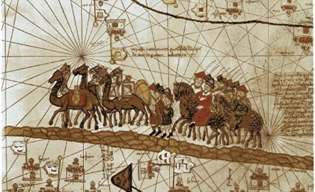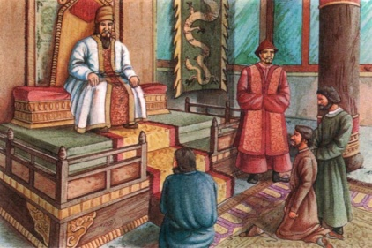  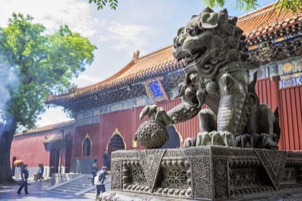  [G]. SCAN THE TEXT.  Read the text again, make TRUE/FALSE and correct them.  a. Marco Polo was the emperor of China.  b. Kublai Khan doesn’t like Marco because he was very clever.  c. There was a war between China and Venice.  d. Marco Polo wasn’t explorer.  Differentiation: by teacher’s support  Less able learners will be given phrases, more able learners will be found themselves.  Descriptor: a learner  - Skims the text  - Matches the picture according to the text  - Read the text  - Corrects sentences  Oral-Assessment: Good, Well-done, Try better  POST-READING: Answer the questions.  [G] Cаrоusеl. Teacher divides learners into two groups by get a piece of paper with the name of their group.  The first group is VENICE. The second group is CHINA. Each group is given a sheet of A3 with a question on the topic. Each sheet may have its own questions. After this time, students move to another sheet of paper. They read then if they agree they put a tick, if not then they write an answer to the previous group.  (for the first group)  1. Who was Marco Polo?  2. When did he arrive in Venice?  3. Whom did he meet in prison?  (for the second group)  1. Who was Kublai Khan?  2. How many years did Marco Polo work for the emperor?  3. When did he leave China?  Descriptor: a learner  - Identifies some specific information  - Answers the questions  - Makes up sentences  Differentiation by support – students work in groups, exchange opinions, listen to each other, more-able learners support less-able learners.  Group assessment by checklist.  Each group will assess other group by the checklist.  For the first group Tick/Cross  Explorer  Three years later  A writer  For the second group Tick/Cross  The emperor of China  For 17 years  In 1292  [I] Соllаgе. Students make a poster according to the chosen word and describe it in written sentences. Choose ONE invention from the box and describe it.  Telephone Robot Internet  Descriptor: a learner  - choose ONE invention  - create a poster  - make 5-7 basic sentences  Differentiation by scaffolding. (NOTE: Teacher supports less-abled learners with the list of unknown words with their definition)  Oral-Assessment: Excellent, well-done, try better. |  |  |  | Smiles Pupil’s Book, page 88  Worksheet 1
End  5 | PLENARY  Teacher provides learners with self-assessment paper  I can … Tick Cross  Understand specific information  Ask questions using new words  Describe people, places and objects in short basic sentences  Create a poster  CLASS ROUTINE  Home task: to learn words  Teacher thanks learners and say good bye!
Additional information
Differentiation – how do you plan to give more support? How do you plan to challenge the more able learners? |  | Assessment – how are you planning to check students’ learning? |  |  |  | Health and safety check
Differentiation: by teacher’s support  Less able learners will be given phrases, more able learners will be found themselves.  Differentiation by support – students work in groups, exchange opinions, listen to each other, more-able learners support less-able learners.  Differentiation by scaffolding. (NOTE: Teacher supports less-abled learners with the list of unknown words with their definition) |  | Oral-Assessment: Good, Well-done, Try better  Group assessment by checklist.  Each group will assess other group by the checklist.  For the first group Tick/Cross  Explorer  Three years later  A writer  For the second group Tick/Cross  The emperor of China  For 17 years  In 1292  Oral-Assessment: Excellent, well-done, try better.

