Unit of a long term plan:  All about me |  |  |  | School: Zh. Eginabaev
Date: |  |  |  | Teacher name: Abilkairova Roza Iskakovna
Class: 2 |  |  |  | Number present: | absent:
Lesson title |  | My clothes and things
Learning objectives(s)  that this lesson is contributing to(link to the Subject programme) |  | 2. R2 identify, remember and sound out high-frequency sound and letter patterns  2. UE3 use basic adjectives to describe people and things  2. W5 write letters and familiar high frequency words when read aloud or spelt out for learners  L1 understand a range of short basic supported classroom instructions
Lesson objectives |  | All learners will be able to:  - Name the topical words  - Read and match the words, follow the teachers instructions  Most learners will be able to:  - Answer the questions  - Make the sentences using topical words  Some learners will be to:  - Describe the picture using the topical vocabulary
Assessment criteria |  | - Identify and remember the sounds and words  - Describe people and things using adjectives  - Write the letters and words
Language objective |  | Useful classroom language for dialogue \ writing  Discussion points:  Can you say why…?  Writing prompts:
Values links |  | Respect, Cooperation
Cross-curricular links |  | Art
Previous learning |  | I can...
Plan
Planned times | Planned activities(replace the notes below with your planned activities) |  |  |  |  |  | Resources
Start  0-5 min | - Greet the learners: Speech drill.  - "Hello!"/"Good morning!"/"Good afternoon!" How old are you?/What date is it today?/What day of the week is it today?  Let’s start our lesson.  2. Warm up: Phonetic drill  - Teacher asks pupils to watch a video and identify the clothes  2. Introducing the lesson objectives:  Teacher asks the learners to find out the theme of the lesson  Learners guess the theme  Teacher introduces the topic of the lesson. “My Clothes”  Introduction of the vocabulary:  Teacher pronounces the topical words one by one, making learners repeat after her. Teacher introduces the new words  Task 1. Name the clothes Snowballing FA (Oral comments)  Learners name the words they remember and add one new word quickly |  |  |  |  |  | https://www.youtube.com/watch?v=AxPOEUwTBvc
Middle | Task 2. Learners read the words and match them to the pictures  Teacher hands out worksheets with the pictures of the following items of clothes (shoes, a blouse socks, a dress, a skirt,) and word cards  Teacher makes learners to walk round the class and try to collect pairs of matching cards. Matching (Peer assessment)  Task 3 Describe people and clothes using adjectives  Descriptors:  A learner:  - describes clothes using adjectives;  - talks about feelings;  - uses topic words;  - pronounces words and expressions clearly  Task 4. Teacher gives the image of a clown. A learner listens, completes and colours the image of a clown  according to teacher  instructions and describes the picture  Teacher asks questions and learners continue to practice to respond the questions. Think and thick questions  - What are you wearing today?  - What s she/she wearing?  - Is she wearing a blue dress?  Task 5. The teacher introduce the structure and learners make the sentences using the topical words  Learners write their own possible according to the given structure..  I am wearing….. .  He is wearing …. .  She is wearing ….  Game activity  Find the words  dresstieskirtjacketsweatertrousersshorts  Pupils finds and circle as many words as they can |  |  |  |  |  | Pictures,  Active board,  Worksheets  PPT slides
End | Groups come review the words and give their stars  Closing reflexion/self assessment  - I learned new words.  - Everything was clear.  - I can say what I am wearing.
Additional information
Differentiation-how do you plan to give more support?  How do you plan to challenge the more able learners? |  |  | Assessment-how are you planning to check learners’ learning |  |  | Health and safety
Less able students – greater support by means of prompts, visuals  More able students – independent work on definite tasks with little/no support |  |  | - through observation.  - Through questioning. |  |  | Health promoting techniques  Points from Safety rules.
Reflection
Were the lessons objectives/learning objectives realistic?

What did the learners learn today

What was the learning atmosphere like?

Did my planned differentiation work well?

Did I stick to things? What changes did I make from my plan and why?

Summary evaluation
What two things went really well (consider both teaching and learning)?
1:

2:

What two things would have improved the lesson (consider both teaching and learning)?
1:

2:

What I have learned from this lesson about the class or individuals that will inform my next lesson?

Formative assessment task
Subject: English Grade: 2 Unit 1 Name________________________________

Subject Programme  reference | Learning Objective | Assessment Task
2.UE3 | Use common adjectives in descriptions and talk about simple feeling  simple feelings | Describe clothes and people using adjectives happy, sad, surprised, green, yellow, blue etc.  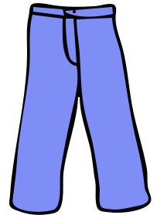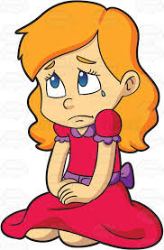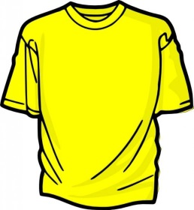  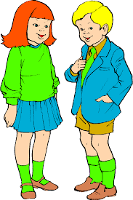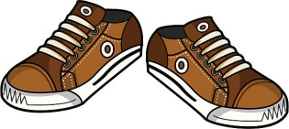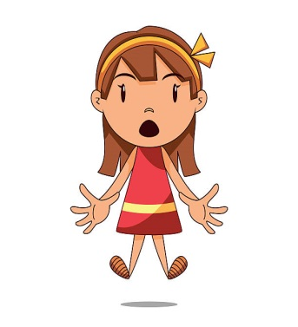
Assessment criteria |  |  | Talk about feelings using simple feeling words  • Give description using common adjectives
Descriptors: |  |  | A learner can:  - describes clothes using adjectives;  - talks about feelings;  - uses topic words;  - pronounces words and expressions clearly

Conclusion
A – Achieved
W – Working towards

