Teacher of English: Rakhimbayeva Karshyga Karimovna
School: Gymnasium №37 of Semey

Subject | English | Grade | 9 «A» | Date
Theme | Music and musical instruments
Aim of the lesson: | To introduce related vocabulary  To develop speaking and listening skills and provides practice of the sub-skills of reading for gist and reading for specific detail.
Objectives: | - to enlarge students’ knowledge on the theme;  - to enrich students’ lexicon through new vocabulary;  - to develop students’ speaking, reading, listening skills and learn to think critically  - to discuss music tastes and trends  - to practice reading for gist and specific detail
Success criteria: | - pupils will learn new vocabulary,  - will learn more about music and musical instruments,  - will discuss their own attitudes towards music  - will improve reading, listening, writing and speaking skills.
Used modules: | Using new technology in teaching, Assessment for and of learning, Critical thinking, Management and leadership of learning, Using of ICT.
Strategies: | Project work, «Cinquain poetry», feedback «Note»
Communicative tasks: | Talk about music
Resources: | Active board, cards, markers, pictures, Power Point Slides, E-book, Cambridge / English in Mind / SB2/ WB2

Lesson plan

Stages | Contents | Teacher’s activity | Pupils’ activity | Assessment | Resources
Introduction  5 min. | Org. moment  Aim: to form a friendly atmosphere | - Good morning, boys and girls!  - Nice to meet you! How are you?  - Tell me please, what date is it today?  - Who is on duty today? Are you ready to work?  Teacher gives the «Assessment paper» to the leaders. | Good morning, teacher!  We are fine, thank you!  Today is the 23th of February  I am on duty today  Yes, we are | Good!
 | Checking up the home task | - What wаs your hometask?  (teacher checks the homework by asking in oral form) | To retell the text «Music that changes lives» | Good job!
 | Brainstorming | Good! Ok. Let’s go further. Look at the blackboard, please. I want to know your point of view about these proverbs.  - Do you agree or disagree with these quotations about music? Give your arguments  - What types of music do you know? | “Music is the universal language of the world”  Henry W. Longfellow  Students ‘answers: jazz, rock, classical music, rap, club music, hip-hop, country. |  | 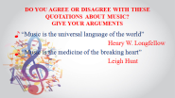
Main part  20 min | NEW THEME  I. Presentation of new vocabulary | - Piano [piˈænoʊ] – пианино  - Drums [ˈdrəmz] –барабан  - a trumpet [ˈtrʌmpɪt] – труба  - a violin [vaɪəˈlɪn] – скрипка  - a clarinet [ˌklærəˈnet] - кларнет  - guitar [ænɪˈlektrɪkɡɪˈtɑːr] – гитара  - a saxophone [ˈsæksəfoʊn]- саксофон  - a flute [fluːt] –флейта  - a synthesizer [ˈsɪnθəsaɪzər] – синтезатор  - a keyboard [ˈkiːbɔːrd] – клавиатура  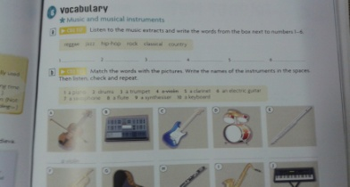  What about our national musical instruments? | What about our national musical instruments?  Dombra – Kazakh two-stringed plucked musical instrument. It is used as accompanying, solo and main instrument in the Kazakh traditional music.  Kazakh shan-kobyz is the ancient Kazakh reed musical instrument. The instrument is made of the wooden plate, in the middle of which there is a reed.  Kobyz might be considered one of the widely-spread musical instruments of the Kazakh people. Kobyz is the bow instrument. Kobyz is made of the whole wood.  To play on a musical instrument if they can. | Well done!  . | Slides 4/5
 | II. Practice of new vocabulary | I think everything is clear for you. If so let’s practice our vocabulary. Please, switch on your monitors and do the task. Unit 9-10. Vocabulary. The 2nd task. First off all you should complete the sentences then we’ll listen the right answers and check together. | Students do the task and check their answers.  Unit 9-10. Vocabulary. The 2nd task. |  | CD Unit 9-10  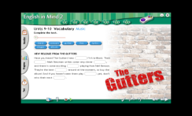
 | III. Reading stage  1. Pre-reading task | Discussion  - How is it important in your life?  - Can you imagine our life without music?  - When do you listen to music?  - How often do you listen to music?  - Who is your favourite singer or group?  - What kinds of music do you dislike? Etc. | Students ‘answers.
 | 2. While-reading task. | Now, I have prepared texts according to the theme, i.e. about music. You’ll work in 2 groups. You have to choose one of these signs and choose your texts. | Students must choose one of signs and choose their texts and work on the text. | Very good!
 | 3. Post-reading task | Students should draw the main idea of the text on A3 paper |  |  | Project work
 | Training exercise | Aim: to make better pupils’ mood and invigorate them | Singing a song | Thank you! Good for you!
 | IV. Listening stage | Ok. Thank you. Our next task is Listening. Please, switch on your computers and do the task «My Music» Units 9-10. As you see your task is to listen and click on the correct answers. Be careful more than one answer may be correct. | Students do the task and check their answers. |  | CD Unit 9-10  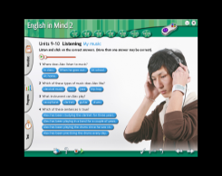
Conclusion | «Cinquain poetry»  Aim: to conclude the lesson. | So it’s time to sum up. You were great today. Did you like the lesson? What you did at the lesson? Have you learnt anything new? What musical instruments can you name? What types of music do you know? What type of music do you like listening to?  In order to finish the lesson I’ll ask students to express their opinion in «Cinquain poetry» | Cinquain poetry:  1word (a subject or a noun)  2 words (adjectives) that describe word 1  3 words (action verbs) that relate to word 1  4 words (feelings or a complete sentence) that relates to word 1  1 word (a synonym of line 1 or a word that sums it up) |  | 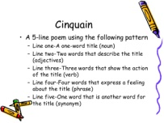
 | Feedback  «Note» | I have three types of Notes. You should choose one of these Notes and write your reflection about our today’s lesson and stick it  «» - interesting or likes  «» - difficulties during the lesson  «» - dislikes or don’t understand. | Pupils write their reflection about the lesson and stick the notes to the musical lines. | Good job!  Well done! | 3 types of notes  Pictures of musical line  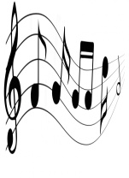
 | Assessment | Assessment of the leaders.  Group assessment.  Your marks are: … | The leader of each group assesses the members of the group by evaluation card. | Thank you so much for your work! Good-bye! | Evaluation card.
 | Home task | Write down an essay «Music in my life» | Pupils write down the home task in their diaries.

