Lesson: I love weekends |  |  | SCHOOL: №11
Date: 16.10.2019y |  |  | Teacher name: Balishanova A
Class: 8 “B” |  | Present: |  | Absent:
Learning objectives |  | 8.R.2.1 understand specific information and detail in texts on a growing range of familiar general and curricular topics, including some extended texts.  8.S.7.1 use appropriate subject- specific vocabulary and syntax to talk about a range of general topics, and some curricular topics.  8.C.1.1 use speaking and listening skills to solve problems creatively and cooperatively in groups.  8.W.9.1 punctuate written work at text level on a range of familiar general and curricular topics with growing accuracy
Lesson objectives |  | All leaners will be able to:
 |  | Read the text
 |  | Most leaners will be able to:
 |  | Understand. the main point of the topic by listening
 |  | Some leaners will be able to:
 |  | Write and speak about they are weekend , how they spend it.
Language objectives |  | Key words:  Useful classroom language for dialogue: mainstream fashion, alternative shop, cool, window –shopping , court , chat, waterslide
Level of thinking skills: |  | Analyzing and creating
Assessment criteria |  | - provide unprepared speech to answer a variety of questions at sentence level with limited flexibility.  - read and identify the main idea in the text  - identify details in a text with little support  use the information to write sentences which describe people, places, objectives
Value links |  | Respect and cooperation
Cross curricular links: |  | Culture
Previous learning: |  | Learners make up dialogue about shopping
PLAN
Planned timings | Planned activities/replace the notes below with your planned activities |  |  |  | Resources
5 min  5 min  15 min  5 min  7 min | - Organization moment:  Reflection. “Rise and Shine”  II. Divided pupils into two groups by picture  1st group “ Almaty”  2nd group “New York”  III. Get warm up  How do teenagers spend your free time?  Where do they go? Talk about it  Our new theme for today is “I love weekends”  VI. Active vocabulary.  Introduction of new vocabulary  Students watch a presentation of the words on the topic and repeat the new words after the teacher.  mainstream fashion –негізгі сән үлгісі  alternative shop – альтернативті дүкен  cool- тамаша  window-shopping –сөрелерді қарастыру  court-корт  chat-мылжыңдау  waterslide-су төбешігі  - Task 1 Use the method «Draw your brain»  Descriptor: draws the outline of brain and write words which they remember  Feedback: smiles  Read the title of the text.  I New York  1.where 2. something 3. so 4.out 5. about 6. or  Im not really into mainstream fashion, so the East Village is 1) …. I hang out at the weekends. I just love the alternative shops down there. It’s such a cool area that you can always find. 2) …. interesting and different to buy. There are some fantastic coffee shops there, too. My favourite is alt. coffee, an Internet café. Some of the shops are expensive, 3) …. We just spend time window-shopping. In Tompkins Square Park there’s a basketball court and we play there sometimes.  II. Almaty  I love hanging 4) … with my friends during the weekends. Every Saturday, my brother Rustam and I meet our friends at Almaty Central Park to walk around and chat. We’re all crazy 5) …. Water rides so if the weather is good and the sun is out we go on the waterslides. Then , we either go for a coffee 6)…. We go to the Dostyk Plaza mall to do some shopping.  Questions  - What does Nurlan like do at the weekend?  - What does Jane like do at the weekend?  - How do teenagers spend their free time?  - Where do they go?  Descriptor:  - Listen and complete the missing word.  - Read and understand the main of text.  - Answer the questions  Amusing time  - Say three words with letter A  - Say three animals with letter D  - Say three cities name with letter T  - Say this word in three emotion Astana  - Say three numbers with letter E  - Say three animals with letter F  - Say three flowers name  - Say three vegetables with letter C  - Say your friends name  - Say your favourite subjects  - Say five profession  - Say domestic animals  Task for two group. Who is quickly?  - Where does Jane live?  - What is her favourite coffee?  - What is Nurlan’ brother called?  - Which shopping mall does he sometimes go to?  - Where is Nurlan live?  - Where does Nurlan meet her friends?  - Where do they play a basketball court?  Descriptor:  - Answer the questions  In pairs, discuss why you love weekends. Write down a short article  Descriptor:  - Work in a group  - Discuss about weekend  - Write poster about cities weekend |  |  |  | Pictures      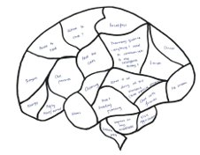  
3 min | Formative assessment  Sequin
Hometask.
Write a short article

Additional information
- Differentiation –how do you plan to give more support? How do you plan to challenge the more able learners?
Listening task  Most support:  Put the missing letters  Some support:  Put the missing words  Minimal support:  Listen to the story and put the sentences in order |  | Self-assessment. Students tick where they are on the success ladder.  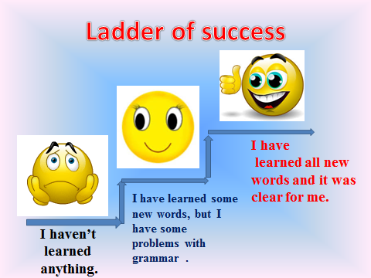
Reflection
Were the lesson objectives
Learning objectives
Realistic?

Did all the learners
Achieve the lesson
Objectives/learning
Objectives?

Did my planned
Differentiation work
Well?

Did I stick to timings?

What changes did I make
from my plan and why?
Summary evaluation

What two things went really well (consider both teaching and learning)?

What two things would have improved the lesson (consider both teaching and learning)?

What have I learned from this lesson about the class or individuals that will inform my next
lesson?

