Short-term plan
Lesson plan
Long-term plan: Unit 8 Sports |  |  |  | School : Chingirlau secondary school
Date: 03.05.2019 |  |  |  | Teacher name: Bayimbetova K.M.
Grade: 5 |  |  |  | Number present: |  | absent:
Lesson title: Sports for all
Learning objectives |  | 5.2.4.1 understand the main points of supported extended talk on a range of general and curricular topics  5.3.2.1 ask simple questions to get information about a limited range of general topic  5.4.4.1 read with some support a limited range of short fiction and non-fiction texts  5.5.4.1 write with support a sequence of extended sentences in a paragraph to give basic personal information
Lesson objectives |  | Аll learners will be able to  - recognize different sport activities  - answer the questions  - read and understand the simple texts with support  Most learners will be able to  -identify the advantages and disadvantages of sport  -classify them into outdoor and indoor sports  -apply phrases connected with theme  Some learners will be able to  - write essay and express own opinion to a given tasks  - compare and collect information through the Internet
Assessment criteria |  | - recognize different sport activities  - read and understand the text  - answer the questions  - identify the advantages and disadvantages of sport  - classify them into outdoor and indoor sports  - write essay and express own opinion to a given tasks  - analyze, compare and collect information
Value links |  | Learners are taught to be healthy and fit a seculiar society with high spirituality (“Mangilik Yel” 3)
Cross curricular links |  | ICT, PE
ICT skills |  | active board for showing tasks, Bilim Land material, Laptop for searching information
Previous learning |  | Learners know about sports vocabulary
Plan
Planned timings | Planned activities |  |  |  |  |  | Resources
Start  3 min  Middle  7 min  5 min  7 min  3 min  3 min  4 min  2 min  3 min  3 min | Greeting  Brainstorming  (W) Students watch and listen to the video about sports and identify the theme of the lesson through the video.  Pre- speaking. Method “Catch the ball”  (W, f) After watching the video learners answer the questions Teacher asks referential questions to pupils bearing on the context of the lesson  1. Whаt’s your fаvourite sport?  2. What kind of sport do you prefer?  3.Why do you like this kind of sport?  4.How often do you play it?  5.Whаt sports do you like playing?  6.Which sports do you dislike?  7.Where do you go to play?  8.How do you get to the gym?  9.What is your favourite sport team?  Descriptor  have a good mood  answer the questions  express their opinion  Assessment Fireworks  All learners clap to each other  Differentiation by tasks, by support of teacher  Differentiation strategy helps learners use their abilities and skills to get more educated  Dividing into groups through the halves of pictures with according our theme  the first team is football  the second team is basketball  Place: Cabaret style. (teams: ‘football’ and ‘basketball’)  (W, f) While- speaking. Strategy Why?  Complete the diagram. Why do people do sport?  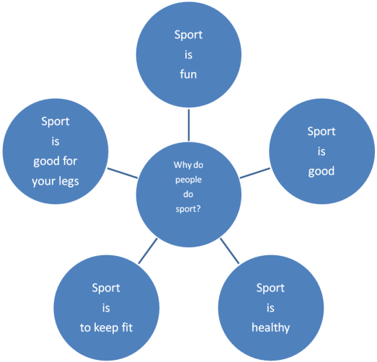  Descriptor  - say the benefits of the sport  - answer the questions  -share ideas  Formative assessment  Teacher gives students different comments: Good of you Well done! Good job!  (W, I, f) Post-speaking Plus and minus  Task 1 Differentiate advantages and disadvantages of sport. Speak about for and against. Collect information through the Internet  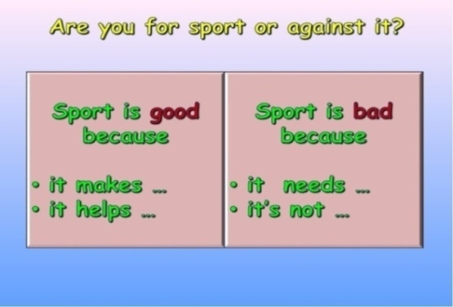  Descriptor  -differentiate advantages and disadvantages of sport  - find information from the internet  Group assessment. Groups assess each other by the criteria  Group assessment Yes/No  speak about the advantages and disadvantages of sport  identify the benefits and harm of sports  (W, f) Pre-reading. “5 Questions”  Students watch and listen to the video about Glasgow sport school  Answer the questions  1. Who has got a silver medal for swimming?  2. What subjects are there at the school?  3. Where is the Glasgow School of Sport?  4. How many students are there at school?  5. Which competitions do students take part in?  (W, P, f) While-reading. “True or False”  Learners write task connected with text  - At a sport school there are school subjects like Biology, PE, History. (False)  - Every day the students do sports. (True)  - There are 1,100 students at the school. (True)  - Many students from Glasgow School become footballers. (False)  - Every year students win competition s for their school. (True)  Self assessment: learners check up with teacher’s answer sheet  (W, P ,f) Post-reading and writing. Who is the quickest?  write four school subjects  write five sports from the text  speak three things  remember about the Glasgow School of sport  Descriptor  work in common  answer the questions  write true or false  write four school subjects  write five sports from the text  remember and speak three things about the Glasgow School of sport  Team assessment. Teams assess each other by comments and likes  Dynamic pause Are you tired? Please stand up and do this activity Energizers. “My favorite sport”  Differentiation by outcomes  is achieved by individuals answering at their own levels of ability so that very different outcomes result from the same task or piece of work  (W, G, f ) Writing  A group Compare differences between indoor and outdoor activities. Strategy Venn diagram.  Descriptor  -compare the differences between indoor and outdoor activities.  -complete the Venn diagram  B group. Match the pictures with kinds of sport  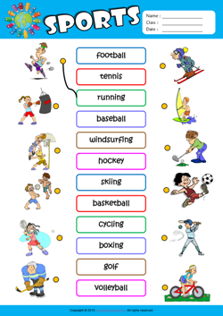  Label the pictures  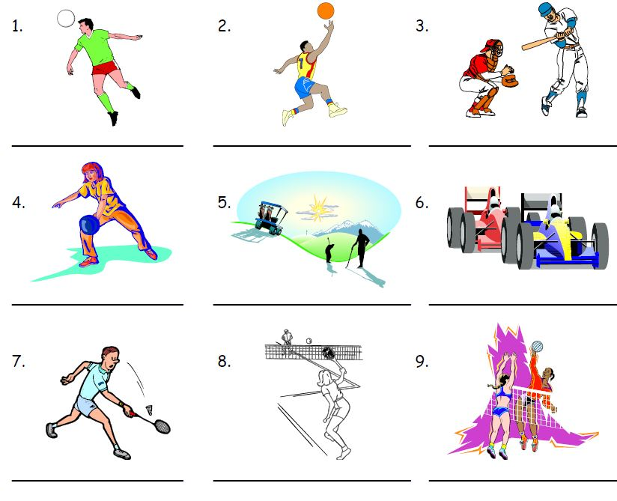  C group. Write an essay about your favourite sport  - Introduce the topic  2. Write about when and where you do it, what you do, what equipment you need for  3. Why you enjoy this sport  Descriptor  Write an e-mail applying words about sport activities  Peer assessment Free microphone  Learners ask questions and the others give proper answers to the questions  Conclusion for speaking. “Basketball questioning”  Move questions and discussions between learners  1. Do you prefer going in for sport or watching it on TV?  2. What kinds of sports are popular in Kazakhstan?  3. What national Kazakh sports do you know?  4. What sports are you good at?  5. Which do you prefer, basketball or volleyball?  Descriptor  answer the questions  discuss and share ideas  . |  |  |  |  |  | Video  https://www.youtube.com/watch?v=qkWlGmhBZVs  PPT  Slide 1  Half  pictures  PPT  Slide 2  Posters  PPT  Slide  Video  https://youtu.be/x4FZiWWVgNQ  Excel,5  p 97  Worksheets  Assessment papers  Whiteboard software  Worksheets  http://eslways.com/m.sports-1.html  https://busyteacher.org/19053-sports.html  PPT  Slide
End 3 min | Feedback Tree of success. Teacher gives the learners three coloured leaves and they should choose one and hang them on the tree.  - if they understand the theme very well, put the green leaf  - if they understand the theme well, put the yellow leaf  - if they understand the theme not very well, put the red leaf on the tree  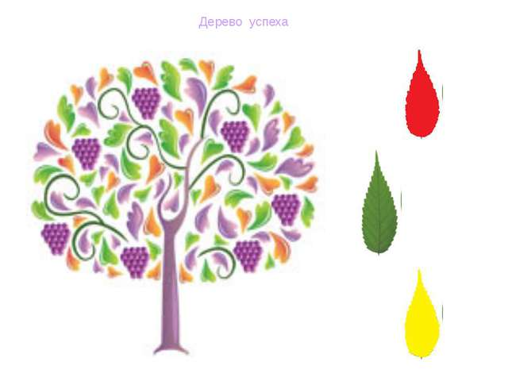  Evaluation Self assessment Pedestal of success  On the blackboard I hang the pedestal of success and learners should come to the blackboard and put their stickers, it shows me how they comprehend the lesson   |  |  |  |  |  | Handout  Stickers
ADDITIONAL INFORMATION
Differentiation – how do you plan to give more support? How do you plan to challenge the more able learners? |  |  | Assessment – how are you planning to check learners’ learning? |  | Health and safety check
- While-Speaking  Differentiation by outcomes, by support of teacher  Collaborative learning. In groups may be students of different levels, that’s why low level students have opportunity for support. High level students by creating their own ideas will help them and share ideas together, so they teach each other  Writing  Differentiation by tasks High level students differentiate advantages and disadvantages of sports  Differentiation is done through abilities of learners and lesson objectives |  |  | Assessment Fireworks  Teacher’s oral assessment You are brilliant, super!  Self assessment Pedestal of success  Peer assessment Free microphone each other through Free microphone  Group assessment. Groups assess each other by the criteria  Team assessment. Teams assess each other by comments and likes  Assessment “Tree of success’ |  | Dynamic pause in the middle of the lesson.  Healthy saving technologies.  - Use whiteboard no more than 15 minutes

