Lesson plan
Lesson: People and profession |  |  |  | School: № 15
Class: 5 |  |  |  | Number present: | absent:
Learning objective  that this lesson  is contributing to |  | 5.L10 to recognize words similar to words in student native language  5.S6 communicate meaning clearly at sentence level during, pair, group and whole class exchanges
Lesson objectives |  | All learners will be able to:  - to recognize the profession and name them
Most learners will be able to:
- ask and answer the questions and make up sentence using new words

Some learners will be able to:
- describe and talk about future professional character
.
Language objectives |  | Learners can:  - to name and describe professions  - to ask and say what you want to be
Key words and phrases:
profession , a chef, actor, doctor, baker, film star, builder, police ,inventor, scientist, musician, politician, journalist, basketball player, TV presenter

Useful classroom language for dialogue/writing
Discussion points:
Do you want to be a …..? What does each person do at work?

Can you say why…….?
Why do people choose different professions?

Writing prompts:
I want to be…..
I’d like to be……
Previous learning: |  | - review grammar on the theme “Adjectives”
Planned timings | Planned activities |  |  |  |  |  | Resources
Start  2 min  3 min  3 min | I. Organization moment:  a) greeting  b) duty's report  Dividing into two groups  Teacher divides learners into two group guessing the puzzle with professions pictures.  II. Brainstorming.  Presentation technique.  Teacher shows some pictures about professions  And give some questions about it.  1.What do you see in the picture?  2.Do you like ……?  3.Do you want to be ……?  III. Picture puzzle  Strategy “Memorizing”  Learners collect pieces of pictures together, put the puzzles together. (group work)  Learners guess about the theme of the lesson  T: Today we’re going to find out about professions.  We’re going to ask and answer questions about what people want to be and we’re also going to do a vocabulary quiz. |  |  |  |  |  | An active  board,  some  pictures  puzzles  cut pieces of pictures
Middle  25 min | IV. Pre-teaching vocabulary.  To interview new words and repeat chorally  1. Teacher [ʹti: tʃə] - мұғалім  2. Doctor [ʹdɒktə] - дәрігер  3. Painter [ʹpeıntə] - суретші  4. Musician [mju:ʹzıʃ(ə) n] - музыкант  5. Policeman [pəʹli: smən] - полиция  6. Driver [ʹdraıvə] - жүргізуші  7. Dentist [ʹdentıst] – тіс дәрігері  8. Builder [ʹbıldə] - құрылысшы  9. Firefighter ['faiə, faitə] – өрт сөндіруші  10. Hairdresser [ʹheə͵dresə] – шаштараз  11. Cook [kʋk] – аспазшы  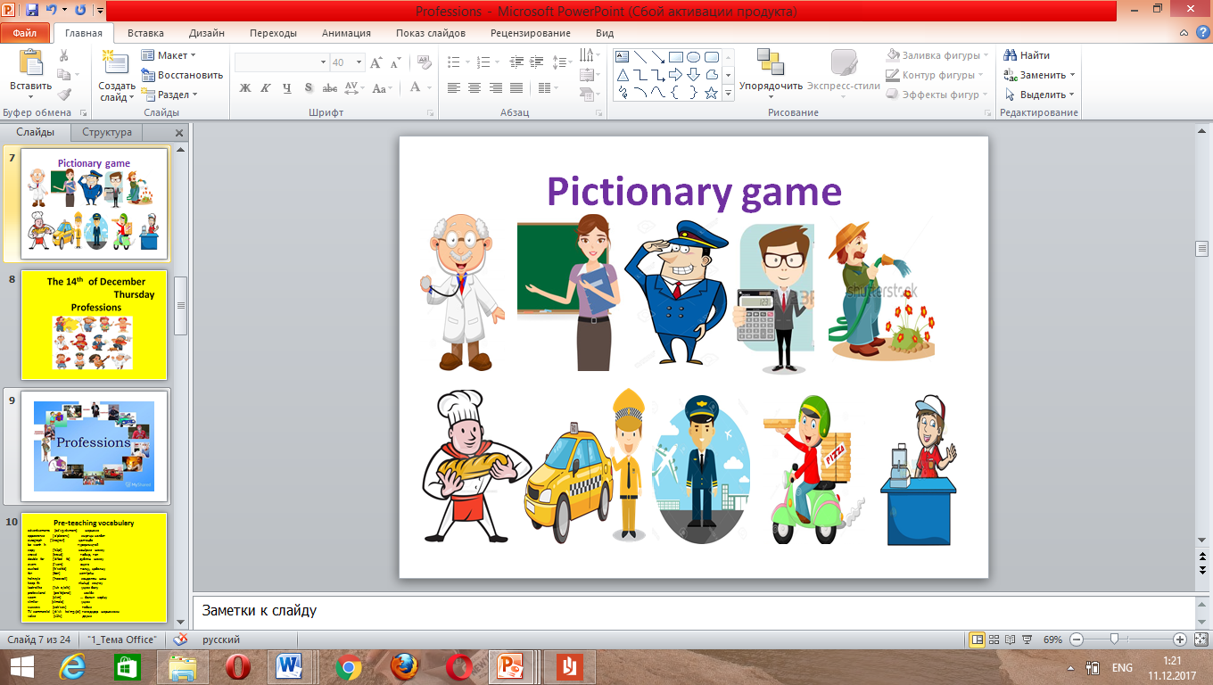  Introduce the new professions by sticking the flashcards on the board. The students repeat the words once or twice. Learners listen and guess the jobs in their native language, listen and repeat the words in chorus and individual. (chorus and individual drilling)  Play the CD The students listen and repeat the new words  V. Listen and say  L10 : Ex. 1a on p. 34  The students look at the photo of Lisa and the map.  Ask: Where’s Lisa from?  The students guess what Lisa wants to be.  Answer the questions :  -Can you guess what Liza wants to be?  -Where’s Liza from?  -Can you name any other professions?  VI. Matching.  Unscramble these words matching pictures  I group –  - iarhdersers – hairdresser  - okoc – cook  - uilderb – builder  - revdir – driver  - nampoecil – policeman  II group  - rodcot – doctor  - ertainp – painter  - iancisum – musician  - tisdten – dentist  Task 2.  Now 1st group should match jobs to the places  2nd group should match jobs with activities  For example: 1) Doctors work in a hospital  VII. Practise new vocabulary.  Modeling.  Type (scaffolding-one of instructional techniques)  The teacher elicits the meanings of any unknown words and reads out the example from the exercise: A scientist works in science. A builder builds houses.  Then the teacher read the question in the speech bubble (Do you want to be a ……?)and the three possible answers (I’m not sure. Maybe. / Yes, I do . It’s my dream!/ No , I definitely don’t ) Elicit or explain the difference between each answer.  S6: ex.2 on p. 34  VIII. Vocabulary quiz  Memory game. Match the pictures and read.  1.This person is a professional cook.  He’s a _____________.  2.This person works in politics and government.  She is a __________.  3.This person has original ideas and makes new things.  He’s an a ___________.  4.This person writes for newspapers and websites.  She’s a ____________.  5. This person plays an instrument and writes music.  He’s a ____________.  6.This person acts in films.  She’s a ____________. |  |  |  |  |  | Flashcards  CD player  formative assessment  Student's book  pictures  performance task  visual  demonstrations  Activity  book
5 min  End  2 min | IX. Conclusion:  Teacher ask about learner’s future jobs  I want to be…  Learners write five sentences about what they have learnt  during the lesson. Next they reduce their five sentences to  five words. Finally they reduce their five words to one word.  Learners share their key word with the whole class.  X. Feedback  The tree knowledge  What I have learnt ?  What was difficult?  What task was interested in…..?  b)Giving homework:  ex.3on p.34 |  |  |  |  |  | Summative  assessment  Sticker
Additional information
Differentiation-how do you  plan to give more support?  How do you plan to challenge the more able learners? |  |  | Assessment-how are you planning to check learners' learning? |  |  | Cross-curricular links  Health and safety check  ICT links  Values links
I plan give more support in the middle of the lesson.  For less able learners:  They are supported by prompts, motivational techniques, by key words, worksheets, simple task.  For more able learners:  they are given tasks  according to their abilities. |  |  | I evaluated with smiles and by criteria based assessments and with pupils feedback.  Assess with descriptor  3 smiles – well done  2 smiles – good  1 smiles – not bad |  |  | Economics, English  smart board, computer  working well
  Thinking speed | 
  Can say own  opinion | 
  Specific answer | 
  Assessment criteria | Descriptor
  1.Learners can talk about profession .  2.Learners are able to describe professional characterize  3.Learners say what do they you want to be…. | Learners could talk about types of profession .  Most learners were able to describe professional characterize  Some learners could talk about future profession
Reflection  Were the lesson objectives/learning objectives realistic?  What did the learners learn today?  What was the learning atmosphere like?  Did my planned differentiation work well?  Did I stick to timing? what changes did I make from my plan and why? |  |  | The lesson/learning objectives were realistic because the learners could recognize and understand new words  The learners ask and answer questions relating to the theme "People and profession", describe what people of various occupations do.  The learning atmosphere was friendly, calm, pleasant, ordered. My lesson was interesting for learners.  It is impossible to plan our lessons ignoring this fact. During writing my lesson plan I planned some differentiation tasks.  One of the conditions of planning the lesson is to stick to timing. It's one of the SMART lesson conditions.
Summary evaluation
What two things went really well (consider both teaching and learning)?
1: translation new word by speaking.
2: the game
What two things would have improved the lesson (consider both teaching and learning)?
1: group work
2: I should use the time effectively
What have I learned from this lesson about the class or individuals that will inform my next lesson?
Group work helps most shy learners work out the tasks asking for support from others.

