Module 5 Food and Drinks |  | School: S.Seifullin
Date: 02.02.26 |  | Teacher name: Tileukul A.D
Grade: 4 Б |  | Number present: | absent:
Lesson theme | CLIL. Design and technology.
Learning objectives | 4.1.4.1 understand a wider range of short standard questions on general and educational topics with support;  4.2.2.1 ask questions to identify existing and past experience within a wider range of general and educational topics.
Lesson objectives | Learners will be able to:  - read and answer questions in a quiz about healthy eating;  - understand and use vocabulary related to food and health;  - create a project about healthy eating;  - present their project to the class.
Plan

Stages / Time | Teachers actions | Students’ actions | Assessment criteria | Resources
Beginning of the lesson  Warming-up  5 min | Organization moment:  Good morning, pupils!  How are you today!  Let`s watch the video, listen and repeat please!  Teacher explains self-assessment sheet.  Teacher shows video about health and unhealthy foods.  Look at the pictures. Is this food healthy or unhealthy? | Pupils answer the teacher.  Look and answer.  Healthy! Unhealthy! | The teacher assess learners for their ability.  “Good job!  Well done!” | Video  Canva presentation
Middle of the lesson  Presentation and practice.  35 min | Teacher introduces the lesson topic and objectives.  Teacher shows new words.  Task 1. Quiz.  Teacher explains the task clearly. Monitors pupils` answers and gives feedback.  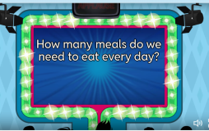  Task 2. Group work.  Teacher explains task.  1st group fill in the missing letters.  2nd solve the crossword.  3rd group: Healthy or Unhealthy?  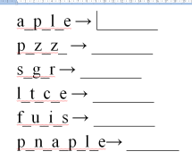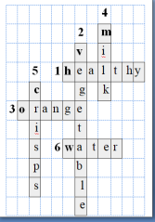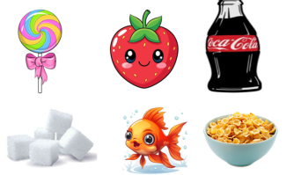  Warm-up  Task 3. Individual work. Students need to mark the given sentences as true or false.  1. Fruit is healthy food.  2. Vegetables are good for the body.  3. Water is good to drink every day.  4. Fast food is healthy.  Task 4. Match the words and pictures.  Show the words and pictures to the students. Explain how to match the words with the correct pictures. Monitor and help students while they are matching. Check the answers together and give feedback. | Pupils listen carefully.  Pupils listen and repeat new words carefully.  Pupils do the quiz.  Answers:  1.three ,  2. 2 fruit and 3 vegetables,  3.8-10glasses,  4.3 glasses ,  5. one ,  6. not much ,  7. 4-6 slices ,  8. a lot  Pupils correctly identifies the word from the letters and writes the word clearly on the A3 paper  Answer:  1st group – apple, pizza, sugar, lettuce, fruits, pineapple.  2nd group – vegetable, water, crisps, healthy, milk, orange  3rd group –cereal, strawberry, cola, sugar, fish, lollipop.  Pupils mark the statements as True (T) or False (F).Work individually and complete the task.  Answers:  1. T  2. T  3.T  4.F  Pupils look at the words and pictures carefully. Match each word with the correct picture. | Descriptor:  -read the questions correctly  -answer the questions  2 point  Descriptor:  -find correct word  -Clear presentation with picture  2 point  Descriptor :  -Reads the sentences correctly  -Understands the meaning of the sentences -Identifies  True and False statements correctly - Marks the answers accurately  4 point  Descriptor:  -Matches the words with the correct pictures  - Recognizes the words and pictures  2 point | Canva presentation  Wordwall  https://wordwall.net/resource/106647751  A3 paper,  Pictures  Video  Educaplay  https://www.educaplay.com/learning-resources/27597908-healthy_food.html
End of the lesson  5 min | Teacher concludes today’s lesson. Asks students what had they learnt today. Tell learners to show their assessment sheets and assesses learners.  Reflection  Teacher tells to reflect on today’s lesson  Homework  Draw picture:  `My healthy breakfast.`  The lesson is over!  Good bye! | Students count their scores and evaluate their knowledge and attitude to the lesson  Learners reflect on today’s lesson  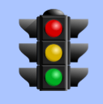 | Self-assessment | Assessment sheet  Active board https://teacher.gynzy.com/en/board/

