Short term plan

Theme: Unit 2 Communication and Technology |  | lesson
Name of school: |  | School #42
Teacher name: |  | Rakhymzhanova F.Zh.

Date:
Grade: 7 |  | Number present: | absent:
Lesson title | «Electronic devices»
Learning objectives | 7.3.3.1 give an opinion at discourse level on a growing range of general and curricular topics;  7.4.1.1 understand the main points in texts on a limited range of unfamiliar general and curricular topics
Lesson objectives  (assessment criteria) | Learners will be able to:  - Introduce new vocabulary about computers  - Predict the content of a text  - Read for specific information.
Instilling values of the program “Birtutas tarbiye” | Diligence and professional competence  Justice and Responsibility

Stages/  Time | Teachers actions | Students actions | Assessment | Resources
Beginning  5 min | Greeting.  Hello, students! How are you?  Warm-up activities:  Description: A student chooses a word from a specific topic, and another student chooses a different word from the given topic.  - Instructions: Begin with a word (e.g., “book”). The next student says a related word (e.g., “reading”), and so on.  - Example Sequence:  Book – Reading – Library – Study – Exam  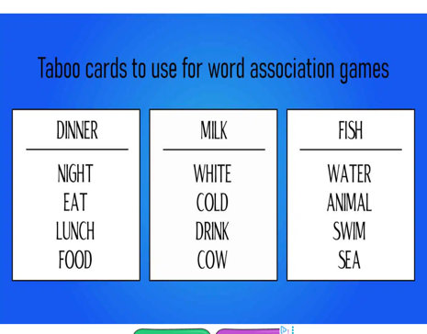  Homework: Ex: 10, p. 21 |  | Teacher controles the process, gives feedback and asks additional questions if it’s nessasery.  Teacher evaluate pupils with phrases like:  “Good job!  Well done!  Not bad?!”  Formative Assessment   | Flashcards/pictures, projector/board, worksheets
Middle  15 min | New theme: For starting our lesson, I would like to ask you some questions, for underlying the theme of the lesson.  • How can you stay safe on the Internet?  • What personal information should you keep secret online?  • What will you do if someone is rude to you on the Internet?  • Why should you use a strong password?  That’s why, today’s theme is «Digital safety: The Internet and You»  Teacher’s speech:  Today we will talk about digital safety — how to be safe when you use the Internet.  The Internet is a great place to learn, play games, and talk with friends. But we must be careful, because not everyone online is friendly, and some websites are not safe.  Here are some important rules:  - Keep your personal information secret.  Don’t tell your full name, address, school name, or phone number online.  - Use strong passwords.  Make your password long and special — with letters, numbers, and symbols. Don’t share it with anyone except your parents.  - Be kind online.  Don’t write mean comments. If someone is rude to you, don’t answer — tell your teacher or parents.  - Think before you share.  Don’t post photos or messages that you might regret later. Remember — the Internet never forgets!  - Ask for help if something feels wrong.  If you see something scary or confusing, talk to an adult you trust.  New vocabulary: (bullying, fake, harmful, illegal, link, lower case – строчная буква, password, permission – разрешение, personal, post, privacy setting – настройки конфиденциальности, private, respect, rule, symbol, treat – лечить, upper case – заглавная буква )  Ex: 1 P:22 (Use the phrases to make sentences about the items in the pictures)  - Click on links – connect to the Internet to download files – copy and save files – see pictures, films or information – type a document – listen to music – record a podcast – read digital books  - Microphone  - Screen  - Router  - Mouse  - Keyboard  - Headphones  - Hard drive  - E-reader | Learners answer for the teacher’s questions:  -I can stay safe by not talking to strangers, not clicking on unknown links, and using safe websites.  -I should keep my full name, address, phone number, and passwords secret.  -I will not answer them, take a screenshot, and tell my parents or teacher.  Learners use the phrases to make sentences about the items in the pictures.  Answers:  We use a screen to see the pictures, films or information. | Excellent (4)  - Clearly understands and identifies all listed actions.  Good (3)  - Understands most actions; 1–2 unclear.
10 min  5 min  5 min | Ex: 2 P: 22  Lead-in  Ask Ss to open their books.  Direct them to the title and the first paragraph of the text.  Say: “Read the title and the first paragraph. What do you think the text will be about?”  Elicit guesses from Ss (accept all reasonable ideas). Write a few on the board.  Exercises using AI, the purpose of these exercises are to help S/s write in English correctly and grammatically. Also, to learn new vocabulary.  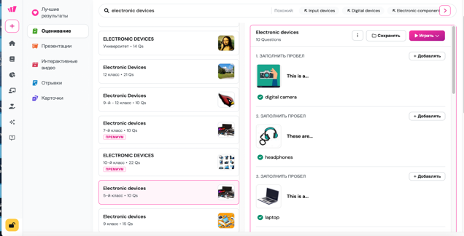  Listening Task: “Electronic Devices in Our Life”  🎙️ Audio Script (Teacher reads or records)  Hi, my name is Emily, and today I want to tell you about the electronic devices I use every day.  In the morning, my smartphone wakes me up. I check the weather and listen to music while I get ready for school.  At school, we sometimes use tablets to read books and do exercises online. My teacher shows presentations on a projector and sometimes plays short videos.  After school, I do my homework on my laptop. It’s very helpful for writing essays and searching for information on the Internet.  In the evening, my family watches movies together on our smart TV. My younger brother also plays games on his game console.  I think electronic devices make our lives easier and more interesting, but it’s important not to use them too much. We should also spend time outside and talk to real people!  ✏️ Comprehension Task A: Choose the Correct Answer  - What wakes Emily up in the morning?  a) Tablet b) Smartphone c) Alarm clock  - What does Emily use at school?  a) Projector and tablet b) Laptop c) TV  - What does Emily do after school?  a) Plays games b) Does homework on laptop c) Watches TV  - What does her family do in the evening?  a) Reads books b) Watches movies c) Plays games  - What advice does Emily give at the end?  a) Use devices more b) Don’t use devices at all c) Don’t use them too much  Checking Answers  Ask Ss to compare their answers with a partner (pair-check).  Then check answers as a class. Call on different Ss to share.  Provide feedback and correct where necessary. | Learners read the title and the first paragraph in the text.  ANSWERS  The text is about a smart house that will use technology to make our lives easier in the future  Descriptor:  - makes a clear, logical guess about the text  - understands the main idea and key details from the text  S/s marks and writes the correct options of the task on their mobile phone (Wayground.ai)  S/s write the correct variant of the test on their paper | Excellent (3)  - Makes a clear, logical guess about the text topic based on the title and first paragraph.  Good (2)  - Makes a general guess with some connection to the topic.  9-10 points –5  7-8 points – 4  5-6 points – 3  The results will be in the app, the teacher will put them.  12-14 points – 5  10-11 points – 4  6-9 points – 3 | Wayground AI  https://wayground.com/admin/reports/68e391b4d61c852f5601404d/players
End  5 min | “My Point” method is used to find out was the lesson clear or not.  Ex: 3 P: 22  Home task | Ss show their knowledge according to the lesson  Ss evaluate each other and encourage classmate with phrases like:  Well done! Brilliant! Good job! I like it! |  | Poster Success Ladder

