Unit 1: Hobbies and Leisure lesson 1 |  | School: 276
Date: |  | Teacher name: Ibaidulla Gulzhanat
Grade: 7 |  | Number present: | absent:
Lesson title | Vocabulary: Free-time activities
Learning objectives | 7.3.3.1 express an opinion at the level of reasoning within the framework of most general and educational topics;  7.3.5.1 try to interact with classmates for cooperation, discussion, coordination, planning, and prioritization in order to complete educational tasks;
Learning objectives  (assessment criteria) | Learners will be able to:  - Overview of the module
Levels of thinking skills | Knowledge and comprehension
Value link | “Educating students to develop diligence and make wise choices about their future professions.”

Stages/  Time | Teachers actions | Students actions | Assessment | Resources
Beginning  5 min | Greeting. (Whale class, Individually)  T tells the class to make groups of 2.  Warm up:  Sentence scramble  For this activity, you can divide the students into small groups or pairs or they can work on their own. Come up with a few sentences before class, and write the sentence’s words on your physical or virtual whiteboard in a random order. The first group or individual student to unscramble the words and read the sentence aloud correctly wins that round.  T: What do you think about today’s theme?  Setting the aim of the lesson.  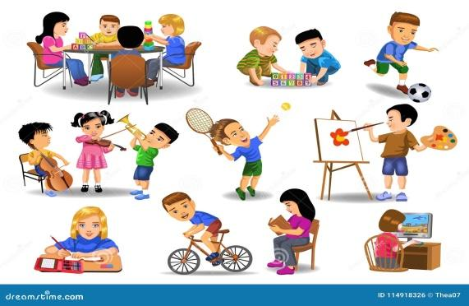 | Learners read the given sentences on the board and guess the topic and share with their ideas.  Remember and recognize the main vocabulary. | Teacher controles the process, gives feedback and asks additional questions if it’s nessasery.  Teacher evaluate pupils with phrases like:  “Good job!  Well done!”  Formative Assessment   | Sheets of peppers  Pictures of to be  https://images.app.goo.gl/ue3aL8Yxkcadqnvm9
Middle  30 min | Task. I (Wh, I) (pair dicsussion)  Ex: 1 P:5  Go through the list of free-time activities 1-9 and play the recording with pauses for students to repeat chorally and individually.  • Explain any unknown words and then ask students to make sentences following the example.  • Students compare answers with a partner. Ask some students around the class to present answers and make a list on the board.  Differentiation with individual need:  Learner will be supported by teacher and by helpers from his class. Allow them to discuss their ideas in pairs. Model and drill pronunciation of words that are new to students. | Learners listen and say. Which are outdoor activities? Indoor activities? Extreme sports? Hobbies?  ANSWERS  Hang-gliding is an outdoor activity. It is an extreme sport.  Dancing is an indoor activity. It is a hobby.  Model making is an indoor activity. It is a hobby.  Kayaking is an outdoor activity. It is an extreme sport.  Rock climbing is an outdoor activity. It is an extreme sport.  Bungee jumping is an outdoor activity. It is an extreme sport. | T’s feedback  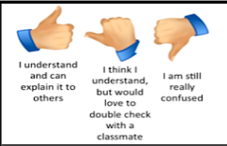  Descriptor:  - list of free-time activities  - repeat chorally and individually.  Total: 2 point  Feedback:  “Thumbs up, thumbs down”  After correct answer teacher shows thumbs up, if there are some mistakes thumbs down with comments | Student’s book
 | Task. II (Wh, I) (Task for location)  Ex: 2 P:5  To present and practice adjectives, to express and compare likes, dislikes.  •Go through the adjectives and explain their meanings.  • explain the task and give students time to complete it | Learners use the phrases to complete the sentences.  ANSWERS  I like dancing because it is fun. I don’t like rock climbing because it’s dangerous. | Self -assessment  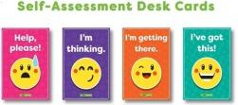  Descriptor:  - use the phrases  - complete the sentences.  Total: 2 point | Worksheets  Stickers
End  5 min | “Finger” method is used to find out was the lesson clear or not.  5 fingers- I understood  4 fingers -I have some questions  2 fingers-I need a help  Ex: P:  Home task | Ss show their knowledge according to the lesson  Ss evaluate each other and encourage classmate with phrases like:    Well done! Brilliant! Good job! I like it! |  | Poster Success Ladder

