***New ways to learn English language***

Learning English, like any language, can be approached in various ways to suit different learning styles and preferences. Here are some innovative methods and resources you can explore:

1. **Language Exchange Apps**: Utilize language exchange apps like Tandem or HelloTalk to connect with native speakers of English who are learning your native language. This allows for reciprocal language practice through conversation.



1. **Online Language Communities**: Join online forums, Facebook groups, or Reddit communities dedicated to language learning. Engage in discussions, ask questions, and seek advice from fellow learners and teachers.



1. **Language Learning Podcasts**: Listen to podcasts designed for English learners. These often cover a range of topics and provide valuable listening practice along with explanations of vocabulary and grammar.



1. **Language Learning YouTube Channels**: There are numerous YouTube channels dedicated to teaching English. Channels like Rachel's English, EnglishClass101, and Learn English with TV Series offer lessons on grammar, pronunciation, vocabulary, and more.



1. **Language Learning Games and Apps**: Explore language learning apps and games like Duolingo, Memrise, or FluentU. These platforms gamify the learning process, making it more engaging and enjoyable.

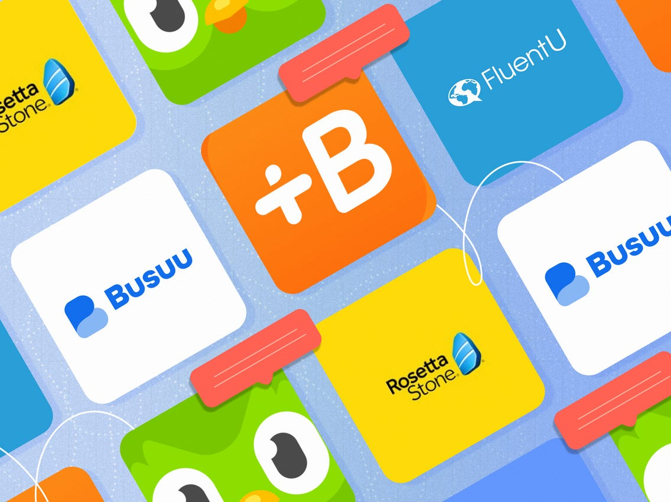

1. **Immersive Language Learning**: Immerse yourself in English by consuming English-language media such as movies, TV shows, music, and books. Subtitles and translations can aid understanding, and you can gradually increase exposure to more challenging content.
2. **Online Courses and MOOCs**: Enroll in online English courses offered by platforms like Coursera, Udemy, or edX. These courses cover various aspects of language learning, from basic grammar to advanced writing and speaking skills.



1. **Virtual Reality (VR) Language Learning**: Experiment with VR language learning platforms like MondlyVR or ImmerseMe, which offer immersive experiences where you can practice speaking with virtual characters in realistic scenarios.

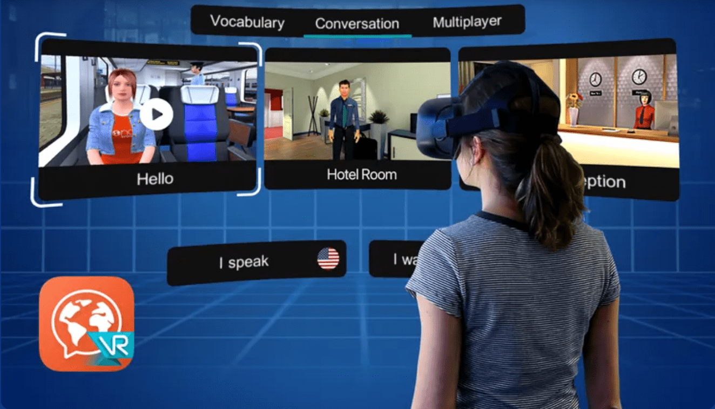

1. **Language Learning Blogs and Websites**: Follow blogs and websites dedicated to English learning, where you can find tips, resources, and interactive exercises to improve your skills.
2. **Creative Writing and Journaling**: Practice writing in English by keeping a journal, writing stories, or participating in online writing communities. Platforms like Wattpad or Medium allow you to share your writing and receive feedback from native speakers.



1. **Language Learning Challenges**: Challenge yourself to accomplish specific language learning goals within a set timeframe. This could involve activities like learning a certain number of new words per week, practicing speaking for a certain amount of time each day, or completing language learning tasks.
2. **Language Learning through Social Media**: Follow English-speaking accounts on social media platforms like Twitter, Instagram, and Facebook. Engage with their content, participate in discussions, and use the language in a real-world context.



By incorporating a combination of these methods into your language learning routine, you can make significant progress in mastering the English language while keeping the process enjoyable and engaging.