Short term plan

Unit of a long term plan: Space and Earth
Teacher name: |  | Dautova A.Zh.
Date: |  | 04.12.2024
Grade: 7 b |  | Number present: | absent:
Lesson title | Past Continuous: affirmative and negative
Learning objectives | 7.1.6.1 organize and present information clearly to others  7.5.2.1 write with minimal support about real and imaginary past events, activities and experiences on a growing range of familiar general topics and some curricular topics  7.6.10.1 use present continuous forms with present and future meaning and past continuous forms for background and interrupted past actions on a limited range of familiar general and curricular topics
Lesson objectives | Learners will be able to:  Learn the affirmative and negative forms of the past continuous.  • Practise using reference material.  • Use the past continuous to talk about an event.
Value links | Open-Mindedness – An open-minded person is someone who is always willing to hear new points of view and even change their own point of view if new arguments are highly convincing. It’s the opposite of stubbornness.
Plan

Stages / Time | Teachers actions | Students actions | Assessment criteria | Resources
Beginning of the lesson  Warming-up  5 min | Organization moment:  1.Greeting.  Ask about the weather.  Warm-up  Meet children and give them flags with good wishes.  Today we are going to travel to English speaking countries. Are you ready? What English speaking countries do you know? In the lesson, we continue the theme: “Past Continuous Tense” Today we will continue the theme, do some exercises. Write down the date today and our theme. Now, begin our lesson.  Lead – In  Now I divide you into 2 groups  1st affirmative  2nd negative | “The wish flags” method helps to start the lesson with good wishes to each other.  The aim: create friendly atmosphere  Efficiency: By wishing each other they feel better and feel the support of others | At the organization moment T tries to award active Ss. «The praise» method is used to evaluate Ss with phrases like:  “Good job!  Well done!”  Formative Assessment    Good job! | Pictures  PPT  worksheets
Middle of the lesson  Presentation part.  35 min | Task 1. Ask the homework  Worksheet past simple or past continuous.  Task 2. Put the words in the correct order to make sentences. (Individual work)  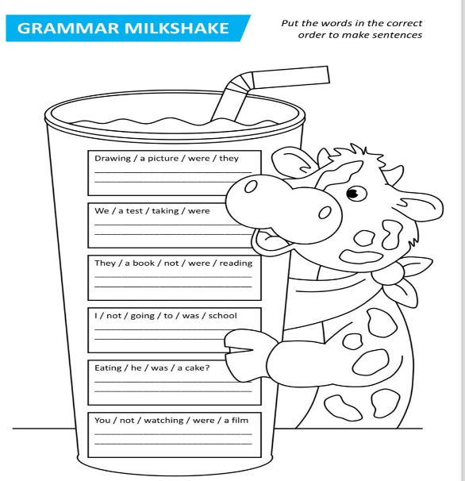  Differentiation:  «Verbal support» method is used to help Students use words in the correct order.  Task 3. Read the text in past continuous. (Pair work )  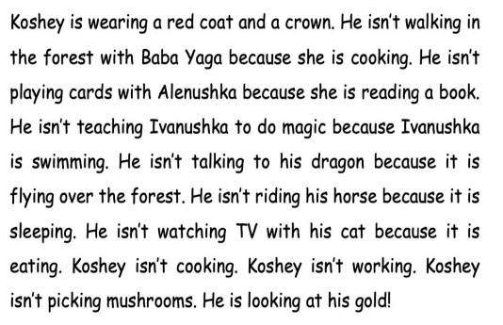  Task 4. Make sentences with pieces of watermelon.  The world record for the heaviest watermelon is approximately 90 kilograms (200 pounds). This weight was achieved by the Carolina Cross 180 watermelon.  The most expensive Densuke watermelon was sold at an auction in Tokyo for 350 thousand yen (about 3.5 thousand dollars).  In 2009, Igor Likhosenko, a farmer from the Temryuk district of the Krasnodar Territory, grew a watermelon of the “Russian size” variety weighing 61.4 kilograms. It is the largest watermelon grown in Europe.  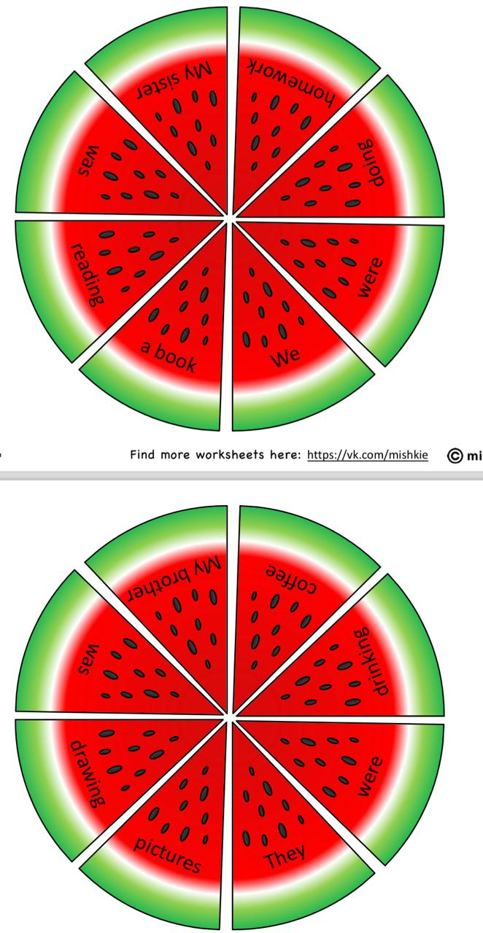 | Student’s answer  Students put the words in the correct order.  Students read the text using past continuous form. | Assessment criteria  - Learn the affirmative and negative forms of the past continuous.    Descriptor:  - complete the sentences with the words  Assessment criteria:  - Practise using reference material.  Descriptor:  - complete the text using past continuous form.  Descriptor:  • Students work in group.  • Point out that they can use either the affirmative or negative forms of the verb to make the sentence true for them. | Cards  Worksheets  Students book
End of the lesson  5 min | Home task:  Ex: 4 P: 39 WB | Reflection  Bee reflection  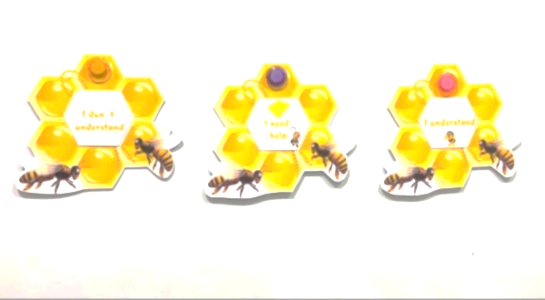 |  | Poster Success  KWL chart

