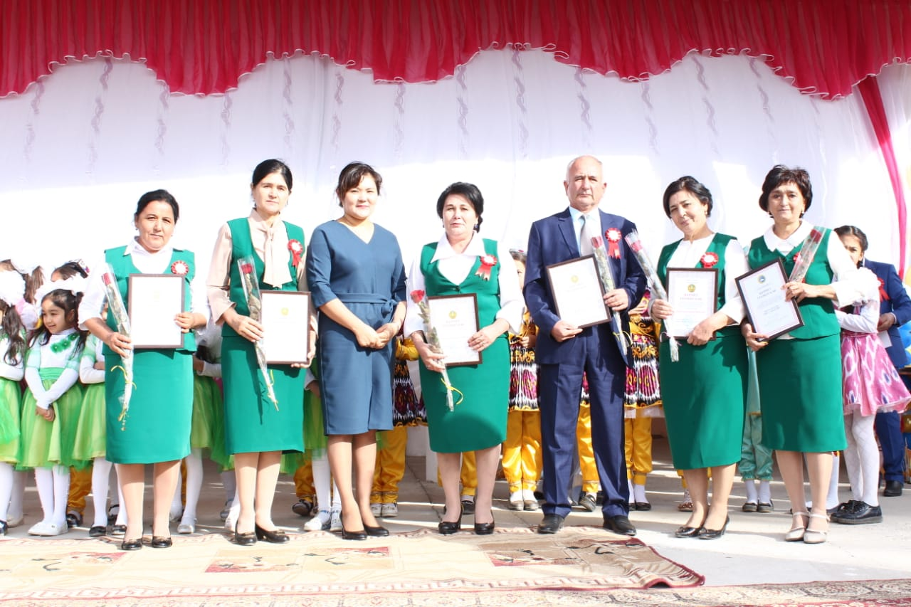**САТИБАЛДИЕВА ФЕРУЗА ТОКТАНОВНА,**

**М. Қашғари атындағы жаратылыстану**

**бағытындағы мектеп-лицейінің**

**ағылшын тілі пәні мүғалімі**

**Түркістан облысы**

**Кентау қаласы**

**Қарнақ ауылы**

**TEACHING SPEECH SKILLS**

The development of oral speech is one of the main practical tasks of teaching a foreign language to secondary school. Graduates of high school should be able to hear and understand foreign language speech.

In school experience, there are many problems associated with the teaching of oral speech, despite the fact that oral speech has not taken its proper place for a long time and to some extent has become a means of teaching.

In particular, in school conditions, the foreign language was difficult to meet in the acquisition of oral speechchiliklar identified, linguistic and psychological aspects of oral speech were analyzed and the materials of the studied oral speech were partially described, the receptive and reproductive relations of the foreign language knowledge were considered. Also, the various links of the teaching are cross-linked issues about the functions of oral speech acquisition, a variety of exercises are recommended for the cultivation of different types of oral speech.

“Many of these studies have not lost their value even now. At the same time, many issues are required to be revised from the point of view of their current tasks, talay is experiencing new problems.”

First of all, it will be necessary to mention the first problem of the study of oral speech. If earlier it was considered to separate lexical and grammatical elements, as a material of oral speech, then now, based on the current linguistic speech, it consists of a unit of the grammatic, lexical and phonetic components of speech.

Komplex gave birth to the opportunity to put the issue of units. Then there will be cross-training exercises aimed at getting to know such units of speech, the types of these exercises, their impact and role in the general system of teaching oral speech.

“In the current practice of teaching foreign languages in secondary school, oral speech is a worthy place. But so far, a lot of attention has been paid to training exercises. The attention of the teachers is mainly focused on increasing the number of these types of exercisestirishga, making them interesting, providing a decent speed of teaching, attracting a large number of students to the lesson. In the lesson there are many places games, songs, competitions of different types. A lot of attention is paid to the use of visual aids in painting and elements, diafilms.

All these methods increase the performance of students, in which they have a great interest in a foreign language lesson. But in the process of teaching oral speech there are also a number of serious defects.

The content of the speech can be expressed by the teacher, usually by an auxiliary question, a picture, then an Uzbek sentence, a text or some other method, which the student himself must speak. Students in this case usually do not decide for themselves what to talk about. This puts a reader who has a good language material lexicon as someone who is completely incompetent, when apart from the lesson a person addresses him with a question with an elementary question, or simply asks him to understand something, he can not get a satisfactory answer. It is also worth noting that the lessons devoted to the teaching of oral speech are not sufficiently directed towards the goal.

The presence of such a variety of shortcomings in school practice suggests that the development of communicative exercises promotes the task of determining the specific nature of the speech situation inherent in school education, the choice of methods that create similar situations in the lesson”. It is necessary to analyze the types of speech activities taught in the school in order to help teachers in order to ensure that the lessons of oral speech are more expedient, to determine their components, that is, the qualifications and skills in which the speech skills of the school are included.

It is also very important to fully determine the features of monological and dialogical speech and determine their interaction in the process of teaching. To solve all these issues, it is necessary to study the linguistic nature of oral speech and its psychological nature on the basis of the current point of view. Oral speech as an activity is a very complex psychophysiological process, the basis of which is the interaction of the first and second signal sounds of the cerebral cortex.

The style of oral speech differs from the style of written speech by the compactness of the expression or, as it is often said, “situativity”. This means that in clarifying a lot of things in the process of oral treatment, speech commentary from the obyektiv situation where the speakers are standing is not required. Some features of pronunciation for the style of oral speech are inherent, for example, weak forms of words; in place of the English-language forms of shall not, will not, can not, usually Shan't, won't forms are used, which are used in the style of written speech.

Knowledge of the socio – psychological characteristics of the interaction between people serves as a means of psychological and pedagogical influence on the hands of the teacher and educator. Such knowledge will ensure that not only will it provide the necessary adjustment to the education and upbringing of the growing generation, but also will be able to see the future prospects for tomorrow.

Students constantly interact with each other, influence each other in their collaborative activities, which are involved in their system.

When it comes to pedagogical creativity, it is necessary to be able to distinguish any imaginary structured projects from real creativity. Because such a dreamer can understand the creative saying that he does not have scientific grounds, does not correspond to reality. Such are very dangerous for pedagogical work. Because imaginary ideas that have not been tested in practice can sometimes cause great harm to pedagogical work.

In accordance with the requirements for the development of the educational system, issues of high professional training and ideological and political maturity of pedagogical personnel, constant growth of the level of their general culture are put forward. In educating schoolchildren in ideological and political terms, it is important to use important events, holidays and unitary dates in the life of the peoples of our country. In the implementation of these tasks, teachers in foreign language classes and extracurricular activities should use these materials to demonstrate to the students important events, holidays and memorable dates of pictures, diaphilmas in a foreign language. On the occasion of the conference and evenings devoted to important dates, wall gazettes are issued, preparation of stands, use of dates in organizing performances through the school radio channel will greatly help to radically improve the quality of foreign language learning of students in the school.

It is recommended to hold an artistic night or conference dedicated to each specific date of the academic year in order to introduce the materials given in foreign languages into the system and to conclude all the work done in the classroom and outside the classroom. In free speech, various variants of empathic intonation are especially distinguished, which reflect the spiritual mood of the speaker by choosing the appropriate lexical, and sometimes by the separate arrangement of words. In general, in addition to the features of oral speech, one can also talk about the peculiarities of dialogical and monological speech. Dialogue is a phrase from a chain of responses or talay thoughts, which usually arise as a result of the direct circulation of two or more persons (in a conversation).

**List of used literature:**

1. See More Of Ishmuhamedov R., Abdukadirov A., Pardayev A. "Innovative technologies in education". Tashkent, 2008.

2. Jalolov J.J, S.T Mahkamova, Sh.S Ashurov ’’English language teaching methodology’’ Toshkent-2015 ’’Fan va texnologiya’’ nashriyoti

3. Hoshimov O’, Yoqubov I.’’Inliz tili o’qitish metodikasi’’, Sharq nashriyotmatbaa aksyadorlik kompanyasi bosh tahriryati Toshkent-2003.