Туркестанская область, город Шымкент
ОСШ №13 имени Мукими
Учитель английского языка
Мавланова Дилорам Адахамбековна
Short term plan. Term 2.

Unit 3. Our planet. Project. A community project.
Unit 3 Our planet |  | Lesson 35
Teacher name: |  | Mavlanova D.A.
Date: |  | 29.11.2024
Grade: 9 d |  | Number present: 11 | absent:1
Lesson title | Project. A community project
Learning objectives | 9.1.1.1 use speaking and listening skills to solve problems creatively and cooperatively in groups  9. 4. 3. 1 understand evidence in long texts on a variety of familiar general and academic topics;  9. 5. 1. 1 plan, write, correct and check text-level works on general and academic topics without the support of the teacher;
Lesson objectives | Learners will be able to:  - Read a text about a community project.  - Identify the main subject of paragraphs.  - Create a webpage or a community organization.  - the value based on the integrated educational program is to educate students for justice and responsibility
Value links | принятие различий между людьми  терпимость к иным точкам зрения  готовность к диалогу и поиску компромиссов
Plan
Stages / Time | Teachers’ actions | Students’ actions |  | Assessment criteria | Resources
Beginning of the lesson  Warming-up  3 min | 1.Greeting.  Ask about the weather.  Warm-up  Ask students if they know of any community projects near where they live.  Ask them what the projects do and if they know of what they have achieved  Lead – In    The IB Community Project is a major activity for students to complete in their 8th Grade year at Hogg Middle School. Hogg is an authorized IB school with a 3 year MYP programme. | The wish flower” method helps to start the lesson with good wishes to each other.  The aim: To develop Ss speaking skills and create friendly atmosphere  Efficiency: By telling the wishes they show their appreciations .  Students express their ideas |  | At the organization moment T tries to award active Ss.  «The praise» method is used to evaluate Ss with phrases like:  “Good job!  Well done!”  Good job!   | Pictures  PPT
Middle of the lesson  Presentation part.  37 min | Ex:1 P:43  Draw students’ attention to the pictures. In pairs, students describe one of the pictures to each other.  Together they decide what the charity does.  Ask students to feedback their ideas, but don’t confirm any answers yet  Ценности Единство и солидарность. Уважение к разнообразию мнений и культур  Differentiation:  «Verbal support» method is used to help Students use new words in the text.  Ценности Трудолюбие и профессионализм  Инициативность и использование возможностей  Ex: 2 P:43  Focus students’ attention to the headings 1–4. Tell them these are the headings on a webpage.  Tell them that the content has got mixed up and they have to identify which of the texts A–D belongs to each heading  Differentiation:  «Verbal support» method is used to help Students use new words in the text.  Ценности Единство и солидарность. Уважение к разнообразию мнений и культур  Ex: 3 P:43  Tell students that they are now going to write a webpage. Put students in small groups | Students read the slogan and look at the pictures. What do you think the charity does?  ANSWERS:  Student’s own answers  Students read the webpage. Match headings 1–4 with sections A–D  ANSWERS:  1 D  2 B  3 C  4 A  Students write a webpage about your own organization. Follow the steps in the project checklist.  ANSWERS:  Student’s own answers |  | Descriptor:  - read the slogan  - look at the pictures  Pupils are evaluated with phrases like: Well done!  Brilliant! Good job! I like it!  Descriptor:  - read the webpage  - Match headings with sections  -Make CCQ questions  Yes / No  The teacher evaluates learners for their ability. “Good job!  Well done!”    Descriptor:  - write a webpage about your own organization | Student’s book  Vocabulary card  Worksheets    Card  Worksheet  Student’s book
End of the lesson  5 min | Giving the hometask.  Ex: 3 P:23 wb  Self-reflection  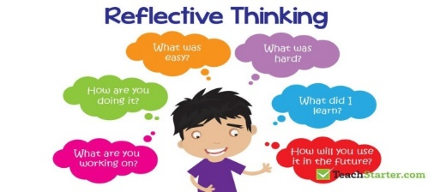 | Peer-assessment. Two stars and a wish.  - You did a really good job on ...  - I really like how you ...  Maybe you could ... |  | Students use their stickers to show their knowledge according to the lesson.  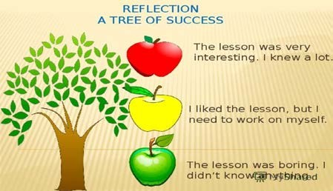 | Poster Success  
Additional information
Differentiation – how do you plan to give more support? How do you plan to challenge fast finishers?  Fast finishers:  Ask students to note down what the exact name of each subject is.  Answers  baking technology management  The Beatles, Popular music and Society Digital and Social Media  Viking studies |  |  | Assessment – how are you planning to check students’ learning?  Oral feedback  Positive reinforcement
Reflection  Were the lesson objectives/learning objectives realistic?  Did all the learners achieve lesson objectives/learning objectives? If not, why?  Did my planned differentiation work well?  Did I stick to timings?  What changes did I make from my plan and why? |  |  | Use the space below to reflect on your lesson. Answer the most relevant questions from the box on the left about your lesson?
Summary evaluation
What two things went really well? Consider both teaching and learning.
1.
2.
What two things would have improved the lesson? Consider both teaching and learning.
1.
2.
What have I learned from this lesson about the class or an individual student that will inform my next lesson?

