Short term plan: term 1

Unit 1: Science and scientific phenomenon |  | lesson 2

Teacher name:

Date:
Grade: 10 |  | Number present: | absent:
Lesson title | Interesting facts about genetics. DNA: A world without disease
Learning objectives | 10.2.1 - understand the main points in unsupported extended talk on a wide range of general and curricular topics, including talk on a limited range of unfamiliar topics;  10.4.1 - understand main points in extended texts on a wide range of unfamiliar general and curricular topics;
Lesson objectives | Learners will be able to:  - reply to informal emails and include relevant information
Value links | Loyalty – Loyalty might be a core personal value to you if you highly prize friends that are reliable and trustworthy. You might put your friends or chosen family first, always being there for them when they need you.
Plan

Stages / Time | Teachers’ actions | Students’ actions | Assessment criteria | Resources
Start    5 min  Main part  30 min | Organization moment  1.Greeting.  Ask about the weather.  The teacher sets the lesson objectives, letting students know what to anticipate from the lesson.  Warm-up  Creating a positive psychological environment  Lead – In  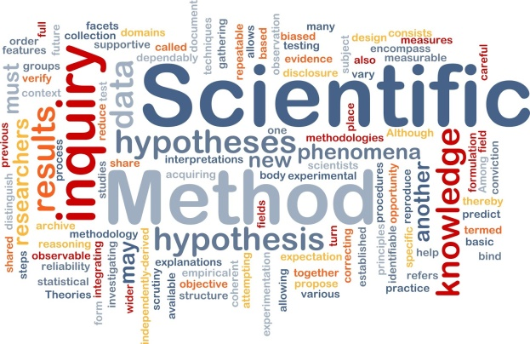  Ex: 1 a P:8  -Refer students to the Word List at the back of their books and give them time to look up the meaning of the words given.  -Elicit student guesses as to what the article is about. | Students' attention is drawn to the lesson.  Students discuss the pictures in pairs.  Determines the topic and aim of the lesson  Students say different words from the picture  Students look up the meaning of the words given. What do you think the article is about?  Answers:  I think the article about genetic engineering. | Formative Assessment    Good job!  Assessment criteria  -Identify detailed information in extended conversation with support  Descriptor:  - work in pairs  - Total: 1 point | Pictures  Student’s book
8 min | Ex:2 P:8  -Ask students to read the sentences 1-8  -then give students time to read to the text and mark the sentences according to what they read.  Ex: 3 P:8  Give students time to complete the sentences using the words in the list.  Ex: 4 a P:8  Read the words / phrases in the list and give students time to match them to make collocations.  Ex: 4 b P:8  Give students time to use collocations from ex 4a to complete the sentences.  Conclusion during the lesson some tasks differentiated by outcomes of the students and by their abilities. | Students read the sentences and decide if they are T (true), F (false) or DS (doesn’t say)  Answers:  1 T  2F  3T  4T  5T  6T  7DS  8DS  Students fill in: debate, inherited, cells, prevent, made, determines, characteristics, brought  Answers:  1 inherited  2 made  3 determines  4 characteristics  5 debate  6 prevent  7 brought.  8 cells  Students match the columns to make collocations  Answers:  1 d  2 e  3 b  4 f  5 c  6 a  Students use the collocations in ex 4a to complete the sentences.  Answers:  1 Inherit diseases  2 gene editing  3 live longer  4 faulty genes  5 Genetically – modified food  6 Designer babies | Descriptor:  - read the sentences and decide  Total: 1 point  Descriptor:  - complete the sentences using the words in the list  Total: 1 point  Descriptor:  - match the columns to make collocations  Total: 1 point  Descriptor:  - use the collocations  Total: 1 point  Differentiation – how do you plan to give more support? How do you plan to challenge fast finishers? |   Cards  Worksheets
End  2 min | FEEDBACK  Learners provide feedback on what they have learned at the lesson. |  | Students evaluate each other and encourage classmate with phrases like:  Well done! Brilliant! Good job! I like it! . | Poster  

