Unit 3: Values |  | Lesson 31
Teacher name:

Date:
Grade: 5 |  | Number present: | absent:
Lesson title | Speaking: Talking about friends
Learning objectives | 5.2.8.1 understand supported narratives, including some extended talk, on an increasing range of general and curricular topics  5.3.5.1 keep interaction going in basic exchanges on a growing range of general and curricular topics  5.5.3.1 write with support an e - mail about a special day
Lesson objectives | Learners will be able to:  - personalise a topic by asking about a friend  -present personal information to the class  -listen for specific information
Value links | Integrity – Integrity is the quality of having strong moral principles. So, a person with integrity will always act with honesty and adhere to their own moral code regardless of what others do.
Plan

Stages / Time | Teachers actions | Students actions | Assessment criteria | Resources
Beginning of the lesson  Warming-up    3 min  Pre-learning  «Brainstorming» method  7 min. | Organization moment :  1.Greeting.  Ask about the weather.  The teacher sets the lesson objectives, letting students know what to anticipate from the lesson.  Warming up  Where are you from?  How old are you?  What color is it?  How many students are there in class?  What day of the week today?  Revise the language of the previous lesson.  Lead – In  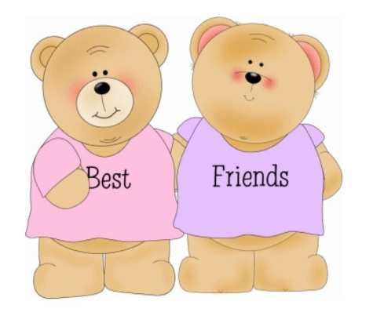 | The aim: To develop pupils speaking skills and create friendly atmosphere  Efficiency: By wishing each other they feel better and feel the support of others  Students of the class are listed.  Students' attention is drawn to the lesson.  • Learners write the numbers from previous lesson  Determines the topic and purpose of the lesson  Students say different words from the picture | The teacher to assess learners for their ability.  “Good job!  Well done!”  Formative Assessment    Good job!  Descriptor:  -know key phrases  - can make sentence  - know vocabulary of previous lesson  Total: 1 point  Assessment criteria  - Learners have met the learning objectives if they can: To talk about natural features and natural wonders | Pictures  worksheet  Student’s book
Middle of the lesson  Presentation part.  30 min | Ex:4 P:39  • Explain the task.  • Allow Ss time to fill in the information about a friend.  • Ss work in pairs to ask and answer the questions.  Ex: 5 P: 39  • Ask Ss to tell the class about their best friend.  • Repeat around the class until Ss have all had a chance to present.  Ex: 6 P: 39  • Explain the task.  • Play the CD.  • Ss listen and match the names with the activities.  Check Ss' answers.  Ex: 7 P: 39  • Explain the task. Allow Ss time to complete it. Alternatively assign it as HW. Then ask some students to read their blog post aloud to the class.  Evaluate Ss' performance. Check for:  -grammar mistakes  -punctuation  - spelling mistakes  - word order  Conclusion during the lesson some tasks differentiated by outcomes of the students and by their abilities. | Pupils complete the sentences about your best friend.  ANSWERS  1 My best friend's name is Anya.  2 She is my best friend because we have a lot of fun together. She is honest and loyal.  3 We like going to the cinema and knowing all about film stars.  Pupils tell the class about your best friend  ANSWERS  My best friend's name is Artyom.  He is my best friend because we like doing things together.  He is friendly and fun.  We like playing football and going to see football matches  Pupils match the people to the activities  ANSWERS  1 E  2 G  3 C  4 B  5 A  Pupils post your comment to Inkar’s blog about your best friend.  ANSWERS  Hi Inkar,  My best friend is Artyom. We are in the same class at school. He's really friendly and fun to be with. He's also very loyal and helps me when I need help and that's great too!  Aldiyar | Descriptor:  - fill in the information about a friend  Total: 2 point  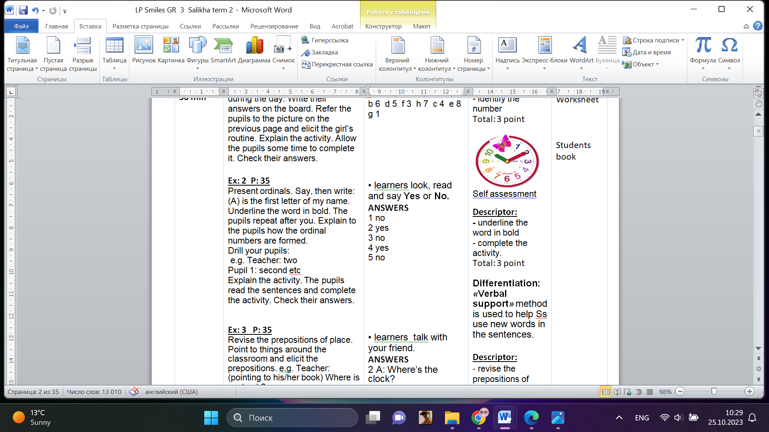  Self assessment  Descriptor:  - tell the class about their best friend.  Total: 3 point  Descriptor:  - match the names with the activities  Total: 2 point  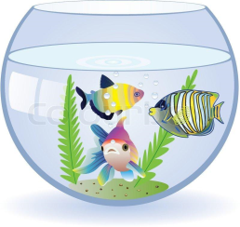  pupils are evaluated by collecting fish  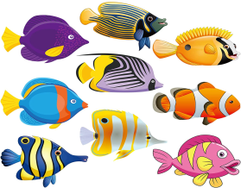  -Make CCQ questions Yes / No |   Card  Worksheet  Students book
End of the lesson  5 min | FEEDBACK  Learners provide feedback on what they have learned at the lesson.  Ex:  Home task: | 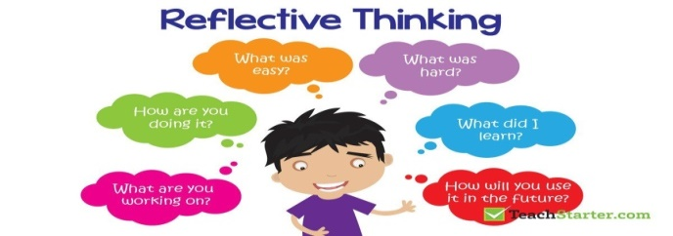 |  | Poster Success  

