Unit 1: Homes and away |  |  | School: M.Gorky
Date: 11.09.2024 |  |  | Teacher name: Rustemova G.D.
Grade: 5 A |  |  | Number present: |  | Number absent :
Theme of the lesson: |  | Cities and countries 1
Learning objectives |  | 5.5.3.1 write with support factual descriptions at text level which describe people, places and objects
Lesson objectives |  | understand a sequence of supported classroom instructions ask simple questions to get information,use adjectives and regular and irregular comparative and superlative adjectives with support
Plan
Planned timings | Planned activities |  |  | Learners’ activities |  | Evaluation | Resources
Start | Greeting: Good day, dear learners! Nice to meet you  How are you? Thank you, sit down.  Are you ready for today’s lesson?  Who is absent today?  Who is on duty today?  What is the weather like today?  “Brainstorming”  everyone takes a piece of paper and writes as many words as you remember from the theme homes. Share ideas asking each student to read out a word from their list. They must not repeat a word that has already been said. |  |  | Greeting  Learners do the task |  | Verbal evalu  ation | Sweets, box, board, video  The pictures of cities and the names of countries
Middle | Task 1. P 12 s.b  Irregular Forms of Comparison  Good Better  Worse  Hot The hottest  Bigger  Task 2. P 12 s.b  Clean –cleaner – cleanest  Easy - ______ - easiest  Fat - ______ - fattest  Hot - ______ - hottest  --------- – simplier - _______  Thin – thinner - _________ |  |  | Learners listen to the recorder and complete the table |  | Individual avaluation | CD
 | Task 3. Listen to the recorder and complete the table with the capitals of countries and nationalities.  Country Capital Nationality  the UK , London English  the USA  Kazakhstan  Turkey  France  Russia  Uzbekistan  Kirgizia  Turkmenia  Mexico  Japan  Spain  Presentation of the grammatical materials through “Bus stop”.  The teacher presents materials as a guide in the bus. Each bus stop presents one city of the Kazakhstan.  Bus stop 1 “Astana” Bus stop 2 “Almaty”  Adjectives  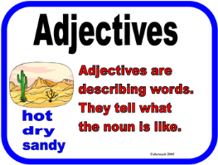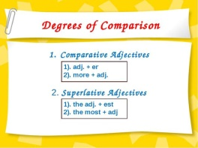  Bus stop 3 “Shymkent”   |  |  | Learners follow the instructions |  | Verbal evaluation  Mutual avaluation | Map of the world
End | Reflection  Learners have to write their answers on the stickers and stick it on a tree:  What have you learnt today?  What would you like to learn?  What would you like to work on?  Home work: ex 2 p 15 w.  Saying goodbye |  |  |  |  | Self-assessment

