Short term plan

Unit of a long term plan: Values |  | School: 274
Date: 23.11.23 |  | Teacher’s name: L.T.Orazymbetova
Grade: 5 |  | Number present: | absent:
Lesson title | A family
Learning objectives | 5.2.3.1 understand an increasing range of unsupported basic questions on general and curricular topics (жалпы және оқу тақырыптарының қарапайым сұрақтарын көмексіз түсіну)  5.3.6.1 communicate meaning clearly at sentence level during pair,group and whole class exchanges(жұпта,топта және барлық сыныппен жұмыста өз ойын ашық және нақты түрде сөйлеммен жеткізу)  5.4.2.1 understand with little support specific information and detail in short,simple texts on a limited range of general and curricular topics (бірқатар жалпы және оқу тақырыптары аясындағы қарапайым,қысқа мәтіндерде арнайы ақпаратты мұғалімнің шамалы көмегімен түсіну)
Lesson objectives | Learners will be able to:  - • Learn and activate background knowledge of the topic  - Негізгі тақырыпты (Отбасы) одан әрі дамыту  - • Practise talking about family  - Отбасы туралы сөйлеу дағдысын дамыту
Plan

Stages / Time | Teachers’ actions | Students’ actions | Assessment criteria | Resources
Start  10min. | Organization moment (Whole class activity)  -Good morning students!  -How are you today?  -What day is it today?  What is the weather like today?  2.Phonetic drill exercise.(Фонетикалық жаттығу)  Fishy,fishy  In the sea  Won’t you come  And swim with me?  3.Checking up the hometask ( Үй тапсырмасын тексеру)  Making up the friendship card and tell about best friends. (достарына открытка жасап,тілек жазып келу) | Students greet the teacher and tell about the date and weather  The aim: To develop Ss speaking skills and create friendly atmosphere (сөйлеу дағдысын дамыту және жақсы көңіл күй атмосферасын қалыптастыру)  Efficiency: By reciting the phonetic exercise students develop their pronunciation.. (фонетикалық жаттығулар арқылы дыбыстардың айтылуын жетілдіреді) | At the organization moment T tries to award active Ss. «The praise» method is used to evaluate Ss with phrases like:  “Good job!  Well done!”( мақтау сөздер арқылы бағалау «Керемет», «Жақсы жұмыс»деген сияқты)  Formative Assessment    Good job! | Pictures  Student’s book
Main part  25 min. | T:Now, students, today we’ll have special lesson.We have many guests.Let’s show them our skills and knowledge.  I’ll divide them by choosing coloured stars into three groups  “Friendship”,”Family” and “Heart”  (Түрлі түсті жұлдызшалар арқылы топқа бөлу «Достық», «Отбасы», «Жүрек» деген топтар шықты)  4.Pre-learning exercises (Оқу алдындағы жаттығулар)  Жанұя мүшелері туралы барлық сөздерді қайталау және «Не жоқ?», «Баскетбол» ойындарын ойнау арқылы сөздікті қайталау.  To revise all the vocabulary about family members and character adjectives we’ll play games  “What’s missing” and “Basketball”  Differentiation by support: I will help silent students by repeating the words after group mates.  The game:Find your partner” («Жұбыңды тап» ойыны, оқушылар қазақ тілінде және ағылшын тілінде сөйлемдер алады ,бір бірінің аудармасы сәйкес келу керек және сұраулы сөйлем мен оның жауабын табу керек)  I’ll give students cards with sentences.  1.They will find sentences with translations  2.They will find questions and answers.  5.While- learning exercises (Оқу кезіндегі жаттығулар)  Listening task.At first I’ll introduce the new words,read them  A poem “A family” Жанұя туралы өлең  New words  Single –parent family-жалғыз ата-анасы бар отбасы  Extended family –үлкен отбасы  Nuclear family- шағын отбасы  Glad-қуанышты  Far away-алыста  Near-жақында,жанында  Apart-бөлек  I’ll ask students to listen two or three times then do the tasks after the poem. (Жаңа сөздер таныстырылғаннан кейін оқушылар өлеңді тыңдайды, сол бойынша берілген жаттығуларды орындайды)  Reading the text.Jigsaw method  I’ll give them sheets of papers with short texts and ask them “Which group is the faster?” ( «Қай топ жылдам?» Топтарға қысқаша мәтін беріліп,тез оқып, тез аударуға тапсырма берілді)`  6.Post-learning exercise.Craft work. (Шығармашылық жұмыс)  Әдемі открыткаға отбасы мүшелерінің суретін жабыстырып,сәндеп , отбасы туралы айтып беру керек)  I’ll give them postcards and ask them to glue the pictures of family members then tell about their family. | Students choose the coloured stars and and take sits with group mates (Оқушылар жұлдызшаларды таңдау арқылы топқа бөлініп отырды)  Students come up to the blackboard and find missing picture.  (оқушы теріс қарап тұрғанда мұғалім бір суретті алып қояды, не жоқ деп оқушыдан сұрайды,оқушы суретті табу керек)  Students catch up the ball thrown by the teacher and tell the word  (Мұғалім доп лақтырып бір сөзді айтады,қағып алған оқушы сол сөзді айту керек)  Students take out cards and look for their halves.  (Оқушылар сыныпты аралап жүріп, бір біріне сәйкес келетін жұбын табу керек)  Students read the words in chorus and individually,then write on the copybook.  Students will read and do the tasks  Exercise 1a),b) and 2p42  (Сенің отбасың қандай отбасы ? деген сұраққа әрқайсысы жауап беру,өлеңде айтылған әрбір адамның отбасы қандай? деген сұраққа жауап беру)  2 жаттығу,өлеңде берілген рифмаларды табу. Мысалы:dad-glad,door-more,street-Pete,day-away,apart-heart.  Students try to translate the text faster and correctly,they will seach unknown words from the vocabulary  Students speak about their family  Оқушылар өздерінің отбасы туралы айтып берді | Assessment criteria  - Identify and practise the topical words  Descriptor:  A learner  -understands the topical vocabulary  -sounds intelligibly  Formative assessment:  Orally as”Welldone”  “You are smart”  Assessment criteria  -recognises the topical sentences  Descriptor:  A learner  -finds the partner  -reads the sentences  Assessment criteria  -understand the content of the poem  Descriptor:  A learner  -answers the questions  -finds the rhyming words  Descriptor:  A learner listens to the poem and answers the questions  Descriptor:  A learner  reads and translates correctly  Descriptor:  A learner  -makes craftwork and speaks about their family | Pictures  Cards with sentences  Student’s book  Worksheets  Postcards,pictures,coloured pencils
End  10min. | 7.Singing a song “My family” «Менің отбасым» деген өлеңмен сабақты аяқтадық .  Ask students to feedback with the method “A letter to the teacher”  Оқушыдан кері байланыс «Мұғалімге хат» әдісі арқылы алынды.Оқушы сабақ туралы өз ойын жазып,почта жәшігіне салды.  Homework  Exercise 3p42 | Students write here their opinions about the lesson | During the lesson I’ll assess all learners by praise method  Сабақ бойына оқушыларды мақтау сөздермен бағалап отырдым.

Short term plan

Тексерілді: Қ. Байсеитов
Unit of a long term plan: Values |  | School: By name S. Erubayev
Date: 09.11.22 |  | Teacher name: S. Muratalieva
Grade: 5 |  | Number present: | absent:
Lesson title | International Festivals
Learning objectives | 5.5.1.1 plan, write, edit and proofread work at text level with support on a limited range of general and curricular topics  5.2.2.1 understand an increasing range of unsupported basic questions which ask for personal information  5.4.3.1 understand the detail of an argument on a limited range of familiar general and curricular topics
Lesson objectives | Learners will be able to:  - • Understand texts about festivals in different countries.  - • Learn and practise vocabulary for talking about festivals.  - • Practise speaking about festivals.
Plan

Stages / Time | Teachers’ actions | Students’ actions | Assessment criteria | Resources
Start | Organization moment  1.Greeting.  Ask about the weather.  Pre-Listening  Warm-up  • Books closed. Ask the students to tell each other about their favourite celebration in the year. Encourage them to give a reason for their choice.  • After about 1–2 minutes, get some feedback from a few pairs by asking students to say what their partner’s favourite festival is and why  Lead – In    I hope this Christmas season will take you closer to all those that you desire in your heart. Wishing you and your family good health, never-ending happiness, peace, and prosperity this Christmas and in the coming years. Merry Christmas and Happy New Year! | The aim: To develop Ss speaking skills and create friendly atmosphere  Efficiency: By telling the wishes they show their appreciations .  Students say about celebrations | At the organization moment T tries to award active Ss. «The praise» method is used to evaluate Ss with phrases like:  “Good job!  Well done!”  Formative Assessment  Good job! | Pictures  Student’s book
Main part | While-listening  Ex: 1 P: 56  • Focus on the three people on page 44. Ask the students which of these people they would like to meet and get some feedback, e.g. I would like to meet Clara. She looks friendly.  • Explain the task. Focus students on the text and play the recording. Tell them to ignore any unknown words for now  Differentiation:  «Verbal support» method is used to help Students use new words in the text.  Ex: 2 P:56  Draw students’ attention to the statements. In a stronger class, ask the students to complete the activity individually before checking their answers in pairs. Encourage them to guess the meaning of any new vocabulary from the context  Differentiation:  «Verbal support» method is used to help Students use new words in the text.  Ex:3 P: 56  • Refer students to the pictures of food in A–E. Ask the class if they can identify any of them before they do the activity.  • Explain the task. In a weaker class, ask students to find the words in the texts to help them work out the meanings from context | Students read and complete the text with the verbs  ANSWERS:  1 go  2 celebrate  3 make  4 jump  5 decorate  Students read the text again and write true or false  ANSWERS:  1 True  2 False: He eats grapes at twelve o’clock on New Year’s Eve.  3 True  4 False: Heidi and her friends jump over the fire.  5 False: She sings songs during the days before Christmas.  6 False: Her father cooks the meal at Christmas.  Students match words with pictures  ANSWERS:  1 E 2 D 3 A 4 B 5 C | Assessment criteria  - Understand texts about festivals in different countries.  Descriptor:  - read and complete the text with the verbs  Peer assessment: answer key  Assessment criteria:  -Learn and practise vocabulary for talking about festivals  Descriptor:  read the text again and write true or false  - Make CCQ questions | Cards  Worksheets
End | Home task:  Ex: 3 P: 34 WB | 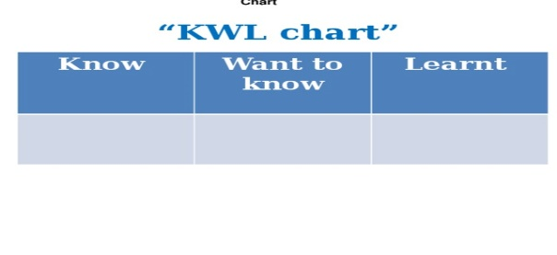 | Students use their stickers to show their knowledge according to the lesson. | Poster  KWL chart

Қазақстан Республикасы Оқу ағарту министірлігі
Саттар Ерубаев атындағы жалпы орта білім беретін мектебі
Short term plan
The theme: International Festivals
Тексерілді: Қ. Байсеитов
Unit of a long term plan: Values |  | School: By name S. Erubayev
Date: 11.11.22 |  | Teacher name: S. Muratalieva
Grade: 5 |  | Number present: | absent:
Lesson title | Language Focus: Present Simple
Learning objectives | 5.3.4.1 respond with limited flexibility at sentence level to unexpected comments on an increasing range of general and curricular topics  5.4.1.1 understand the main points in a limited range of short simple texts on general and curricular topics  5.6.7.1 use simple present to express the activities on special days
Lesson objectives | Learners will be able to:  - • Learn and practise using the present simple in the affirmative.  - • Use the present simple to describe what people do.  - • Practise talking about special days at home.
Plan

Stages / Time | Teachers’ actions | Students’ actions | Assessment criteria | Resources
Start | Organization moment  1.Greeting.  Ask about the weather.  Warm-up  • Books closed. Revise have got with the class. Tell each student to hold a pen and to stand up. Hold a pen yourself for the whole class to see. Say I’ve got a pen, gesturing that you are talking about yourself. Ask the class to repeat  Lead – In  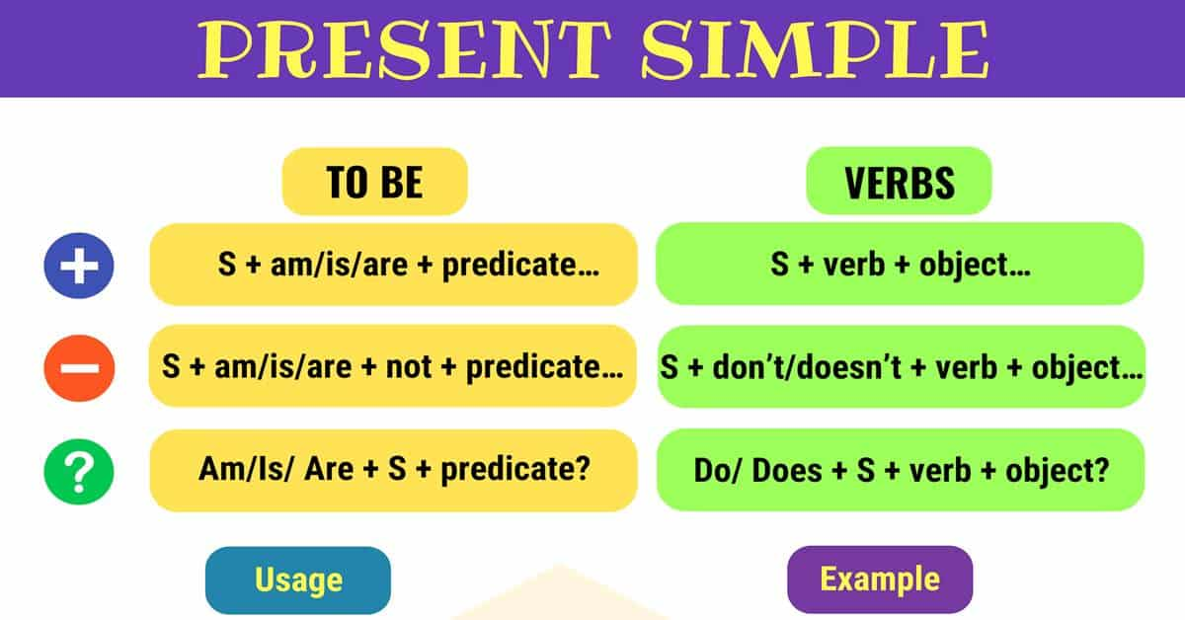  I go to school every day.  She goes to school every day.  I don’t go to school every day.  She doesn’t go to school every day.  Do you go to school every day?  Does she go to school every day? | The aim: To develop Ss speaking skills and create friendly atmosphere  Efficiency: By telling the wishes they show their appreciations .  Students say about daily routines | At the organization moment T tries to award active Ss. «The praise» method is used to evaluate Ss with phrases like:  “Good job!  Well done!”  Formative Assessment  Good job! | Pictures  Student’s book
Main part | Ex: 1 P: 57  • Draw students’ attention to the examples and to the verbs. Allow them a couple of minutes to read through them.  • Tell students to identify which of the sentences have a subject in the third person singular. Elicit that Fernando, My dad, Heidi and Clara are all in the third person singular.  Differentiation:  «Verbal support» method is used to help Students use new words in the text.  Ex: 2 P:57  Allow students some time to read the sentences. Ask them to underline the subject in each case to help them focus on whether they need to add -s or not.  Differentiation:  «Verbal support» method is used to help Students use new words in the text.  Ex:3 P: 57  • Explain that students need to follow the lines from the different people to find out what their activities are in order to make the sentences. Do the first one together as an example.  • Students do the activity in pairs. Monitor, helping where necessary and reminding students to add -s to the verb when using the third person singular. Check answers as a class. | Students look at the verbs in examples.  ANSWERS:  The verbs for he, she and it are different in the present simple because they end in -s.  Students choose the correct words.  ANSWERS:  1 make  2 eats  3 wear  4 plays  5 dance  Students look at the puzzle and make sentences about the people.  ANSWERS:  1 Curtis sings in a band. 2 Dee and Susan make cakes.  3 Patrick eats hot dogs. 4 Dee and Patrick play an instrument.  5 Altynay and Boris dance salsa | Assessment criteria  - Learn and practise using the present simple in the affirmative.  Descriptor:  -use the present simple  Peer assessment: answer key  Assessment criteria:  -Use the present simple to describe what people do.  Descriptor:  -look at the puzzle and make sentences about the people.  - Make CCQ questions | Cards  Worksheets
End | Home task:  Ex: 2 P: 35 WB |  | Students use their stickers to show their knowledge according to the lesson. | Poster  KWL chart

Қазақстан Республикасы Оқу ағарту министірлігі
Саттар Ерубаев атындағы жалпы орта білім беретін мектебі
Short term plan
The theme: The months and seasons.
Тексерілді: Қ. Байсеитов
Unit of a long term plan: Values |  | School: By name S. Erubayev
Date: 14.11.22 |  | Teacher name: S. Muratalieva
Grade: 5 |  | Number present: | absent:
Lesson title | The months and seasons.
Learning objectives | 5.2.1.1understand a sequence of supported classroom instructions  5.3.4.1 respond with limited flexibility at sentence level to unexpected comments on an increasing range of general and curricular topics  5.4.1.1 understand the main points in a limited range of short simple texts on general and curricular topics
Lesson objectives | Learners will be able to:  • Learn and practise the months and the seasons.  • Understand an interview about holidays.  • Practise talking about holidays in different times of the year.
Plan

Stages / Time | Teachers’ actions | Students’ actions | Assessment criteria | Resources
Start | Organization moment  1.Greeting.  Ask about the weather.  Pre-Listening  Warm-up  • Books closed. Write the word holiday on the board. Tell the class to imagine they have two weeks off school and that they can go anywhere in the world for a holiday. • Students compare their ideas briefly in pairs. Get feedback from a few pairs.  Lead – In  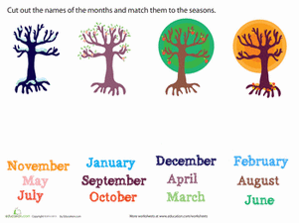  In a year we have four sesons. Each season has three month. | The aim: To develop Ss speaking skills and create friendly atmosphere  Efficiency: By telling the wishes they show their appreciations .  Students say about seasons | At the organization moment T tries to award active Ss. «The praise» method is used to evaluate Ss with phrases like:  “Good job!  Well done!”  Formative Assessment  Good job! | Pictures  Student’s book
Main part | While-listening  Ex: 1 P: 58  • Write the following words on the board: lambs, snow, leaves, sunshine. Draw students’ attention to the photos of the seasons at the bottom of the page. Ask them to match each of the words with one of the photos. Explain the task.  Differentiation:  «Verbal support» method is used to help Students use new words in the text.  Ex: 2 P:58  • Ask the class what the incomplete words are and elicit that they are the months of the year. Tell stronger students to try to complete them before listening to the recording.  • Write the correct spelling of the months on the board for students. Drill the class on pronunciation of the months.  Differentiation:  «Verbal support» method is used to help Students use new words in the text.  Ex:3 P: 58  • Draw students’ attention to the questions in the quiz. In a stronger class, ask students to go ahead and answer the questions. In a weaker class, read the questions together with the students and check for understanding.  Ex:4 P: 58  Students compare their answers in pairs. Play the recording straight through for students to check their answers. Check answers as a class. | Students match the words with the photos in the Month Quiz.  ANSWERS:  autumn (leaves),  winter (snow),  spring (lambs),  summer (sunshine),  Students copy and complete the names of the months.  ANSWERS:  2 February  3 March  4 April  5 May  6 June  7 July  8 August  9 September  10 October  11 November  12 December  Students do the months quiz.  ANSWERS:  1 August  5 Students’ own answers  2 21st June  6 Students’ own answers  3 1st January  7 Students’ own answers  4 September (2017)  8 Students’ own answers  Students listen to an interview with Lady Tara Toffingham  ANSWERS:  1 Switzerland 3 London 2 Rio de Janeiro 4 New York and Boston | Assessment criteria  - Learn and practise the months and the seasons.  Descriptor:  - match the words with the photos in the Month Quiz.  Peer assessment: answer key  Assessment criteria:  - Understand an interview about holidays.  Descriptor:  -copy and complete the names of the months.  -Make CCQ questions  Yes / No  1 Is the August eighth month of the year? Yes  2 Are there five seasons in a year? No  3 Is the January coldest month in winter? Yes | Cards  Worksheets  CD 2.04  CD 2.05
End | Home task:  Ex: 1 P: 36 WB |  | Students use their stickers to show their knowledge according to the lesson. | Poster  KWL chart

Қазақстан Республикасы Оқу ағарту министірлігі
Саттар Ерубаев атындағы жалпы орта білім беретін мектебі
Short term plan
The theme: Present Simple (negative)
Тексерілді: Қ. Байсеитов
Unit of a long term plan: Values |  | School: By name S. Erubayev
Date: 16.11.22 |  | Teacher name: S. Muratalieva
Grade: 5 |  | Number present: | absent:
Lesson title | Present Simple (negative)
Learning objectives | 5.4.1.1 understand the main points in a limited range of short simple texts on general and curricular topics  5.5.3.1 write with support factual descriptions at text level which describe people, places and objects  5.6.3.1 use Present Simple (negative) to speak about activities
Lesson objectives | Learners will be able to:  • Learn how to form and use the negative form of the present simple.  • Practise talking about activities at different times of the year.
Plan

Stages / Time | Teachers’ actions | Students’ actions | Assessment criteria | Resources
Start | Organization moment  1.Greeting.  Ask about the weather.  Warm-up  Books closed. Write My favourite month on the board. Tell students to think for a moment about their favourite month. Divide them into pairs and ask them to tell each other what it is and why.  Lead – In  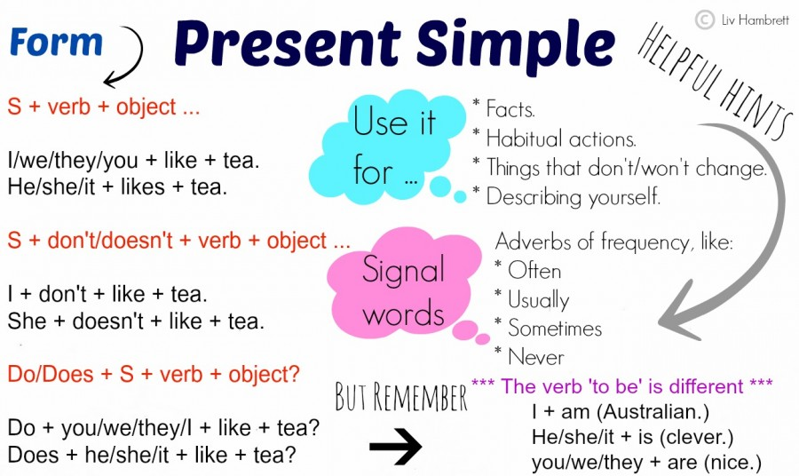 | The aim: To develop Ss speaking skills and create friendly atmosphere  Efficiency: By telling the wishes they show their appreciations .  Students say about like or don’t like | At the organization moment T tries to award active Ss. «The praise» method is used to evaluate Ss with phrases like:  “Good job!  Well done!”  Formative Assessment  Good job! | Pictures  Student’s book
Main part | Ex: 1 P: 59  Write the following sentence on the board: I travel in the summer. Point out that the verb travel is in the present simple affirmative.  Differentiation:  «Verbal support» method is used to help Students use new words in the text.  Ex: 2 P:59  • Refer students to the sentences and explain the task. They complete the activity individually. In a weaker class, do the first one together as an example.  • Students check answers in pairs. Check answers as a class. Ask fast finishers to make three more negative sentences using don’t / doesn’t of their own.  Differentiation:  «Verbal support» method is used to help Students use new words in the text.  Ex:3 P: 59  • Refer students to the sentences. Tell them to look through them quickly and ask them if they are affirmative or negative. Elicit that they are all affirmative.  • Explain the task. Students complete the task individually, and check answers in pairs. Check answers as a class.  Ex:4 P: 59  Draw students’ attention to the incomplete sentences and ask them to read through them quickly. | Students look at the table and complete the rules.  ANSWERS:  don’t,  doesn’t  Students choose the correct words  ANSWERS:  1 don’t  2 doesn’t  3 doesn’t  4 don’t  5 doesn’t  Students make negative sentences  ANSWERS:  1 doesn’t.  2 don’t.  3 don’t.  4 doesn’t.  5 don’t.  6 doesn’t.  Students complete the sentences with the correct Present Simple negative form of the verbs in the box  ANSWERS:  1 don’t give  2 don’t celebrate  3 doesn’t eat  4 don’t eat  5 don’t play  6 don’t make  7 don’t celebrate | Assessment criteria  - Learn how to form and use the negative form of the present simple.  Descriptor:  - look at the table and complete the rules.  Peer assessment: answer key  Assessment criteria:  - Practise talking about activities at different times of the year.  Descriptor:  complete the sentences with the correct Present Simple negative form of the verbs  Make CCQ questions  Yes / No  1 I go to school.  Is the negative form? No  2 she doesn’t speak in English. Is the negative form? Yes | Cards  Worksheets
End | Home task:  Ex: 1 P: 37 WB |  | Students use their stickers to show their knowledge according to the lesson. | Poster  KWL chart

Қазақстан Республикасы Оқу ағарту министірлігі
Саттар Ерубаев атындағы жалпы орта білім беретін мектебі
Short term plan
The theme: Making suggestions
Тексерілді: Қ. Байсеитов
Unit of a long term plan: Values |  | School: By name S. Erubayev
Date: 18.11.22 |  | Teacher name: S. Muratalieva
Grade: 5 |  | Number present: | absent:
Lesson title | Making suggestions
Learning objectives | 5.2.8.1 understand supported narratives, including some extended talk, on an increasing range of general and curricular topics  5.3.5.1 keep interaction going in basic exchanges on a growing range of general and curricular topics  5.4.2.1 understand with little support specific information and detail in short, simple texts on a limited range of general and curricular topics  5.6.13.1 use numbers on a limited range of familiar general and curricular topics
Lesson objectives | Learners will be able to:  • Learn and practise phrases for making suggestions.  • Practise making suggestions about activities.
Plan

Stages / Time | Teachers’ actions | Students’ actions | Assessment criteria | Resources
Start | Organization moment  1.Greeting.  Ask about the weather.  Warm-up  • Books closed. Ask students to work in pairs to tell each other about their favourite music group. Allow them 1–2 minutes for this.  • Get feedback from a few pairs by asking students to describe their partner’s favourite group. Ask students if they would like to go to see their group in concert and get any feedback  Lead – In   | The aim: To develop Ss speaking skills and create friendly atmosphere  Efficiency: By telling the wishes they show their appreciations .  Students say about suggestions | At the organization moment T tries to award active Ss. «The praise» method is used to evaluate Ss with phrases like:  “Good job!  Well done!”  Formative Assessment  Good job! | Pictures  Student’s book
Main part | Ex: 1 P: 60  • Focus on the photo and ask students to discuss it in pairs.  • They answer the questions. Check answers as a class.  Differentiation:  «Verbal support» method is used to help Students use new words in the text.  Ex: 2 P:60  • Draw students’ attention to the incomplete dialogue and the words in the box. Explain the task. In a stronger class, ask students to try to complete the gaps before they listen  Differentiation:  «Verbal support» method is used to help Students use new words in the text.  Ex:4 P: 60  • Elicit the meaning of problem and solution from the class. Explain that when offering a solution to a problem, we can use these phrases for making suggestions.  • Refer students to the two lists and explain the task. Check their answers. | Students look at the photo and where are the people  ANSWERS:  They are at school. The two girls in front have got their school bag.  Students listen and complete the dialogue  ANSWERS:  a what’s  b We’ve  c July  d make  Students match problem with solutions  ANSWERS:  1 f  2 b  3 a  4 c  5 d  6 e | Assessment criteria  - Learn and practise phrases for making suggestions  Descriptor:  - look at the photo and where are the people  Peer assessment: answer key  Assessment criteria:  - Practise making suggestions about activities  Descriptor:  -listen and complete the dialogue  Make CCQ questions  Yes / No | Cards  Worksheets  CD 2.06
End | Home task:  Ex: 3 P: 34 WB |  | Students use their stickers to show their knowledge according to the lesson. | Poster  KWL chart

Саттар Ерубаев атындағы жалпы орта білім беретін мектебі
Short term plan
The theme: A composition about a special occasion.
Тексерілді: Қ. Байсеитов
Unit of a long term plan: Values |  | School: By name S. Erubayev
Date: 21.11.22 |  | Teacher name: S. Muratalieva
Grade: 5 |  | Number present: | absent:
Lesson title | A composition about a special occasion.
Learning objectives | 5.3.5.1 keep interaction going in basic exchanges on a growing range of general and curricular topics  5.5.3.1 write with support an e - mail about a special day  5.4.6.1 recognise the attitude or opinion of the writer in short texts on a limited range of general and curricular topics
Lesson objectives | Learners will be able to:  • Learn how to write a simple composition.  • Learn and practise how to use because.  • Practise writing about special occasions
Plan

Stages / Time | Teachers’ actions | Students’ actions | Assessment criteria | Resources
Start | Organization moment  1.Greeting.  Ask about the weather.  Warm-up  • Books closed. Divide students into pairs. Ask them to tell each other about the last time they were at a street parade or a festival.  • After about 1 minute, stop the students and get some feedback from each pair by asking a student to describe their partner’s experience  Lead – In    Every year on December 16, our country celebrates one of the main national holiday - the Independence Day of Kazakhstan, which is forever associated with sacred events in the history of the country! This holiday is important to all Kazakhstanis as a memory of those who defended the independence of the country. | The aim: To develop Ss speaking skills and create friendly atmosphere  Efficiency: By telling the wishes they show their appreciations .  Students say about suggestions | At the organization moment T tries to award active Ss. «The praise» method is used to evaluate Ss with phrases like:  “Good job!  Well done!”  Formative Assessment  Good job! | Pictures  Student’s book
Main part | Ex: 1 P: 61  Draw students’ attention to the pictures and discuss them with the class. Ask them what they can see and elicit that there are a lot of people in colourful clothes  Differentiation:  «Verbal support» method is used to help Students use new words in the text.  Ex: 3 P:61  • Refer students to the sentences and explain the task. In a weaker class, do the first one as an example for the students and ask them to continue the activity in pairs.  • Students check answers in pairs. Check answers as a class.  • Ask fast finishers to make three new sentences of their own using because.  Differentiation:  «Verbal support» method is used to help Students use new words in the text.  Ex:4 P: 61  Go through the Writing guide with the class. Firstly, explain the task and what the students have to do. If they cannot think of a festival or celebration that they know about, encourage them to invent one. | Students read the model text and answer the question.  ANSWERS:  1 Every: because it is the first word in the sentence; Brighton: because it is the name of a place; Brighton Carnival: because it is the name of a festival.  2 The carnival is in July. 3 Yes, the writer is in a samba band.  Students match sentences with reason using because  ANSWERS:  1 b: We go to Switzerland every year because we like skiing.  2 e: I wear warm clothes because it is very cold.  3 d: I don’t like crocodiles because they are dangerous.  4 c: They close the roads because people dance in the street.  5 a: My grandmother doesn’t dance because she’s very old  Students follow the steps in the writing guide.  ANSWERS:  Students’ own answers | Assessment criteria  - Learn how to write a simple composition.  Descriptor:  - read the model text and answer the question.  Peer assessment: answer key  Assessment criteria:  - Learn and practise how to use because.  - Practise writing about special occasions  Descriptor:  -match sentences with reason using because  - follow the steps in the writing guide.  Make CCQ questions  Yes / No | Cards  Worksheets  CD 2.06
End | Home task:  Ex: 3 P: 35 WB |  | Students use their stickers to show their knowledge according to the lesson. | Poster  KWL chart

Саттар Ерубаев атындағы жалпы орта білім беретін мектебі
Short term plan
The theme: My Country. Holidays.
Тексерілді: Қ. Байсеитов
Unit of a long term plan: Values |  | School: By name S. Erubayev
Date: 23.11.22 |  | Teacher name: S. Muratalieva
Grade: 5 |  | Number present: | absent:
Lesson title | My Country. Holidays.
Learning objectives | 5.2.8.1 understand supported narratives, including some extended talk, on an increasing range of general and curricular  5.3.3.1 give an opinion at sentence level on a limited range of general and curricular topics  5.6.5.1 use questions, including tag questions to seek agreement, and clarify meaning on a limited range of familiar general and curricular topics
Lesson objectives | Learners will be able to:  • Read a text about special days in Kazakhstan.  • Learn prepositions of place and direction.  • Learn and practise using adverbs of manner.
Plan

Stages / Time | Teachers’ actions | Students’ actions | Assessment criteria | Resources
Start | Organization moment  1.Greeting.  Ask about the weather.  Warm-up  • Books closed. Write school holidays on the board.  • Explain that students in different countries have different school holidays. In the UK, for example, students have 13 weeks of school holidays per year (6 weeks of summer holidays, 1 week for Christmas, 1 week for Easter, 3 weeks of half term holidays, bank holidays and 5 additional days).  Lead – In  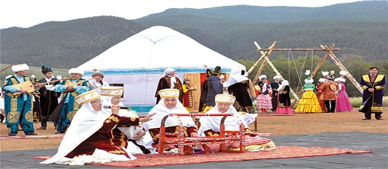  Nauryz is the most important holiday of the year for both the Kazakhs and many peoples of Asia, which has been celebrated for more than five thousand years. Nauryz is a holiday of spring, the renewal of nature, the beginning of a new year and a new life. And on the eve of this holiday, I would like to tell you about the history of the beautiful song "Nauryz - Duman", without which we cannot imagine holding this holiday. | The aim: To develop Ss speaking skills and create friendly atmosphere  Efficiency: By telling the wishes they show their appreciations .  Students say about different holidays about our country | At the organization moment T tries to award active Ss. «The praise» method is used to evaluate Ss with phrases like:  “Good job!  Well done!”  Formative Assessment  Good job! | Pictures  Student’s book
Main part | Ex: 1 P: 62  • Use two books and a pen to demonstrate the meaning of the prepositions, e.g. put the pen behind one of the books and ask Where is the pen? (It’s behind the book.), then place it between the two books and ask again (It’s between the books.), then hold it above one of the books. • In pairs, students look at the photo and complete the description with five of the prepositions in the box.  Differentiation:  «Verbal support» method is used to help Students use new words in the text.  Ex: 2 P:62  Ask students to do the task individually, then play the recording for them to listen and check their answers.  Differentiation:  «Verbal support» method is used to help Students use new words in the text.  Ex:3 P: 62  • Explain the difference between adjectives and adverbs. Elicit that adjectives modify nouns (She is a careful driver. – the adjective careful modifies the noun driver) while adverbs modify verbs (He drives carefully. – the adverbs carefully modifies the verb drives).  Ex:3 P: 62  • Explain the task and ask students to do it individually. | Students check the meaning of these words  ANSWERS:  1 Next to  2 Behind  3 under  4 between  5 in front of The people in the photo are celebrating Nauryz.  Students read the special days calendar and write the names of the holidays.  ANSWERS:  1 New Year’s Day  2 Nauryz  3 Capital Day  Students look at the words in blue in the text. Then choose the correct words in the rules.  ANSWERS:  1 how  2 –ly  Students complete the sentences with adverbs forms from the adjectives in brackets  ANSWERS:  1 beautifully  2 quietly .  3 carefully  4 quickly  5 slowly | Assessment criteria  - read a text about special days in Kazakhstan  - Learn prepositions of place and direction  Descriptor:  - check the meaning of these words  - read the special days calendar and write the names of the holidays.  Peer assessment: answer key  Assessment criteria:  - Learn and practise using adverbs of manner.  Descriptor:  - complete the sentences with adverbs  Make CCQ questions  Yes / No | Cards  Worksheets  CD 2.06
End | Home task:  Ex: 3 P: 36 WB |  | Students use their stickers to show their knowledge according to the lesson. | Poster  KWL chart

Саттар Ерубаев атындағы жалпы орта білім беретін мектебі
Short term plan
The theme: Asking about dates/ Summative assessment for the unit ”Values”
Тексерілді: Қ. Байсеитов
Unit of a long term plan: Values |  | School: By name S. Erubayev
Date: 25.11.22 |  | Teacher name: S. Muratalieva
Grade: 5 |  | Number present: | absent:
Lesson title | Asking about dates/ Summative assessment for the unit ”Values”
Learning objectives | 5.2.8.1 understand supported narratives, including some extended talk, on an increasing range of general and curricular topics  5.2.8.1 Understand supported narratives, including some extended talk, on an increasing range of general and curricular topics  5.3.3.1 Give an opinion at sentence level on a limited range of general and curricular topics
Lesson objectives | Learners will be able to:  - Learn how to say dates.  -Understand a conversation that uses dates to say when something is happening  -Recognise the meaning of a story and extended talk with some support  -Provide a point of view in connected sentences
Plan

Stages / Time | Teachers’ actions | Students’ actions | Assessment criteria | Resources
Start | Organization moment  1.Greeting.  Ask about the weather.  Warm-up  Write the following numbers on the board: 28/29, 30, 31. Ask students to put the correct months under the correct number of days that they contain (28/29: February; 30: April, June, September, November; 31: all other months).  Lead – In  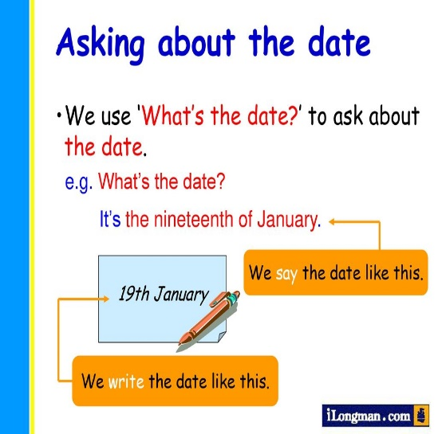 | The aim: To develop Ss speaking skills and create friendly atmosphere  Efficiency: By telling the wishes they show their appreciations .  Students say about dates,months | At the organization moment T tries to award active Ss. «The praise» method is used to evaluate Ss with phrases like:  “Good job!  Well done!”  Formative Assessment  Good job! | Pictures  Student’s book
Main part | Ex: 1 P: 63  • Focus students’ attention on the numbers in the box and explain that we call them ordinal numbers. This means that they tell us the order that things are in. Point out that we use ordinal numbers to say dates.  Differentiation:  «Verbal support» method is used to help Students use new words in the text.  Ex: 2 P:63t  Students work in pairs to practise the dates. Play the recording for them to check their answers.  Summative assessment for the unit ”Values”  Listening  Task 1.  Listen to Jenny’s letter and fill in the blanks with suitable words from the box as in the example:  Speaking  Task 2.  Choose one picture you liked most and answer the question “Why is this picture special for you?” | Students match the words in the box with the ordinal numbers  ANSWERS:  1 twenty-eighth  2 eleventh y  3 sixth  4 third  5 fourteenth  6 thirtieth  Students study the key phrases and say dates  ANSWERS:  1 the second of June  2 the twenty-sixth of August  3 the fifteenth of January 4 the first of March  5 the twenty-second of October  6 the thirty-first of May  Students fill in the blanks with words in the box  ANSWERS:  1 shining  2 looking  3 asking  4 learning  5 doing  Students choose one picture and answer the question  ANSWERS:  Students own answers | Assessment criteria  - Learn how to say dates.  Descriptor:  - match the words in the box with the ordinal numbers  Peer assessment: answer key  Assessment criteria:  - Recognise the meaning of a story and extended talk with some support  Descriptor:  - fill in the blanks with words in the box  Make CCQ questions  Yes / No | Cards  Worksheets  CD 2.06
End | Home task:  Ex: 1 P: 37 WB |  | Students use their stickers to show their knowledge according to the lesson. | Poster  KWL chart

