Checked by:___________
School |  | №2 secondary school of the village Abay
Subject |  | English
Unit 7 |  | Reading for pleasure
Teacher’s name |  | Yergesh Sandugash
Date |  | 05.03.2024
Grade 6 D |  | Number present: |  | Number absent:
Theme of the lesson |  | A folktale Kyz- Zhibek
Learning objectives(s) that this lesson is contributing to |  | 6.2.5.1 keep interaction going in basic exchanges on a growing range of general and curricular topics
Lesson objectives |  | Learners will be able to tell about the folktale
Value links: |  | to share a common history and highlight important traditions
Lesson plan
Planned timing | Pedagogue`s activities |  | Learner`s activities |  | Assessments | Resources
Organizing moment:  Test for focusing  (3 минут) | Greeting students;  Asking present students  Making a good atmosphere. Students divide into 2 groups and stay in front of each other. Then play a game “ball”   |  | A good atmosphere  When teacher tells “touch” students touch their body parts. When teacher tells “ball” students take the ball first |  | «The star» method is used to evaluate students with phrases like:  “Good job!  Well done!”   | Ball
Remember previous lesson  (4 минут) | Asking homework:  By game Board teacher asks home tasks  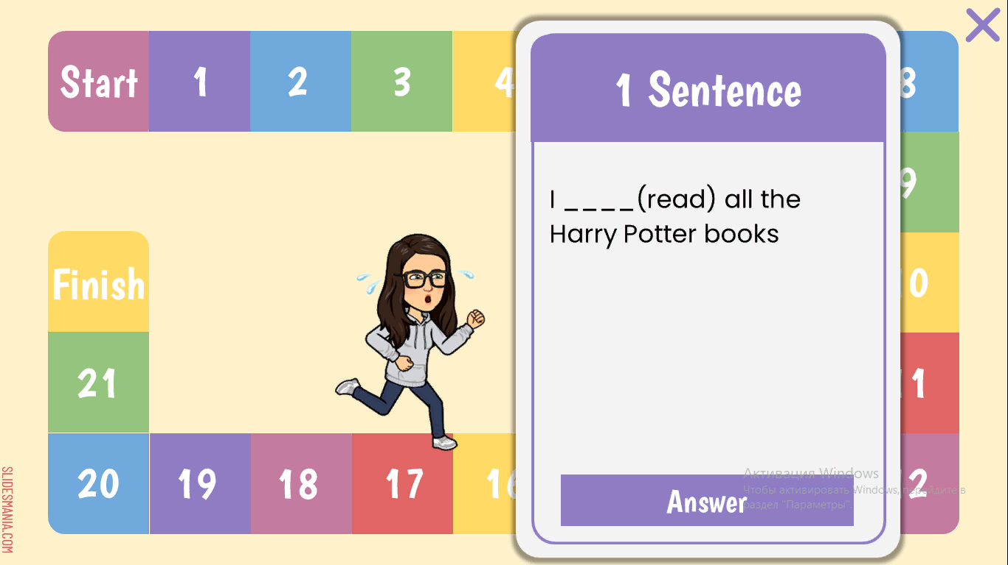 |  | Students raise their hands and tell |  | «The star» method is used to evaluate students with phrases like:  “Good job!  Well done!”   | PPT  Board game
New lesson  (30 минут) | Brainstorm. Teacher shows a pictures and asks what about it.  Teacher tells about the lesson theme and lesson objects. Teacher explains the theme with the help of PPT.  Teacher gives students new key phrases and practice with the method “Lost word”  Looked like (a prince) -ұқсады (сияқты көрінді) Comes from (the 16th century) - Шыққан (16 ғ.) Fell in love - Ғашық болды Tragic love - Қайғылы махаббат Set off - Жолға шығу Rich but unhappy - Бай, бірақ бақытсыз |  | Students tell their opinions by pictures.  Listen to the teacher’s speech about the lesson and practices the new vocabulary by “Lost word” |  | «The star» method is used to evaluate students with phrases like:  “Good job!  Well done!”   | Flash cards  Board  Papers with words  PPT
 | Task 1. Individual work. Listening. (Level task)  Teacher gives to each student level tasks for revise the vocabulary.  Teacher tells listen to the text and fill the gap. For this use key phrases.  High level students write 6 key phrases in text  Middle level students write only 3 key phrases in the text  Low level students write missing letters  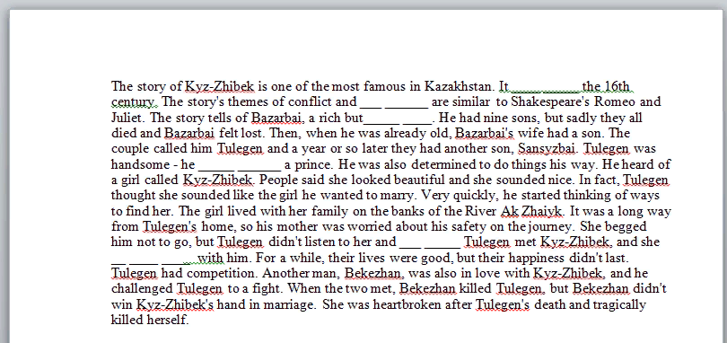 |  | Students listen to the text. Then complete the sentences with different tasks:  - Filling  - Finding missed words |  | Descriptors:  Total points-4  Learners:  - listen to the text text;-1  -revise the vocabulary-1  - understand text;-1  - fill the gaps;-1  Task for low performing learners.  Descriptors:  Total points:4  -revise the vocabulary-2  -write answers correctly-2  Evaluation with comments:  Great job!  Excellent! | Worksheets with texts
 | Task 2. Work in-pair. Exercise 3 p.88  Focus students on the blue words in the text. Ask a couple of students to read them out.  1.Tulegen _____ like a prince  2. Kyz-Zhibek ______ beautiful.  3. She__________ the girl Tulegen wanted to marry.  4. She _____ nice |  | Students complete the sentences in the exercises.  - Read sentences and complete it |  | Descriptors:  Total points - 2  Learners:  - read the sentences;-1  -use vocabulary-1  Evaluation with comments:  Great job!  Excellent! | Board  Copybook  “English plus 6”  Oxford University Press p.120
 | Task 3. Work in-group.  Teacher asks to students write names of places, objects and animals that can be used in the folktales. |  | Students listen to teacher’s speech and do tasks  - 1st group students write names of places and characters (people)  - 2nd group students write names of objects and animals |  | Descriptors:  Total points:4  -revise the vocabulary-2  -write answers correctly-2  Evaluation with comments:  Great job!  Excellent!   | worksheet
End of the lesson  (5 min) | Revise the lesson.  Students should translate words into Kazakh language    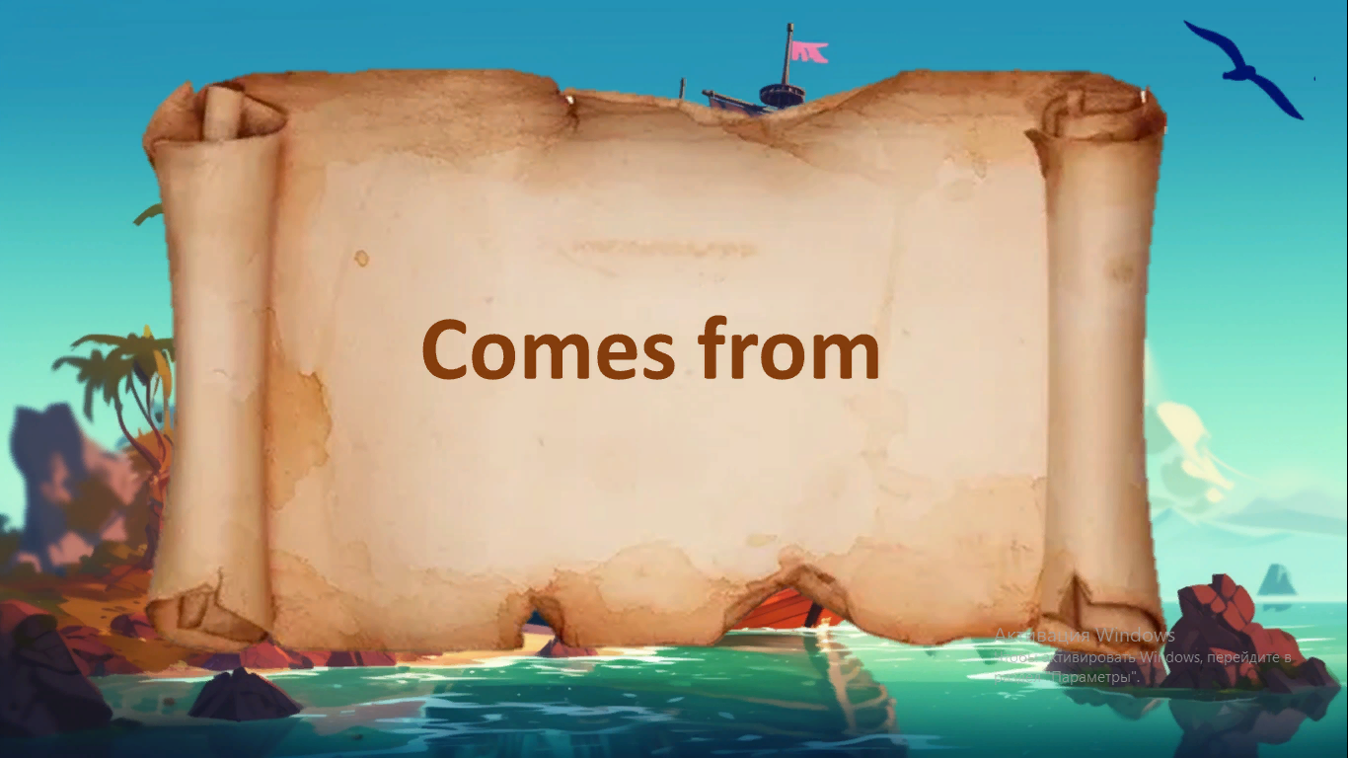 |  | Students translate words into Kazakh language by game |  | Evaluation with comments:  Great job!  Excellent!  Total points-10 | PPT
Homework  (1 min) | - homework: learn by heart new vocabulary and make sentences with it |  | Write the home task to their diary |  |  | New vocabulary
Reflection:  (2 min) | Feedback:  Teacher tells students to send a message   |  | Students tell their opinion about the lesson   |  |  | Sheets of paper

