Lesson plan

Unit of a long term plan Celebation |  |  |  | School: “Koktem”
Date:17.11.17 |  |  |  | Teacher’s name: Tanatarov Nauryzbek
CLASS: 5b |  |  |  | Number present:25 |  |  |  | absent:
Lesson title |  | Talking about holidays
Learning objectives(s) that this lesson is contributing to (link to the Subject programme) |  | 5.W3 write with support factual descriptions at text level which describe people, places and objects  5.C1 use speaking and listening skills to solve problems creatively and cooperatively in groups  5 S.3 begin to describe past experiences on an increasing range of general and some curricular topics  5R.1 understand the main points in a limited range of short simple texts on general and curricular topics
Level of thinking skills |  | Lower-order thinking skills
Lesson objectives |  | All learners will be able to :  - talk about their holidays using pictures and write sentences using if clauses;  Most learners will be able to :  - talk about their holidays describing place, objects and write some sentences;  Some learners will be able to :  - link sentences into paragraph using zero conditionals and defining relative clauses with which who that where
Assessment criteria |  | -Write about holidays describing place, objects using zero conditional
Values links |  | Respect intercultural awareness and to be polite and respectful to each other
Cross-curricular  liks |  | Geography
Previous learning |  | Holiday activities
Plan
Planned timings | Planned activities (replace the notes below with your planned activities) Planned activities (replace the notes below with your planned activities)  What will the pupils learn? How will they learn it?  Suggested Teaching Activities  Active Learning activities |  |  |  |  |  | Resources
Start  2 min | Greeting: learners respond to greeting of the teacher and take their places.  1. Organization moment: greeting the students. Dividing into subgroups using cards with word {1 group - Italy ; 2 group - England; 3 group – Spain; 4 group- Japan}  Warming up: “every country in their language welcomes out” activity.  New words:  - EAT-ЖЕУ  - WALK-ЖҮРУ  - STAY-ТҰРУ,ҚАЛУ  - CAMP-ЛАГЕРЬ  - TRAVEL-САЯХАТ  - FLY-ҰШУ  - SWIM-ЖҮЗУ  - CYCLE-ВЕЛОСИПЕД  - SUNBATHE-КҮН СӘУЛЕСІ  - SHOP-ДҮКЕН  Use words. (holiday, day off, weekend, day of rest)How do you think what theme have we got for today?  The learners find the odd word and identify lesson’s theme.  Teacher introduces lesson objectives and Assessment Criteria to the learners. |  |  |  |  |  | Pictures of transport, back bags, slides  
Middle  3 min  3 min  3 min  6 min  4 min  8 min  6 min  End  5 min | Activity –Matching  - Drawing up words from letters.  Differentiation by outcome  CHRISTMAS, HALLOWEEN, NAURYZ,  MOTHERSDAY  - Instead of words, setting appropriate  Don’t eat in class:  1 _____ English in class.  2 _____samba on the tables in class  3_____your homework  4_____your friends’ homework  5_____in the school building  - Prepositions  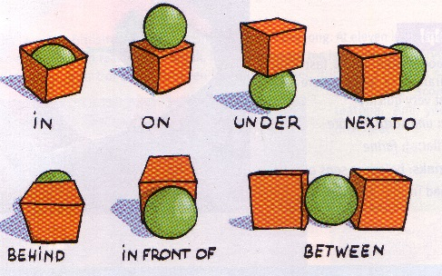  - Celebration’s Benn’s diogramme  Britain  Kazakhstan  Learners choose pictures of celebrations and activity and use them to talk. They are asked to questions:  - Do you like celebrations?  - What do you do on celebrations?  AFL: Gallery- nomination “Best work”  W. Task-3 (flies strategy)  New Year’s Day Christmas Nauryz Easter Halloween Mothers day Victory day St. Valentine’s Day Constitution day Presedent day Dates is celebrated On August 30 On December 1 in April. On May 9 On March 8 on January, 1. on October, 31. on December, 25. on February, 14. On March 22  Play games (listening to music and finding a festive father)  Feedback: “Mikrafon”  Reflection  All learners put stickers into three groups according their understanding of the lesson  Smiles  Home task is...repeat new words  So, our lesson is over. Good bye! |  |  |  |  |  | Much letters:  C,,H,I,L,N,A,  T,M,O,T,H,D,  Work in pairs  Run, dance, do, eat, copy, speak  Pictures, cards  A3 paper, colour marker  A3 drawing  Diogramme  Words flashcards,  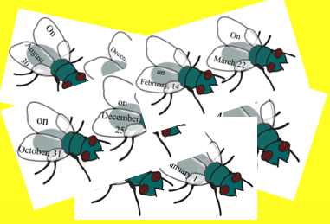      Stickers
Additional information
Differentiation – how do you plan to give more support? How do you plan to challenge the more able learners? |  |  | Assessment – how are you planning to check learners’ learning? |  |  | Health and safety  check
Task 1. Divide these words on the categories and make up sentence.  Differentiation by outcome for more able learners:  Why you choose this type of transport?  Task 5. Differentiation by task for more able learners:  -make up a story connecting sentences into paragraph  Task 6. Match a word in A with a word in B to take a new word.  Differentiation by More able learners make up sentences using compound nouns;  Less able learners translate the words |  |  | At the end of the lesson, learners reflect on their learning:  - “All you know”.  - Yes or No cards  - 2 stars and a wish  - Gallery  - Oral feedback |  |  | - ICT displays - smart/interactive white boards or screens, projectors;
Reflection  Were the lesson objectives/learning objectives realistic?  Did all the learners achieve the lesson objectives/ learning objectives? If not, why?  Did my planned differentiation work well?  Did I stick to timings?  What changes did I make from my plan and why? |  |  |  |  | Use the space below to reflect on your lesson. Answer the most relevant questions from the box on the left about your lesson.
Summary evaluation
What two things went really well (consider both teaching and learning)?
1:
2:
What two things would have improved the lesson (consider both teaching and learning)?
1:
2:
What have I learned from this lesson about the class or individuals that will inform my next lesson?

