Бекітемін: №249 мектеп – лицей директорының оқу – тәрбие
жұмыстары жөніндегі орынбасары Г. Қарақұлова

Unit of a long term plan: Journey into space |  | School: 249
Date: 19.04.2023 |  | Teacher’s name: Seraliyeva Dinara
Grade: 4 a |  | Number present: 15 | absent:
Lesson title | Aliens 1 (2).
Learning objectives: | 4.S.4 respond to questions on an increasing range of general and some curricular topics  4.R.6 understand with some support, some specific information and detail in short, simple texts on a growing range of general and some curricular topics  4.UE.4 use determiners a, an, the, zero article to refer to things on a growing range of general and some curricular topics
Level of thinking skills | Higher order thinking skills  Knowledge and Application
Lesson objectives | Learners will be able to:  - recall vocabulary to answer of questions through the picture  - identify specific information and details in a text with little support;  - apply determiners a, an, the, zero article to describe rule

Stages / Time | Teachers actions | Students actions | Assessment | Resources
Beginning the lesson  2 min | Greeting the classroom  - Good afternoon children!  - How are you?  - What is the date today?  - Who is absent? | - Good afternoon teacher!  - We are fine, thanks.  - Today is the 19th of April  - All are present. | Assessing by teacher’s comment
Checking up homework  8 min | Task. Look at the first letter planet and write their names.  J U N E    M Me S Sa V | Students look at the first letter planet and write their name.  Sun  Venus  Mars  Mercury  Earth  Jupiter  Neptune  Uranus  Saturn | Descriptor:  A learner  - looks at the first letter planet and writes, reads their names.
Reading stage  15 min | Listen the text and read it.  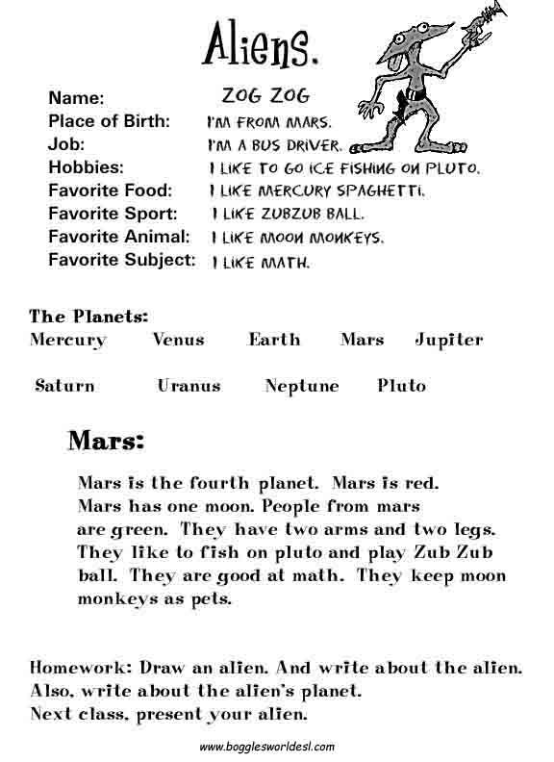 | Ss read the text | Descriptor  A learner  - reads the text;
Post reading stage  “True/False statements”  method  10 min | Task. Read the text again and match the statements as T(true) or (False)  - Alien’s name is Dok Dok.  - It lives on Jupiter.  - It likes zub zub ball.  - Its favorite animal is monkey.  - Its favorite subject is Technology | Ss read the text and match the statements as T(true) or F(false)  - F  - F  - T  - T  - F | Descriptor:  A learner  - matches the statements as T(true) or F(false) correctly;
Eliciting  “Fill in the gaps”  method  5 min | Task. Fill in the blanks with a, an, the or zero article.  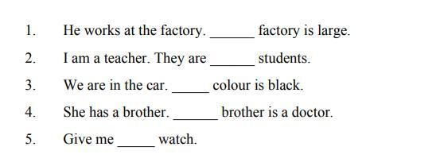 | Ss fill in the blanks with a, an, the or zero article.  - The  - –  - The  - The  - A | Descriptor:  A learner  - fill in the blanks with a, an, the or zero article; correctly; | Google
End of the lesson  Home work  5 min | Task. Read, look and number  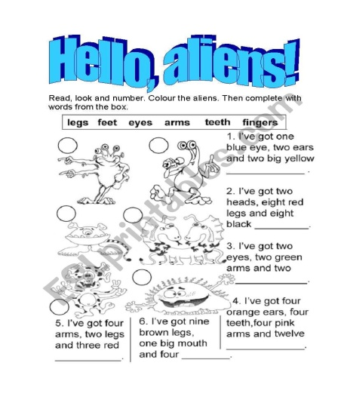 | SS read, look and number | Descriptor:  A learner  - finds the correct word and number them correctly; | worksheet

