|  |  |  |  |
| --- | --- | --- | --- |
| Unit of a long term  The world of work | | “Secondary school №2 of Kengir village” | |
| Date:12.12.2022 | | Teacher name: Tynybekova. G. M | |
| Grade:6 | | Number present: | Absent: | |
| Lesson title | | Professions | | |
| Learning objectives | R5.4.2.1 understand with little support specific information and detail in short, simple texts on a limited range of general and curricular topics  S5.3.5.1 keep interaction going in basic exchanges on a growing range of general and curricular topics | | | |
| Lesson objectives | -Read the text and complete a Venn Diagram to find similarities and differences between 2 jobs.  - Make up a dialogue and act out it. | | | |

|  |  |  |  |  |
| --- | --- | --- | --- | --- |
| Stages time | Teachers action | Students action | Assessment | Resources |
| Start  5 min | **1.Greeting & org. moment**  - Good afternoon, class.  - Good afternoon, teacher.  - How are you today?  - We are … , today.  - How are you teacher?  - I’m fine, thanks.   * Who is on duty today? * Who is absent? * What day is it today? * What date is it today? * What weather like today? | Students  respond to greeting and take their places. | *Oral assessment*  -Very good!  -Excellent! |  |
| Presentation | Teacher shows pictures to students guess the lesson theme  Teacher shows pictures of professions and ask questions.  1. Who are these people?  2. How do you think what is the theme of our lesson? | Students answer the questions.  -doctor, nurse, cook, waitress  secretary, builder  -Our lesson theme is Professions | Group assessment | <https://legkopolezno.ru/wp-content/uploads/2016/09/83-vybor-professii-1.jpg> |
| Pre-reading  5 min | Teacher gives definitions of words and explains the task. | Students match the words with their definitions | Peer assessment | Handout 1 |
| While reading  10 min | Teacher gives an instruction to read the text “My fun job”.  Teacher gives the task to complete a Venn Diagram to find similarities and differences between 2 jobs. | Students read the text.  Students complete a Venn Diagram. | Teacher’s observation  Group assessment | Handout 2  Handout 3 |
| Post reading  5 min | Teacher asks concept checking questions to check the comprehension of the text.  CCQs:  1. Is Steven basketball mascot?  2. Does he wear a red owl costume?  3. Does he love your job?  4. Is Mark waterslide tester?  5. Does Mark love your job? | Students answer the questions | Teacher’s observation | Concept checking questions |
| Production  15 min | Teacher gives explains the task. To the first group teacher gives ready dialogues and act out it. To the second group teacher gives an instruction to make up the dialogue and act out it. | The first group students read the dialogues and show role-playing game.  Students make up the dialogue and show role-playing game. | Formative Assessment | Handout 4 |
| Ending  5 min | Teacher hands out cards with colors to check the students’ understanding.  **Green** The lesson is clear for me  **Yellow I** have got some questions.  **-Red I** don’t understand anything.  Teacher gives a home task  “My favorite profession”  Write a short essay about your favorite profession (10-12 sentences). | Students choose appropriate color of traffic light to show their comprehension of the lesson. |  |  |

**Handout 1**

**Task. Match the words with their definitions before reading the text.**

1. A person, animal or thing that people believe will bring them good luck, or that represents an organization or event.

2. A person who admires somebody/something or enjoys watching or listening to somebody/something very much.

3. A sports event where people or teams compete against each other.

4. to interest somebody or make somebody laugh in order to please them.

5. to move easily over a smooth or wet surface; to make something move in this way.

6. To win points, goals, etc. in a game or competition.

A. match

B. entertain

C. mascot

D. fan

E. score

F. slide

<https://www.oxfordlearnersdictionaries.com/definition/english/mascot?q=mascot>

<https://www.oxfordlearnersdictionaries.com/definition/english/fan_1?q=fan>

<https://www.oxfordlearnersdictionaries.com/definition/english/match_1?q=match>

<https://www.oxfordlearnersdictionaries.com/definition/english/entertain?q=entertain>

<https://www.oxfordlearnersdictionaries.com/definition/english/slide_1?q=slide>

<https://www.oxfordlearnersdictionaries.com/definition/english/score_1?q=score>

**Handout 2**

‘Excel grade 5, Students book p46

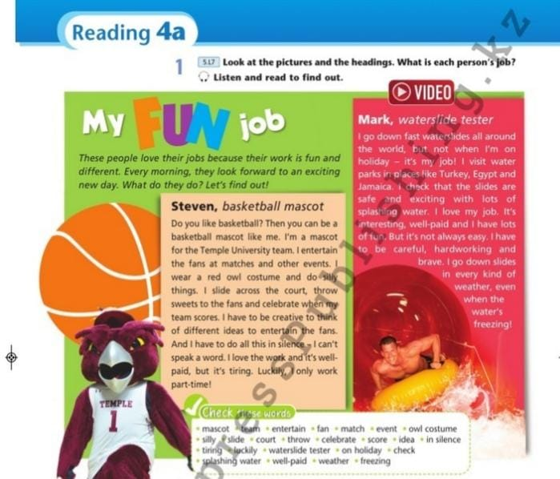

**Handout 3**

**A Venn diagram**

Task. Complete the diagram to show the differences and similarities of two jobs

**Handout 4**

**Formative assessment**

|  |  |
| --- | --- |
| Learning objective | S5.3.5.1 keep interaction going in basic exchanges on a growing range of general and curricular topics |
| Assessment criteria | -Make up a dialogue and act out it. |
| Level of thinking skills | Application, HOTS |
| Task | Make up the dialogues: Steven and journalist or Mark and journalist, act out it. |
| Differentiation for less able students | Descriptors for less able students:  Student:  -makes up a dialogue using teacher’s supportive sentences.  **Steven and journalist**.  S1. – Hello!  S2. – Hi!  S1. – Are you basketball mascot?  S2. – Yes, I am basketball mascot.  S1. - Do you love your job?  S2. – Yes, I love my job.  S1. - Do you like play basketball?  S2. - Yes, I like play basketball.  S1. –Ok. Good-bye!  S2. - Good-bye!  **Mark and journalist.**  S1. – Hello!  S2. – Hello!  S1. – Are you waterslide tester?  S2. – Yes, I am waterslide tester.  S1. - Do you love your job?  S2. – Yes, I love my job.  S1. - Is your job interesting?  S2. - Yes My job is very interesting.  S1. –Ok. Good-bye!  S2. - Good-bye! |
| Differentiation for more able students | Descriptors for less able students:  Student:  -makes up a dialogue without support and act out it. |