Unit 5: Hot and Cold |  |  | School: 10
Date: 10.02.2022 |  |  | Teacher name: Batyrkhanova A.K
Grade: 4 |  |  | Number present: |  | Number absent:
Theme of the lesson: |  | Snow and ice
Learning objectives |  | 4.R6 understand with some support, some specific  information and detail in short, simple texts on a growing range of general and some curricular topics  4.W16. use conjunctions and, or, but, because to link words and phrases  4.UE13 use can to make requests and ask permission, use must / mustn’t / have to to talk about obligation, use have to +object + infinitive to talk about obligations
objectives |  | All learners will be able to:  -recognise and use some target language correctly and show comprehension of some written and spoken familiar words in simple sentences To explore other subject areas (Geography); to talk about snow and ice  -supported talk on an increasing range of general and some curricular topics  using conjunctions and, or, but, because
Criteria |  | Structures: Consolidation.  Language in use: It's a place you have to see to believe. There are lots of fun activities for all the family. Book now for an amazing experience. It's a windy day in London Town.
Previous learning |  | Volcanoes
Plan
Plannedtimings | Planned activities |  |  | Learners’ activities |  | Evaluation | Resources
Begining  the lesson | GREETINGS.  Good day, children!  How are you? What is the weather like today?  The weather is windy, cold and snowy today  Play the song from the greetings and dance the pupils to sing along.  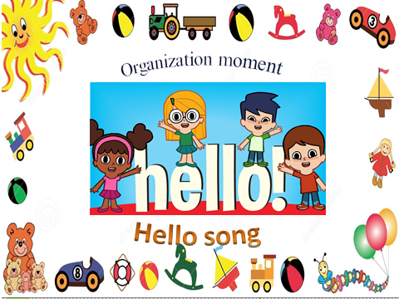  Checking up the homework with method focus.  An activity to revise the language of the previous lesson. |  |  | Greeting.  Answer the question.  Leaners sing a songs “Hello, how are you?” and they dance  Leaners do tasks on the blackboard  Pupils choose the most suitable title to the text by the method of ‘BRAIN ATTACK’ |  | By the method of  “FIREWORKS”    ‘excellent’  ‘well done’  ‘good job’ | https://youtube.com/watch?v=tVlcKp3bWH8&feature=share  Copybooks
Middle  the lesson | Warm up  INTRODUCE THE OBJECTIVES.  Choose and answer on the blackboard.Under each question, one letter is hidden. By answering the question, the topic of the new lesson will appear. Theme is “Snow and ice”.  Individual work  Method “CRISPS”  Teacher offers crisps to leaners. Read and match.  Bord game  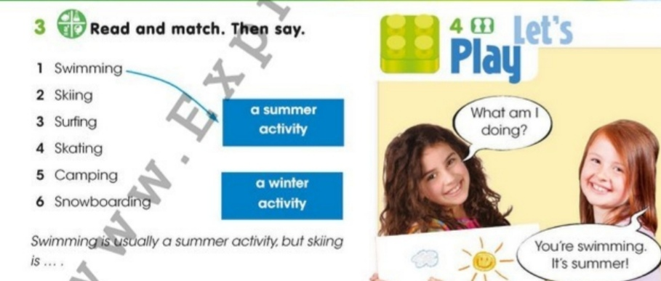  Descriptor: a leaners  -to read words  -to find summer and winter activities  Say and write on the board snow and ice. Have a brief class discussion. Read aloud the words and elicit/explain any unknown vocabulary. Explain the activity. Allow the pupils some time to complete it. Check their answers.  Teacher tells children to choose one picture. Gives them a blank piece of paper or card and tells them to write the name of their chosen with a picture.  The teacher divides the students into groups using pictures. The student who chooses the snowflakes picture will be in the Snowflakes group. If you choose an ice crystals image, you will be in the Ice crystals group.  Step 1 Listen, repeat and write.  New words:  Antarctica – [әнтарктика]Антарктида  Penguins – [пэнгуинс] пингвины  Blue whale – [блу уэйл] синий кит  Snowflakes – [сноуфлейкс] снежинки  Winter – [уинтэ] зима  Ice crystal – [айс]ледяной кристалл  Gloves – [глоуес] перчатки  Scarf – [скаф] шарф  Step 2 Listening and reading  Watch the video about Antarctica.  Team work  Teacher asks the question.  - What is the weather like in Antarctica?  - What kind of animals live?  - How many hours dark in the winter?  - Which has Antractica got volcano?  - Are there lakes and rivers?  Descriptor: A leaners:  -to listen and translate  -to answer the question  Physical minute: “A ram sam, sam”  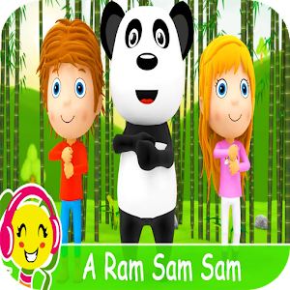  Pair work.  Read again. Correct the sentences  Explain the activity. Allow the pupils some time to read the text again silently and correct the sentences  Then individual pupils read out the texts.  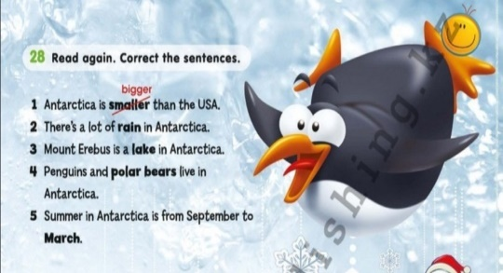  Descriptor: a leaners:  -to find correct the sentences  Ex 29  Step 3  Coloring  This is the penguins. In pairs, coloring. Present it to own pair.  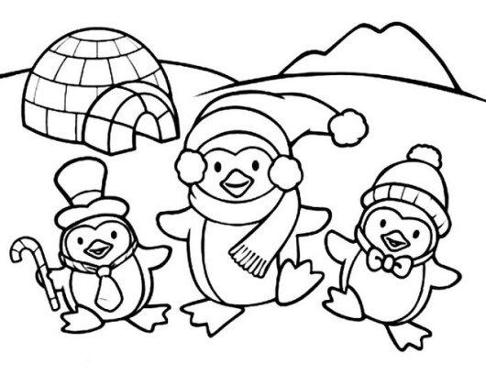  Grammar  Teacher introduces conjunctions and, or, but, because  Pair work .Read the sentences.Fill in the gaps with the words from the table. Use each word once.  Example: Wewear warm clothes and boots in winter.  We play snowballs or make a snowman in the yard.  and or but because  Antarctica is the coldest ___ windiest place on earth.  We like winter __________________it is fun.  We are happy after skiing, __________they are a little tired.  When we go down the hill we can use skis _________ a snowboard.  Descriptor:  fills in the gaps with conjunctions and, or, but, because. |  |  | Learners choose and answer on the blackboard the words that have to do with snow and ice.  Learners read theme and discuss  The student who chooses the snow picture will be in the Snowflakes group. If you choose an ice image, you will be in the Ice crystals group.  Leaners listen, repeat and write new words on the dictionary.  Learners read the words and find the which activities  Leaners watch a video  Leaners answer to question.  Pupils read the text and understand the main point by the method of ‘CHAIN’  Leaners sing a song and dance  It is a pair work. Pupils should read the sentences carefully and choose the right variant by the method of ‘THINK TOGETHER’  Learners complete the activity  Learners color their penguins and present their after coloring to the classmates.  Learners write in the notebook |  | ‘super’  ‘brilliant’  ‘very well’  By the method of  ‘THUMBS’  Formative assessmet  ‘super’  ‘brilliant’  ‘very well’  By the method of  ‘CANDIES’  Stickers  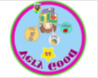  By the method of ‘COMPLIMENTS’  ‘excellent’  ‘well done’  ‘good job’  Formative assessmet | Cards  Blacboard  Picture  PPT  Slide  PPT  slide  PPT  Slide  https://youtube.com/watch?v=S8cGKZXUBIM&feature=share  Student book  Coloring pages  Worksheet
End the lesson | Reflection  Ask leaners how many new words about space they remember  Feedback – Three affective questions  What did you learn today?  What was easy/difficult?  What was the most interesting/boring thing for you today?  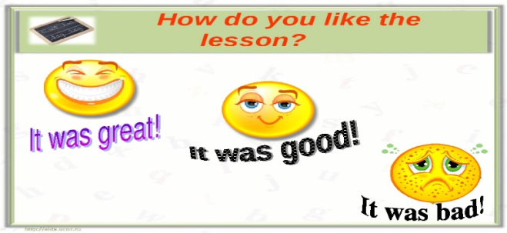  Excellent. You are very active today. Thank you for your attention  Home task:to learn the new words    Saying goodbye |  |  | answer to some questions to know how they understand the lesson. Pupils tell the class if they understand today’s lesson  If they don’t understand they write it to the stickers and leave it to class  Children sing a Good bye song |  | Self-assessment

