Approved:

Unit of a long term plan: Module 6: The Natural World

Teacher name: S.Abzalbekova

Date: 02.02.2023y
Grade: 8 |  | Number present: | absent:

Lesson title: Endangered animals
Learning objectives(s) that this lesson is contributing to | 8.1.1.1 use speaking and listening skills to solve problems creatively and cooperatively in groups  8.1.10.1 use talk or writing as a means of reflecting on and exploring a range of perspectives on the world  8.3.1.1 use formal and informal registers in their talk on a growing range of general and curricular topics  8.3.3.1 give an opinion at discourse level on a wide range of general and curricular topics  8.3.4.1 respond with some flexibility at both sentence and discourse level to unexpected comments on a range of general and curricular topics  8.3.5.1 interact with peers to negotiate, agree and organise priorities and plans for completing classroom tasks
Lesson objectives | Learners will be able to classify animals, answer the questions and prepare a poster how to protect endangered animals
Plan
Stages / Time | Teachers’ actions | Students’ actions | Assessment criteria | Resources
Beginning of the lesson  5 min.  Middle of the lesson  3 min  10 min  7 min  13 min  End of the lesson  5 min | «Brainstorming» method  • Revision of previous lessons materials with the help of the teacher. T asks different interesting questions about animals  -Now, children, look at the active board and let’s answer some interesting questions about animals.  1. Which is the largest animal on earth?  2. Can pandas swim?  3. What is the largest mammal?  4. How long do snow leopards live?  5. How much do rhinos weigh?  6. How long do sea turtles live?  7. Do great white sharks eat humans?  After that T introduces the aim and theme of the lesson.  -Now, children, let’s have a practice Exercise 3, p65  To present endangered animals  • Play the recording. Ss listen and repeat chorally.  • Check Ss’ pronunciation and intonation and then elicit the L1 equivalents from Ss around the class.  -Listen and repeat, say the words in your language.  Exercise 4, p65  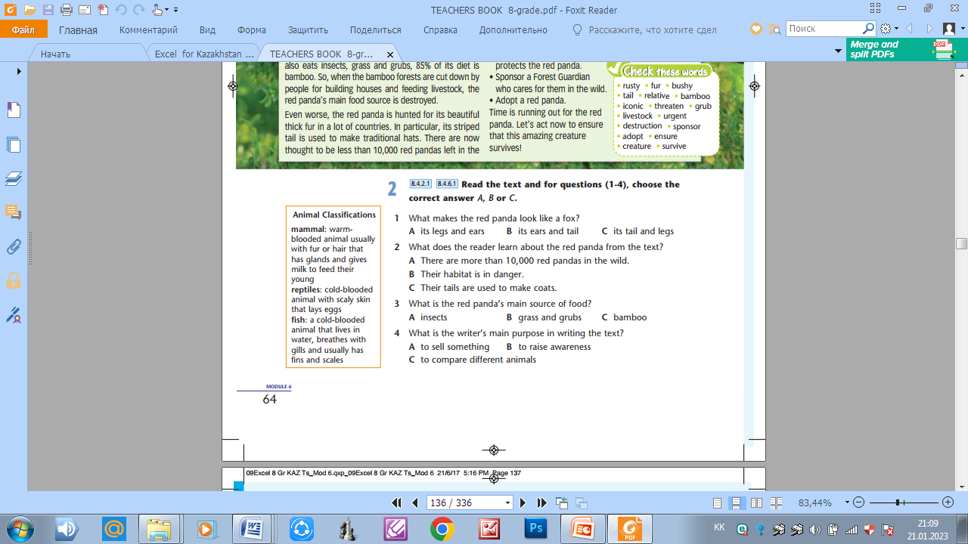  To classify animals  • Ask Ss to read the classifications in the box on p. 64 and explain /elicit the meanings of any unknown words.  -The next task is “Group work”.  -on the table some different pictures, come here and choose one picture.  -Good job! Let’s divide into 3 groups.  -Who has domestic animal pictures, they’re “domestic animal” group. The 2nd “wild animals”, the 3rd is “Fish” group.  Ex 4, p65  Then elicit which classification of animals each of the endangered species in Ex. 3  Aim:To present endangered animals and classify them  Efficiency:  Develop their reading and listening skills.  Exercise 6, p65. Prepositions  Complete the sentences. Use: to (x2), in, under, from.  Give the learners worksheets and then the groups do the task with their groups.  Aim:to present and practice prepositional phrases  Differentiation: practice method is used to assess Ss writing  Exercise 7, p65.  Read the theory, then form adjectives from the words in bold to complete the sentences.  To practice word formation (forming adjectives)  • Ask Ss to read the theory box and then explain the task.  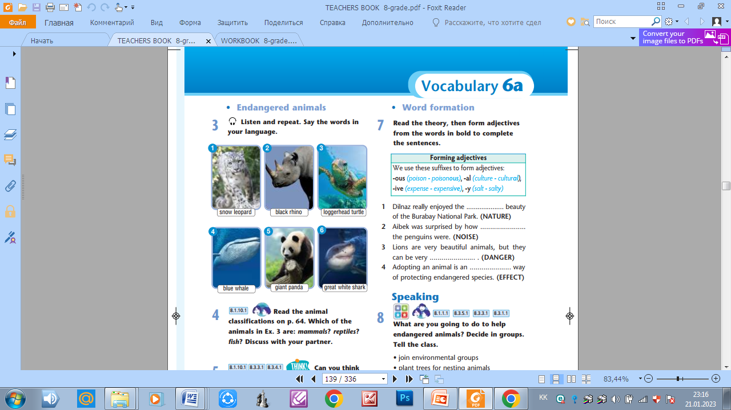  We can form adjectives from nouns by adding suffixes to a noun. Some adjectives can be identified by their endings.  Aim:to practice word formation (forming  adjectives)  Differentiation: practice method is used to assess Ss writing  Exercise 8, p65. Speaking  Ask Ss to work in small groups and discuss the ideas for helping endangered species.  - Can you think of other animals that need our help?  How can we help them?  Aim:to discuss ways to help endangered species, prepare a poster. | Ss give their possible answers.  Revise vocabulary connected with previous lesson  Aim:Revise the previous lessons material  Efficiency: Ss refresh their mind before starting new theme.  Descriptor:  -correct answers  Answer Key  1. The arctic whale  2. They’re good swimmers  3. Whale  4. as long as 21 years  5. 800 and 1400 kilograms  6. 20-25 years  7. They don’t eat humans.  Exercise 3, p65  Listen and repeat.  Snow leopard-қар барысы  Black rhino-қара мүйізтұмсық  Loggerhead turtle-тасбақа  Blue while-көк кит  Giant panda-алып панда  Great white shark-ірі ақ акула  Exercise 4, p65  Listen and repeat, then classify animals.  Descriptor:  - give correct answer  Each group prepares a poster and presents their posters whole class.  Answer Key  mammals: snow leopard, black rhino, blue whale, giant panda  reptile: loggerhead turtle  fish: great white shark  Exercise 6, p65.  Answer Key  1 from 2 to 3 under 4 in 5 to  Descriptor:  - choose the correct answer  Exercise 7, p65.  Read the theory, then form adjectives from the words in bold to complete the sentences.  - There are some fish and back of these fish written tasks. Choose one fish and do the task then read and put the fish in the aquarium.  Answer Key  1 natural  2 noisy  3 dangerous  4 effective  Descriptor:  - write answers correctly  Exercise 8, p65  What are you going to do to help endangered animals? Decide in groups. Tell the class  Descriptor:  - write sentences correctly  - convey the opinion clearly  Answer Key  Tigers need our help as well as gorillas,orangutans and chimpanzees. We need to protect these animals from hunters and protect their natural habitats.  We’re going to join an environmental group that protects tigers. We are going to write letters about threatened species to governments to make laws to stop hunting. We are going to learn about adopting endangered species. | Encourage Ss who answer the questions  Three claps  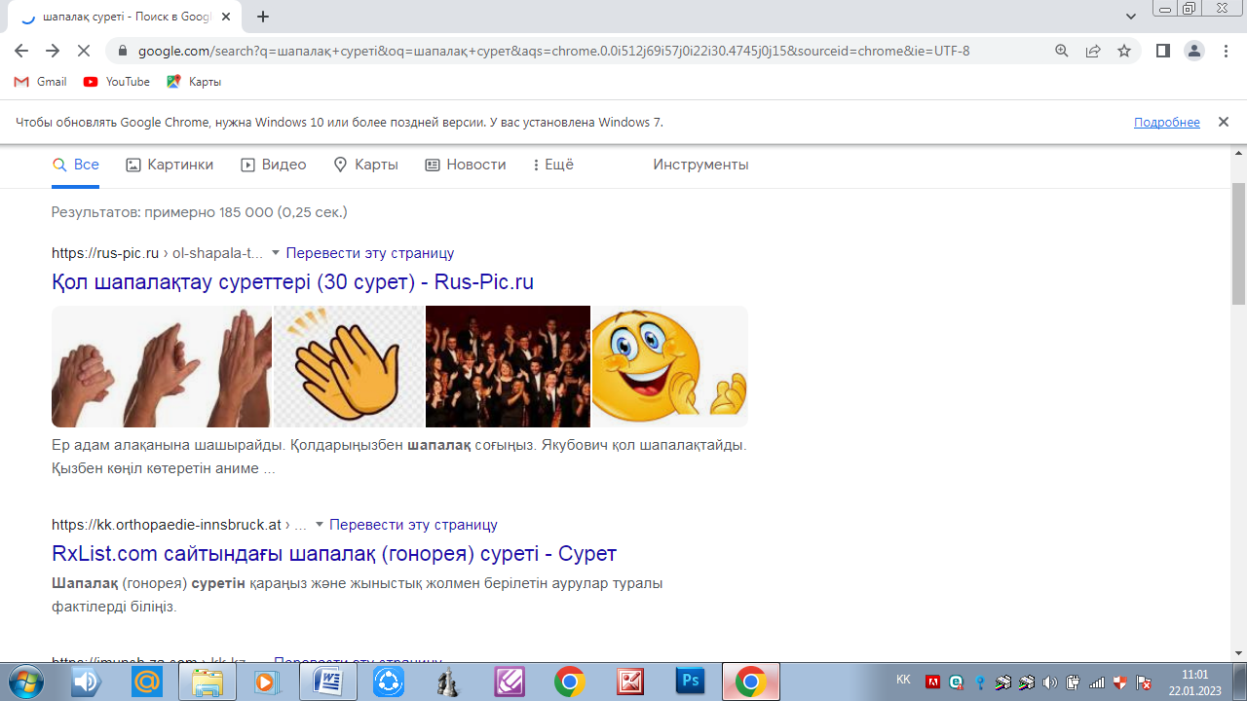  Oral assessment  “Good job!  Well done!”  Thumbs up, thumbs down  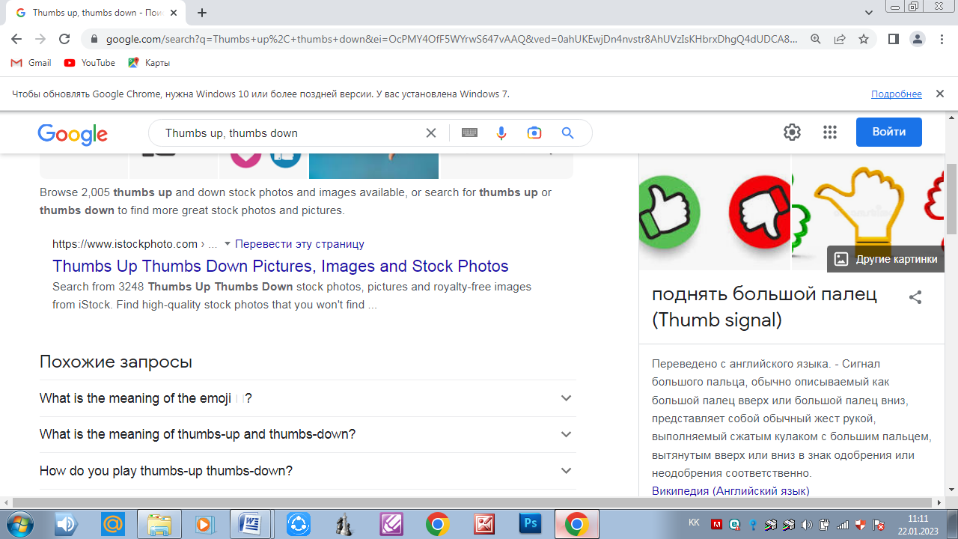  Smiley  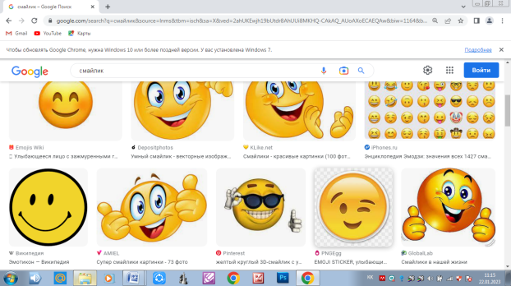  Teacher praises active Ss with phrases such as: “Good job!  Well done!”  Ss evaluate each other and encourage classmate with phrases like:  Well done! Brilliant! Good job! I like it! | Whiteboard  Slide 1  SB  Slide 2  CD Player  SB  Pictures  Posters  Slide 3  Slide 4  SB  Worksheets  Slide 5  SB  Slide 6,7  Fish  aquarium  SB  Slide 8
Feedback | “Finger” method is used to find out was the lesson clear or not. | Ss show their knowledge according to the lesson  5 fingers- I understood  4 fingers -I have some questions  3 fingers-I need a help  Aim: To know how many Ss got the theme  Efficiency:  Ss can use our fingers to show how much do they remember.  Differentiation:«Conclusion» method is used to finish the lesson. | “Finger”  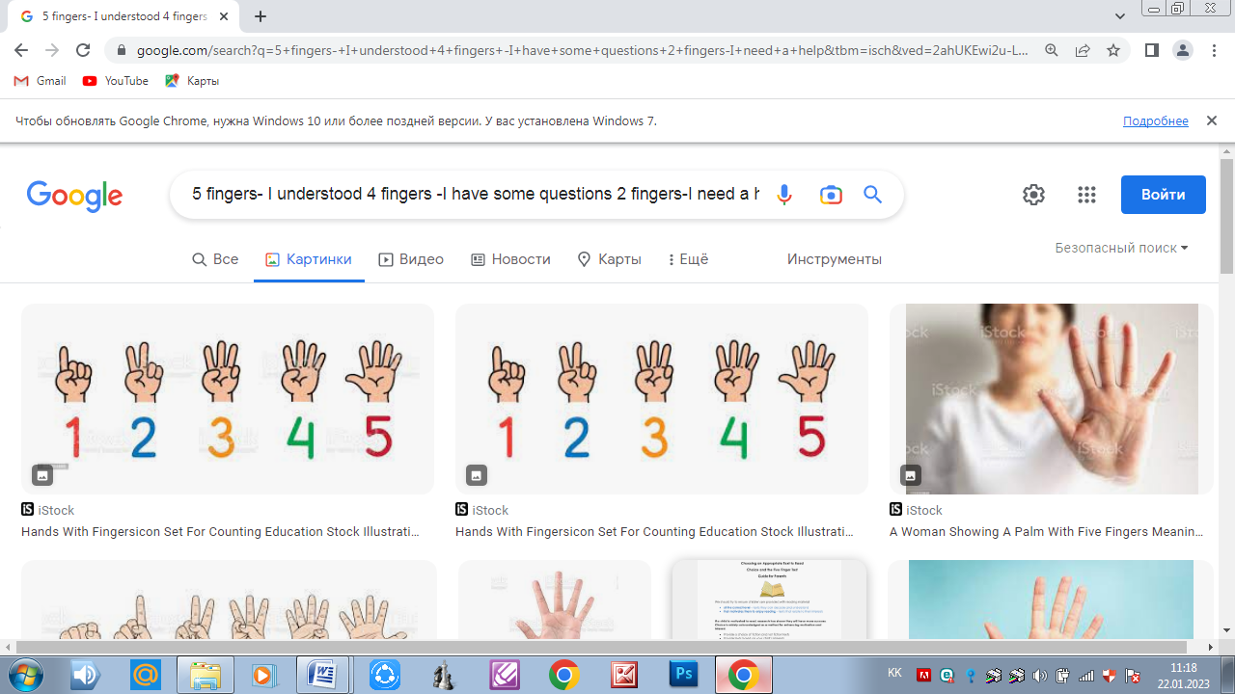 | SB  Slide 9

