"Aksuat College" communal state institution

Parts of a Automobile
(open lesson)

Prepared by: Lecturer of English language Kanafina E.S

2022-2023 teach year

Plan lesson

Date: 02.12.2022 year Group: 3«B» Lesson № 4
Subject name: Professional foreign language (English)
Part: 1. Common types of transportation- Жалпы транспорт түрлері
Lesson theme: Parts of a Automobile-Автокөліктің бөліктері
Lesson objectives
1. Knowledge: to pay attention to the pronunciation and correct spelling of new words in English, to learn to remember what you have seen, to describe based on visuals to express your own point of view.
2. Developmental: increasing the vocabulary, teaching the ability to exchange opinions with free expression of thought and speech, and formation of knowledge qualification.
3. Education: inculcating the morals of listening to each other's opinion in mutual respect.
Expected result: full mastery of the topic, ability to distinguish between sound and language features, ability to evaluate actions and work properly in a group.
Method: Answer questions

Resource:
Interactiveboard, notebook, pictures

Course of the lesson

№ | Сабақ кезеңдері  Lesson periods | Lecturer activity  Оқытушының іс-әрекеті | Student activity  Студент іс-әрекеті
1 | Greetings  2 minute | Establish a warm atmosphere «merry circle» | Students stand in a circle and wish each other
2 | Check homework  15 minute  a.Thinking | Our home task  Land Transport  Repeat new words | Repeat and recall new words  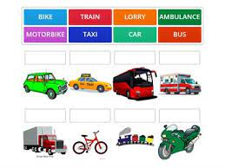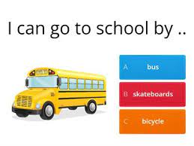  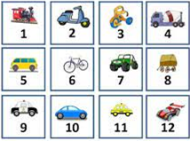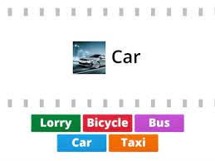  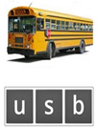
3 | A moment of refreshment.  3 minute | To renew the ticket of the teacher and studen- | Students will be refreshed
4 | Presentation of the new theme  20 minute  b.Thinking  minute | Our new theme «Parts of a Automobile» | Repeat new words one after the other  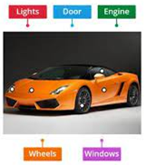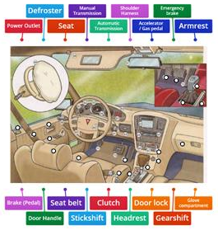
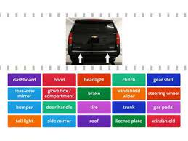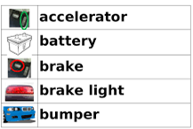
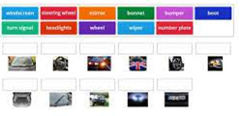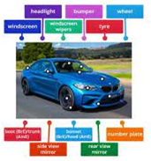
5 | Homework  5 minute | Repeat new words  Reflection | Repeat and recall new words  

