Қысқа мерзімді жоспар Lesson plan
Unit:9 - Reading for pleasure |  | School: Kenesary Khan №64
Teacher name: |  | Faizimuratkyzy Zhanar
Date: |  | 10.02.2023
Grade: 5 «ᴂ» |  | Number present: |  | absent:
Theme of the lesson: |  | Past simple: regular and irregular (p:107)
Learning objectives |  | - understand with little support specific information and detail in short, simple texts on a limited range of general and curricular topics;  - use simple past regular and irregular forms to describe routines, habits and states on a limited range of familiar general and curricular topics
Lesson objectives |  | All learners will be able to answer the questions according to the picture. Some learners will be able to give opinion according to the certain pictures and they use pair work.
Lesson structure
Planned timings | Teacher activities |  | Student activities |  | Ass | Resources
Beginning the lesson  10min | - Greeting.Organization moment  Class organisation  Teacher introduces learning and lesson objectives  Students write the date, day and lesson objectives into their copybooks  - Check home tasks  Home work: Kozy-Korpesh and Bayan-Sulu  Exercise 2 p.106 - read the text and write true or false.  This task will be presented as a formative assessment at the end they may check for their text comprehension using assessment criteria. (if they collect 6 score out of 8 they could manage this task and can be praised with a star).  - Bayan’s father was- Karabay. T/F  - Kozy and Bayan met when they were young. T/F  - Kodar was a farmer. T/F  - Karabay decided to give Bayan to Kozy. T/F  - Bayan didn’t love Kodar . T/F  - Kozy followed Bayan but he didn’t find her. T/F  - Kodar died in a river. T/F  - Bayan didn’t want to live without Kozy. T/F |  | Sts warm/greet the teacher  Read the text again and choose the correct true or false statements. |  |  | SB p:106  Picture  Plate T and F
 | New lesson  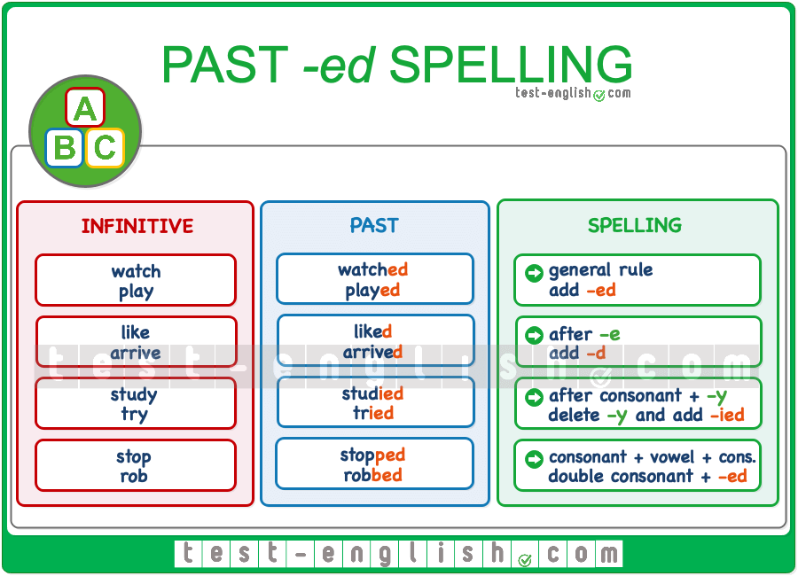 |  | Sts listen and repeat |  |  | Picture
Main Activities  30 min | Common irregular vebs  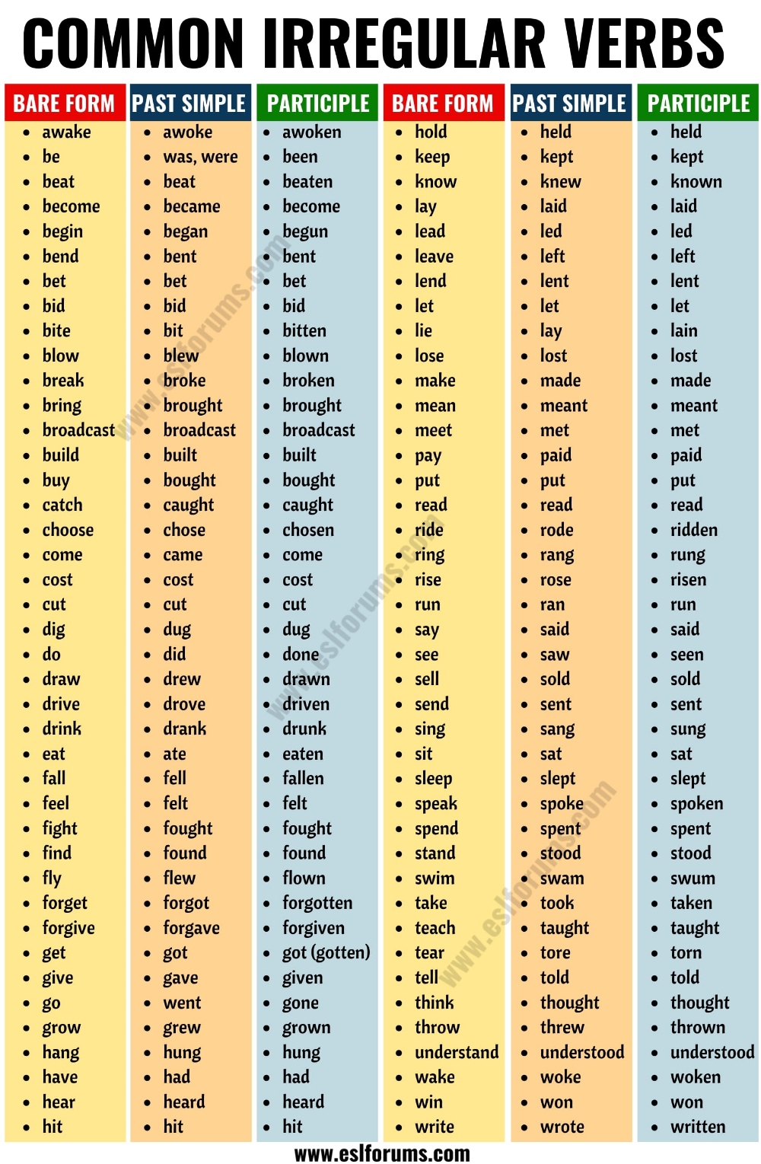  1 - task  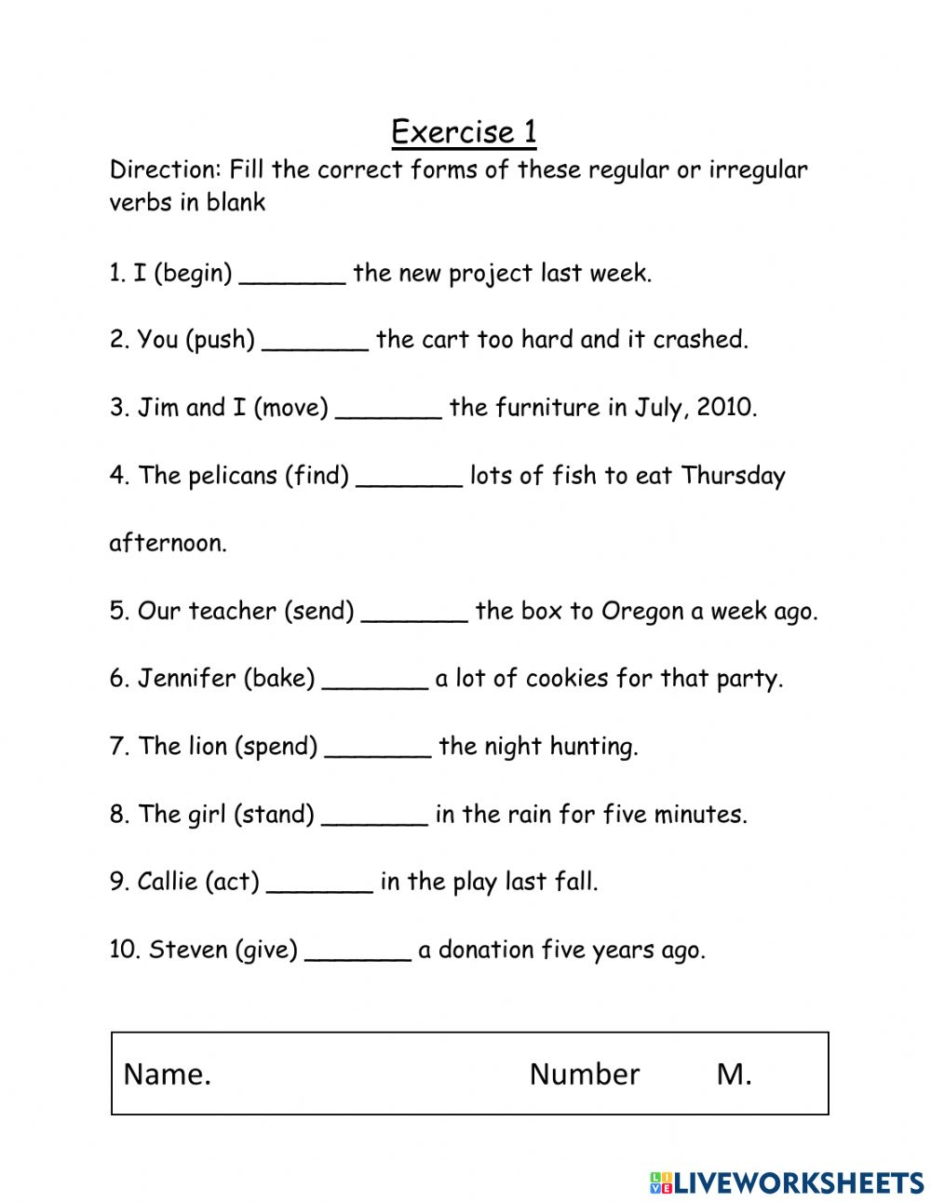 |  | Write the past simple of the verbs and learn their translations  Find the past simple forms in the text |  | 10 | Picture  S/B  A3 papers, glue and worksheets  SB p:107
 | 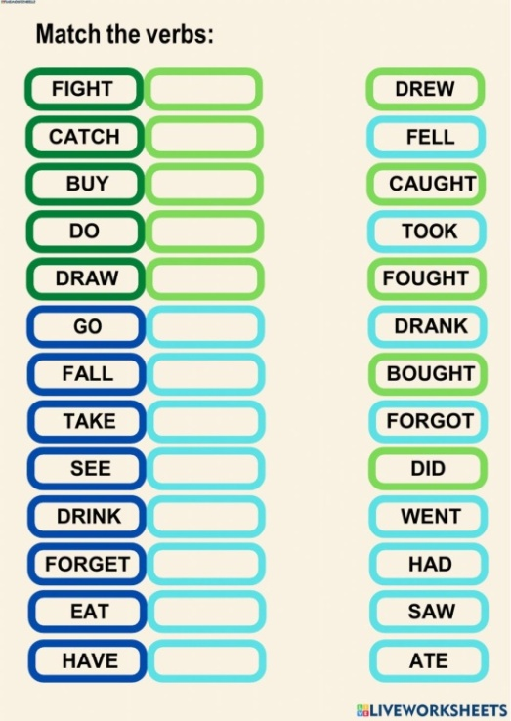  3 - task  2 - task  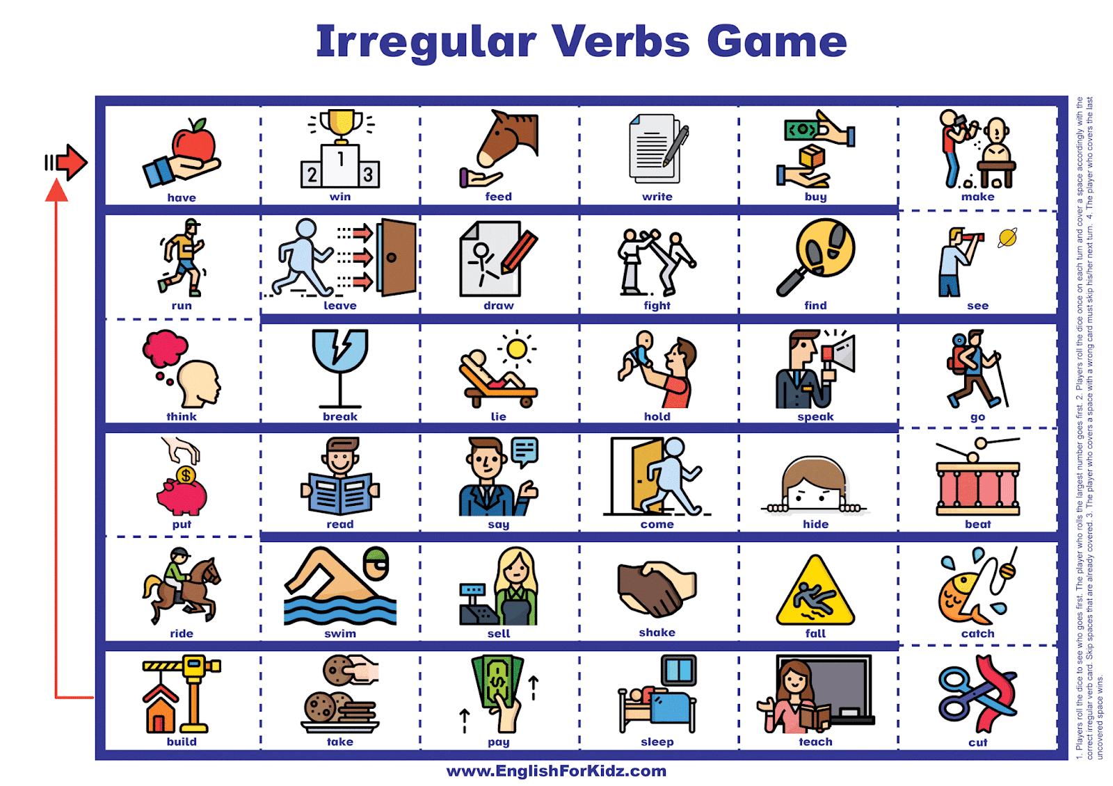 |  | Match the verbs  Board games |  | 10 | Paper  Pictures  Cube
Last 5min | 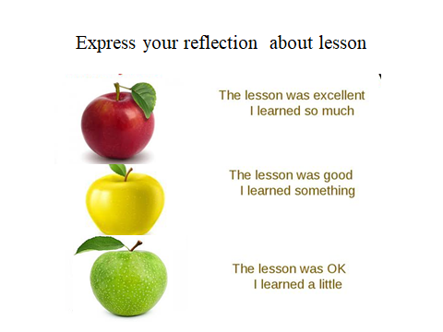    Feedback  Home task: Ex: 3page 107  Saying goodbye |  | Sts reflect the lesson |  |  | Pictures  Apple trees  Red bus

