Department of Education of Mangistau region
Department of Education in Zhanaozen
MSO "№7 comprehensive school"

OPEN LESSON The theme: I can/ I can’t
Grade 2 “V”

Done: Aitesheva Didar

2021-2022 year
LESSON 54. Unit : 7 |  |  | The natural environment
School: |  |  | №7
Teacher name: |  |  | Aitesheva Didar
Date: |  |  | 04.04.2022
Grade: 2 V |  |  | Number present: |  |  | Number absent:
Theme of the lesson: |  | I can/ I can’t
Learning objectives |  | 2.L4 recognise with support short basic questions relating to features such as colour and number  2.UE10 use common present continuous forms [positive, negative, question]  2.UE13 use can to talk about ability and to make requests and offers; use can / can’t to talk about permission  2.UE17 use me, too to give short answers
Lesson objectives |  | All learners will be able to:  name the main vocabulary words;  Most learners will be able to:  -write names and actions of animals;  -use them in their speech.  Some learners will be able to:  -say and all the words correctly;  -use them in their speech;  - complete all worksheets correctly.
Criteria |  | Learners have met this learning objective if they can:  -recognise spoken language slowly and distinctly;  - pronounce weather vocabulary words correctly  - say the names and actions of animals  - do most of tasks correctly.
Previous learning |  | Animals, chimp, bird, frog, fish
Plan
Planned timings | Planned activities |  |  | Learners’ activities | Evaluation |  | Resources
Begining  5 min | ORGANIZATIONAL MOMENT  Learners are introduced the LOs.  Checking of the hometask.  Brainstorming Activity  The song ''Hello''  Pupils make a circle, watch the video, listen to the song attentively and do actions.  Teacher asks them to take closed cards and look. If they take birds it will be the 1-rst group, if they take animals the 2-nd group. |  |  | Learners pretend themselves animals, go in front of the group and guess an animal.  Learners guess the topic of the lesson | Verbal evaluation |  | https://www.youtube.com/wаtch?v=bVCKj0T9-gc
Middle  35 min | 2.Presentation  Use the sounds to get learners to describe what they can hear.  You can remind them of simple animal names/ noises prior to the activity.  Listening to animal noises and writing down what the animals are doing e.g. That’s a bird singing.  (W) Listening and reading  New words  Drill them and have them on the board. These words learners will meet in their listening and reading tasks.  - Children, look at the blackboard and repeat after me all together :  - Can [ kᴂn] -істей алaды  - Can't[ kᴂnt] -істей алмайды  - jump [dʒΛmp]- секіру  - run [rΛn] - жүгіру  - fly [flaı]- ұшу  - climb [klaım]- жорғалау  - swim [swım]- жүзу  - walk [wƆ:k]-жүру  - hop [hop]- бір аяқпен секіру  - crawl [kro:l]-жорғалау  Ls are presented the new words/phrase:  1.What can monkeys do?  2. Monkeys can climb trees.  3. Monkeys can’t fly.  Ls tell what place should they put can. They complete the worksheet with tracing letters and tell (orally) what these animals can’t do.  Speaking. Look, read and complete. CAN/CAN’T  - I can climb.  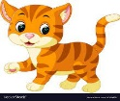 I can’t hop.  - I ______fly.   I _____ crawl.  I ______fly.  - 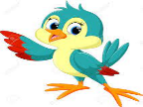 I ______climb.  I _____ sing.  - 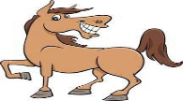 I _____ run.  3. Ph. Training  Learners listen to the song ‘  Sing and do  Mime and say: The pupils repeat after me.  I can jump,  I can run,  I can climb out in the sun!  I can jump,  I can run,  I can swim out in the sun!  4. Practice  (W) Reading speaking  Look at this picture and say what animals can do  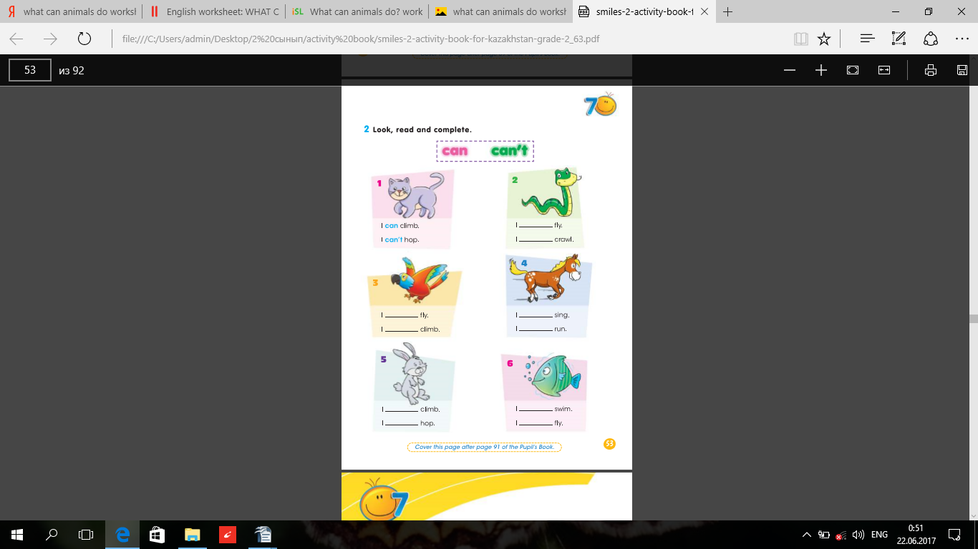  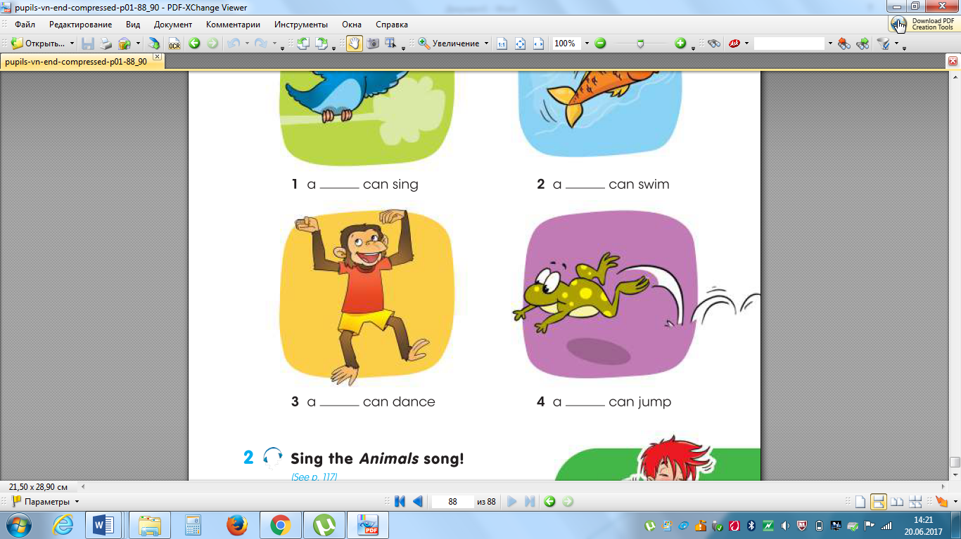  The bird can fly The frog can jump  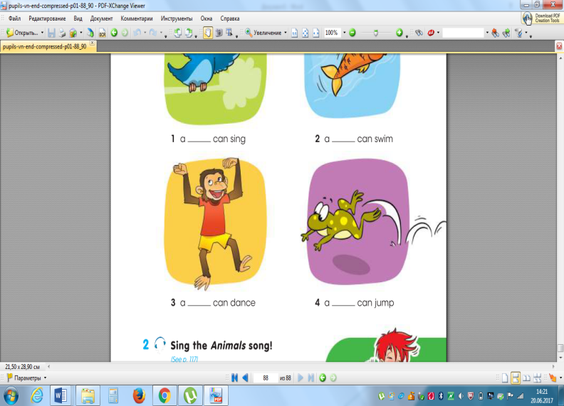  The fish can swim The chimp can dance  The cat can climb The horse can run  Formative assessment  (I) Reading and matching  Pupils must to read the sentences, match to the right picture and say what can she/he do.  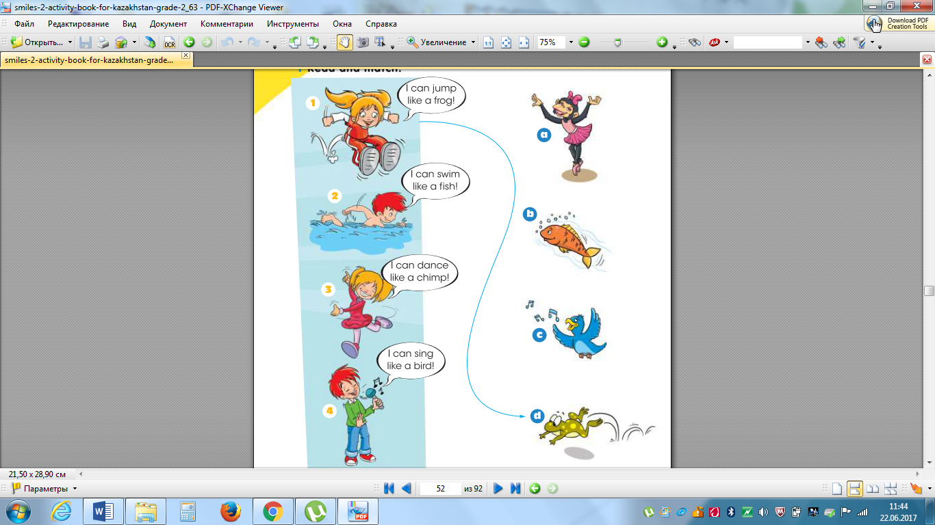  Example: I can jump like a frog (match the picture d).  (G) Speaking  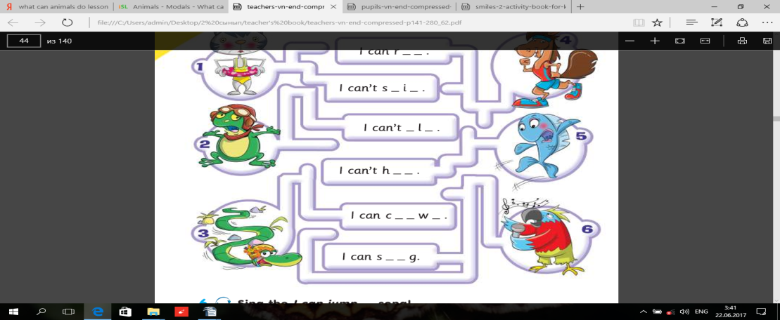  Follow the lines and complete. Play the guessing game  The groups take turns saying what animals can/can't do for the other group to guess the animal. Each correct guess wins a point. The group with the most points wins. To help the pupils you can write the animals and the action verbs on the board for the duration of the game.  WORDWALL. Doing exersices. I give two different tasks to two groups.  Task 1. Make sentences.  - sing./can/ I  - the tree?/chimp/Can/climb  - A/can’t/cat/fly etc.  Task 2. Randome wheel. Pupils circle the circle, and answer the question. |  |  | Learners listen to the sounds and guess animals.  Learners listen and pronounce  Learners ask and answer the question  Ls complete the worksheet | Mutual avaluation  Individual avaluation |  | Animal sounds activity  http://www.englishmedialab.com/cloze/animalsoundquiz/  Whiteboard  https://www.youtube.com/watch?v=EUtE02UpUB8  FA Worksheet 1  Video  Cards with a pictures of animals actions  PB. Ex 1,p, 52  Worksheet 2  Worksheet 3  P.B. Ex.5 p.90  Whiteboard
End  5 min | FEEDBACK  This might be done in oral form.  Learners reflect on their learning:  What has been learned  What remained unclear  What is necessary to work on  Evaluation of the lesson by means of oral feedback from students – thumbs up or down and why.      Teacher asks guiding questions to less able students such as:  - Can you name animals?  - Can you name their actions?  Home task: revise animals and actions vocabulary  Saying goodbye |  |  | Learners give feedback to each other. | Self-assessment

