Theme of the lesson: |  |  |  | Who is the best team?
School: |  |  |  | № 7
Teacher’s name: |  |  |  | Kairbaeva Zulfiya
Date: |  |  |  | 26.01.2023
5th grade |  |  |  | Number present: 12 |  | absent: 0
Learning objectives(s)  that this lesson is  contributing to |  | 5L5.1 - to stimulate the pupils interest, and their power of guessing and thinking in the foreign language  - to memorize and retain in memory the language material they learn  5S5.2 to develop skills and habits in reading, writing, speaking through different exercises
Lesson objectives |  | All learners will be able to:
 |  | - Recognise teacher’s instructions
 |  | Most learners will be able to:
 |  | - Find out about more new words
 |  | Some learners will be able to:
 |  | - Answer the questions and play the association game
Language objective |  | Learners can: understand the main points of the theme and respond to short, basic, supported and unsupported lesson instructions.
 |  | Key words and phrases:
 |  | New words of all units.
 |  | Useful classroom language for speaking/writing:
 |  | Speaking prompts:
 |  | Answer the questions.
 |  | Writing prompts:
 |  | To do exercises
The method of the lesson: |  | Competition game.
Previous learning |  | Revision
Value links |  | Hardwork is valuable
ICT skills |  | PPT, cards, pictures and etc.
Plan
Planned  timings |  | Planned activities (replace the notes below with your planned activities) |  |  |  |  | Resources
Start  Introduction  5 minutes |  | I. Organization moment.  Greeting  Explain the aims of the lesson.  Teacher:  Good afternoon, dear teachers, pupils and guests! You are welcome to our competition game which is named “Who is the best team?”. Today we will define the cleverest pupil and now I want to invite our participants. They are:  The 1st team: “Smart pupils”  The 2nd team: “Alpha pupils” |  |  |  |  | Interactive board
Warm up  Middle  5 minutes  Presentation  Practice  25 minutes |  | II. Starting the lesson.  I wish you good luck! Everyone will get a point for the correct answer in the competition and at the end of the party we will see who the cleverest pupil is!  And I want to introduce you with the members of jury:  1 ----------------------------------------------  2____________________________  3____________________________  4_____________________________  Now I will introduce you with the process of the game. Our game consists of 4 stages:  1. Dividing into two groups and doing exerises.  2. Individual work.  3. Physical drill-Jumping like cartoon.  4. Group work with method Tarsia.  I.Now let’s begin the competition! Our first stage is with the quizlet.com platform the ball is divided and the task is completed. At this stage you must answer my questions. At every correct answer you will get 10 points.  II.That is all. Now let’s count the points. Next stage: Individual work.  Cake method - students answer the questions on each part of the cake individually, 5 points for each correct answer.  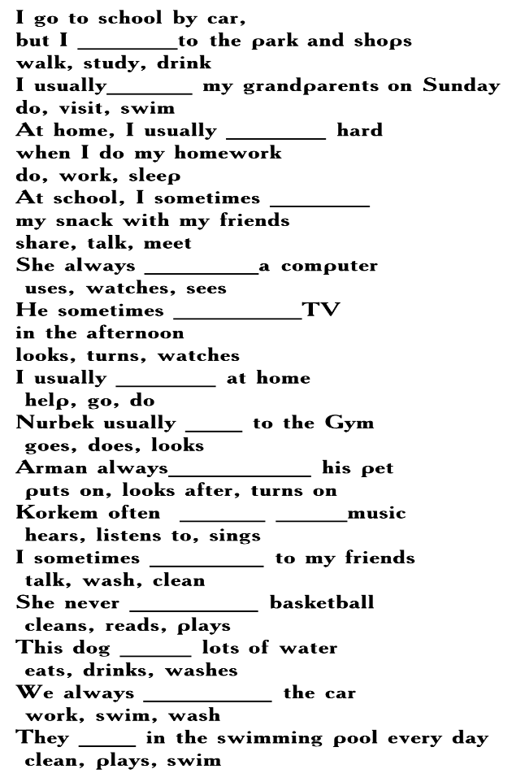  III.That’s all. Let’s count the points and now let’s begin our third stage which called Physical drill-Jumping like cartoon. In this game, if you give a task by jumping and answer correctly, you will get 5 points.  IV.Now we begin our fourth stage. Group work with method Tarsia.  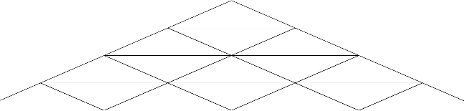  You will find the correct translation of the words. At every correct answer you will get 10 points. |  |  |  |  | Interactive board  PPT  Cake cards  Cartoon cards  Pyramid cards
End\5 minutes |  | Reflection. Revisit Learning Goals. Feedback.  Learners reflect on their learning:  - What has been learned  - What is necessary to work on  - What need practice once more?
Additional information
Differentiation – how do you  plan to give more support?  How do you plan to challenge  the more able learners? |  |  | Assessment – how are you  planning to check learners’  learning? |  | Cross-curricular links  Health and safety check  ICT links  Values links
- Create mixed ability pairs for speaking activity.  - Use TPR and Drilling for speaking activity. |  |  | “Excellent” “Very well” “Good” |  | - Sport  - Geography
Reflection  Were the lesson  objectives/learning  objectives realistic?  What did the  learners learn  today?  What was the  learning  atmosphere like?  Did my planned  differentiation work  well?  Did I stick to  timings? What  changes did I make  from my plan and  why? | Use the space below to reflect on your lesson. Answer the most relevant  questions from the box on the left about your lesson.
Summary evaluation
What two things went really well (consider both teaching and learning)?
1:
2:
What two things would have improved the lesson (consider both teaching and learning)?
1:
2:
What have I learned from this lesson about the class or individuals that will inform my next lesson?

