Unit: 9 | Holidays
Teacher name: | Bolashakova Assel, Gainiyeva Altynay
Date: | 06.06.2022
Grade: 5 | Number present: | Number absent:
Theme of the lesson: | Holiday activities
Learning objectives(s) that this lesson is contributing to | 5.4.1.1 understand the main points in a limited range of short simple texts on general and curricular topics  5.5.4.1 write with support a sequence of short sentences in a paragraph to give basic personal information
Lesson objectives | All learners will be able to recognize new vocabulary words  Most learners will be able to complete the table according to the text  Some learners will be able to write about holiday trip

Lesson plan
Plannedtimings | Teacher'sactions | Pupils` actions | Assessment | Resources
4  Minutes  4 min  3 min | ORGANISATION MOMENT:  Teacher greets students  Teacher: Good morning!  How are you?  Learners answer the question ‘How are you?’  Welcome to our English lesson  Ok, if you are ready let’s start our lesson  Before beginning our lesson let’s choose the list of papers and take a sit. Then we will make a plane with it paper and divide into groups according to the colour of the planes  Brainstorming  – It’s nearly the school holidays! Close your eyes for a moment and think about the summer holidays. Then write to the one wing of the plane the country where you dream to go.  - How do you think what about our new theme today? (about holiday)  MAIN PART  To start our new theme let’s watch this video  Very well my dears, this video was about holiday activities  Now if you have understood let’s make some exercises  Let’s learn by heart new words:  Go on holiday – демалысқа бару  Take photos – суретке түсу  Go to the beach – жағажайға бару  Stay with friend or family – досыңмен немесе отбасыңмен өткізу  Stay in a hotel – қонақ үйде тоқтау  Go sightseeing – көрікті жерлерді аралау  Go swimming – жүзу  Go for a walk – серуендеу  Rent a car – көлікті жалға алу  Travel around – саяхаттау  Have a good time – уақытты жақсы өткізу  To reinforce the new vocabulary we’ll play the game “Spinner”  Differentiation  Teacher helps to learners with translation  Writing task (G)  Teacher gives the text for each group, pupils watch video and read the text, then complete the table  for 1st group Nancy’s holiday  for 2nd group Jeff’s holiday  for 3rd group Bob and Liz’s holiday  Writing task (P)  Pupils read the linking words and fill the worksheet writing a crazy summer story | Students respond to greeting and take their places  They do the planes with papers  Pupils find their groups.  Pupils write the names of countries  Pupils answer the question  Pupils watch the video about holiday activities and repeat them  Pupils listen to the teacher an repeat after her/him and try to learn by heart today’s new words  While playing the game pupils give correct translation to the words which they choose  Task for the groups  Where did Nancy travel? Where did she stay? What did she do?  Where did Jeff travel? Where did he stay? What did he do?  Where did Bob and Liz travel? Where did they stay? What did they do?  Task for the pair work | Well done  Super  By the method of “CLAPPING HANDS” | List of papers  Planes  The internet  White board  PPT  White board  WordWall internet platform  Worksheet  Worksheet
2Minutes | ENDING THE LESSON:  FEEDBACK  To realize your dream where want to go you should pack your suitcase according to our today’s lesson  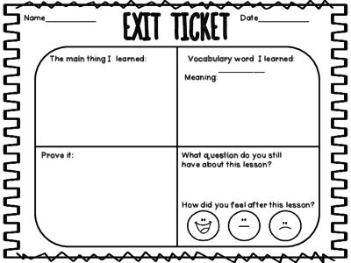  Evaluation  Give the home task  REFLECTION  To conclude our today’s lesson we should write wishes on the other wing of the plane and fly it | Pupils complete the table  Pupils write wishes | Feedback  Reflection | Cards  Plane

Where did Nancy travel? | Where did she stay? | What did she do?
Where did Jeff travel? | Where did he stay? | What did he do?
Where did Bob and Liz travel? | Where did they stay? | What did they do?

