**English around us**

The Organs of Speech and their work

«Do you speak English?» — this is the expression most often heard from people from different countries who are trying to find a "common" language. And when an affirmative "Yes" sounds in response, active communication begins between strangers.

Areas and directions in the world in which English is the only language for communication:

The world of Science — scientific conferences and discussion of global world problems, exchange of experience and important scientific information, writing scientific papers and papers;

Sphere of sports — all international sports competitions (Olympic Games, international starts, championships);

Travel - it is impossible to know the languages of all countries and peoples, but it is enough to know English to travel around the world without problems and communicate with representatives of other peoples;

Getting a job - knowledge of English will help you get the desired position in a large foreign company in any country faster and easier;

The field of education is to get a prestigious education in the best educational institutions in Europe and America.

The field of cinema and literature - English makes it easier to watch movies and read classical literature in the original.

Everyone is interested in something, and it is quite problematic to engage in your hobby and share your experience with the whole world without knowing English. Knowing the language of diplomats, you can enjoy the works of your favorite performers and clearly understand what the performer is singing about, and what emotions he is trying to convey to his fans.

During the scientific and practical conference of students in 2015, the following data were mentioned:

Almost 300 million Chinese study English (comparable to the US population);

In Japan, secondary school students have been learning English for 6 years;

In France, secondary school students are required to study foreign languages (German or English to choose from). Almost 85% of students prefer learning English;

In 90 countries of the world, English is the second state language, or is widely studied.

In Sweden, Norway and Denmark, English is a must to learn.

And another interesting fact about the relevance of the English language in the modern world. Among all European countries, excluding Great Britain and Ireland, the Netherlands ranks first in the number of people who speak English perfectly. In Portugal, students are offered a choice of learning English or French, and more and more students choose the former [9].

To classify the most commonly used Anglicisms in the speech of modern teenagers, we compiled a questionnaire "English around us" and conducted a survey of students in grades 8-11 and teachers of our school.

The analysis data allowed us to draw up a diagram of the use of Anglicisms in various spheres of life. The largest amount of borrowed vocabulary is related to the Internet (22%) and sports (21%). Household appliances and expressions used in everyday life accounted for 15% of all borrowings. Approximately the same number are words denoting professions (11%), as well as products and household goods (12%). The smallest number of words are related to clothing (4%).

The analysis of questionnaires showed that in everyday life students use the following words and expressions:

3.2 The Organs of Speech and their work.

In any language people speak (if they have no physical defects) using their organs of speech (Pic 1.)

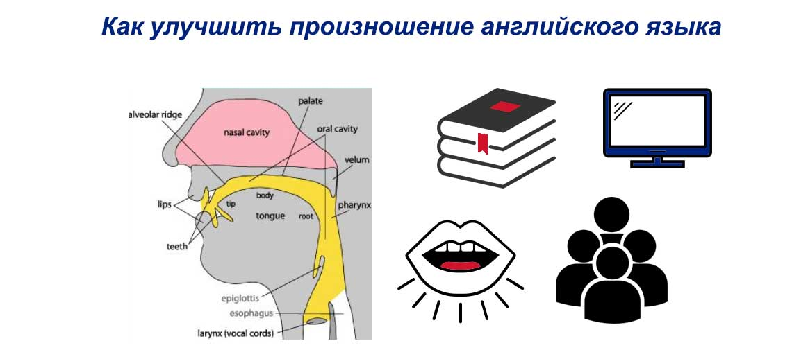

Picture 1.

The air stream released by the lungs goes through the windpipe and comes to the larynx, which contains the vocal cords. The vocal cords are two elastic folds which may be kept apart or brought together. The opening between them is called the g l o t t i s. this is the usual state of the vocal cords, when we breathe out. You will feel the vibration of the vocal cords and hear voice.

The most important organ of speech is the t o n g u e. phoneticians divide the tongue into four sections, the part which lies opposite the soft palate is called the f r o n t; the one lying under the teeth ridge is known as the b l a d e and its extremity the t i p.

All the organs of speech can be divided into two groups:

1. A c t i v e organs of speech, movable and taking an active part in the sound formation: a) the vocal cords which produce voice; b) the tongue which is the most flexible, movable organ; c) the lips affecting very considerably the shape of the mouth cavity; d) the soft palate with the uvula, directing the stream of air either to the mouth or to the nasal cavity; e) the back wall of the pharynx contracted for some sounds; f) the lower jaw which movement controls the gap between the teeth and also the disposition of the lips; g) the lungs providing air for sounds;
2. P a s s i v e organs of speech: a) the teeth; b) the teeth ridge; c) the hard palate; d) the walls of the resonators. (Pic. 2)

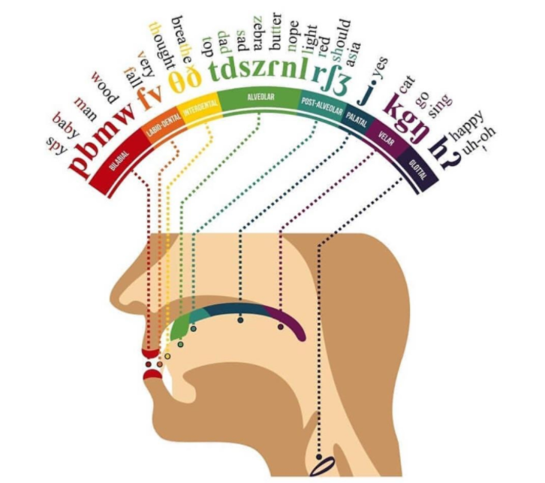

Picture 2.

This exercise is meant to develop the ability to obtain the volume of the voice without raising its pitch. Continue moving back and doing the exercise till you stand with your back against the wall. (Pic. 3.)

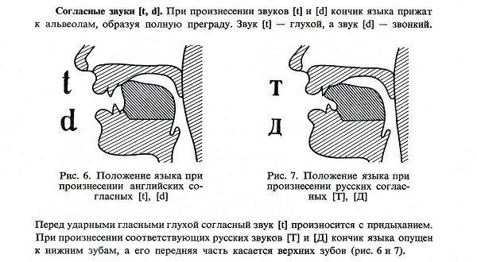

Picture 3.

**Task 1**. Read these phrases, replacing Russian sounds [c] and [з] with interdental English sounds [t] and [d].

* **З**еленая **з**мея **з**але**з**ла под **з**абор и **з**аснула.
* **С**иняя **с**иница **с**вистела-**с**вистела и **с**иганула в ле**с**.
* **З**има **з**аморо**з**ила **з**имовку и **з**аледенела **з**аимка.
* **С**то **с**орок **с**идели на **с**о**с**не и **с**опели в **с**опелки.

**Task 2.** Say Russian proverbs with an English accent:

* Коси коса пока роса.
* Мир тесен.
* Попытка не пытка.
* Мал золотник, да дорог.
* Как постелешь, так и поспишь.
* Нашла коса на камень.

**Task 3.** Say this verse:

2 Y’s U R

2 Y’s U B

I C U R

2 Y’s 4 me!

**Task 4.** Listen to the tongue twister and try to pronounce it as quickly as possible:

This is a rat from Manx. This rat is fat.

This is a cat from Manx. This cat is fat.

This fat cat from Manx likes fat rats.