Қазақстан Республикасы Оқу-ағарту министрлігі
Тараз қаласы №55 орта мектебі
Қысқа мерзімді жоспар

Unit of a long term plan:  Unit 4 Drama and comedy. Lesson plan 38 |  |  | School: 55 secondary school
Date: 6.12.2022 |  |  | Teacher's name: Tursinova G
CLASS: 6e |  |  | Number present: |  | absent:
Lesson title |  | Video Games
Learning objectives(s) |  | 6.S7 use appropriate subject-specific vocabulary and syntax to talk about a range of general topics, and some curricular topics  6.S4 respond with limited flexibility at sentence level to unexpected comments on an increasing range of general and curricular topics  6.R2 understand specific information and detail in texts on a growing range of familiar general and curricular topics, including some extended texts
Lesson objectives |  | All learners will be able to:  - Identify the theme, new words and use them as the basis for discussion.  - Demonstrate basic knowledge for usage of the Present Tenses.  - Transfer information from the given information into a graphic organizer.  - Offer constructive peer-feedback using rubric.  Most learners will be able to:  - Select, compile, and synthesize information for an oral presentation  - Provide a point of view in conversations and discussions;  Some learners will be able to:  - Respond to and discuss the reading passage using interpretive, evaluative and creative thinking skills.  - Make a presentation about a video game.
Plan
Planned timings | Teacher’s activities |  |  | Pupil’s activities |  | Marks | Resources
Start | Org.moment  - The teacher asks Sts. to look at the picture on p.46 and speak about this hobby.  - Learners are informed about the lesson objectives.  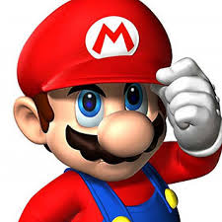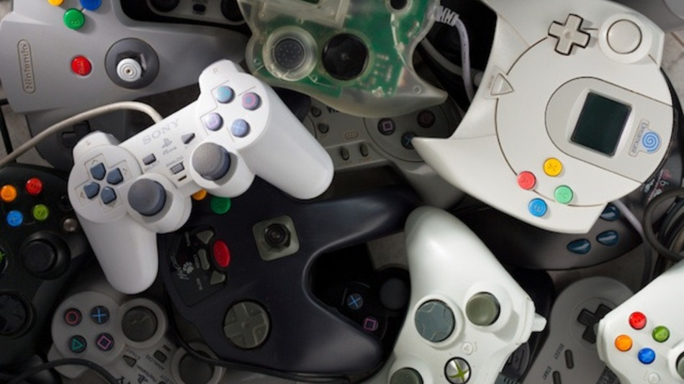 |  |  | Students respond to greeting |  | Emoticon  Formative assessment |  | Slide (useful phrases)  Pictures  PPT  Student's Book p.46
Main part | The main part of the lesson.  A video game is an electronic game that involves interaction with a user interface to generate visual feedback on a video device such as a TV screen or computer monitor  Do you play a video game? What games do you like to  play?  A teacher gives a short information about the first home video game.  Teenagers today often spend a great deal of time playing video games.  Advantages Disadvantages  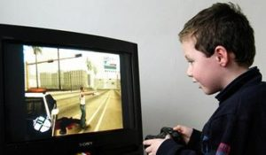  Video and computer games are the biggest addiction with most children but they develop the children’s decision making skills. ,  Video & computer games industry is one of the richest and growing industries in the world. The parents and teachers worry about the games having negative effects on the children. The games leading to violent behavior and addiction .  .  READING AND DISCUSSING THE TEXT" GAME ON".  While reading, complete gaps 1 - 4 with sentences.  Give headlines to each paragraph.  Ex.2 p.46 ( Listen and check).  Discuss the text using the method of " six hats".  Ex. 3 - 4 p.46  ( Optional Activity: Reading and language focus). |  |  | Ss complete the Venn diagram.  Ss read the text and translate and share with your own opinions |  | Emoticon  Formative assessment |  | Teacher's Book p.68  A table  Student Book  Student's Book p.46  Teacher's Book p.68
End | Home task.  WB p.36  Students express their attitude to the lesson and give self-assessment using the method: “Six thinking hats”:  - Green: How can you use today's learning in different subjects?  - Red: How do you feel about your work today?  - White: What have you leant today?  - Black: What were the weaknesses of your work?  - Blue: How much progress have you made in this lesson? (Now I can, I still need to work on, I've improved in, Today I learnt... )  - Yellow: What did you like about today's lesson? |  |  | Feedback  