Lort-term plan unit:  Unit 6. Entertainment and Media. |  |  | School: №4
Date: 7.02 |  |  | Teacher’s name: Senalova Kh.
Grade: 7th Ә |  |  | Number present:9 |  | absent:1
Theme: Film review
Learning objectives that this lesson is contributing to |  | 7. R3 understand the detail of an argument on a growing range of familiar general and curricular topics  7. S3 give an opinion at discourse level on a growing range of general and curricular topics  7. C1 use speaking and listening skills to solve problems creatively and cooperatively in groups.
Lesson objectives |  | All learners will be able to:  Identify 3-4 film genres, read and understand 2-3 film review.  Most learners will be able to:  Make a conversation to each other according to the topics  Some learners will be able to:  Briefly describe the content of the text
Criteria |  | - Student understands the detail of general and curricular topics, including some extended texts  - Gives an opinion about general and curricular topics  - Discusses some problems in small groups
Level of thinking |  | - Knowledge  - Understanding  - Application  - Analysis
Value links |  | Mengilik yel 6:  Common history, culture and language
Cross curricular links |  | Literature
ICT skills |  | pictures, active board, cards
Previous learning |  | Focusing on TV programmes and films
Plan
Planned timing | Planned activities |  |  | Resources
Beginning  3min | The teacher and students greet each other.  To create psychological atmosphere students will say to each other best wishes and compliments.  Dividing class into 2 groups by season when they born
Middle  5 min  2 min  6min  8 min  5min  1min  6min | Brainstorming  Each group will write types of films and TV programmes.  Online test (TV programmes)  FA: teacher manages and monitors learners’ knowledge  Lead-up:  Looking at the blackboard, students should guess the title of the lesson.  Can you guess what the title of our today’s lesson is? What are we going to speak about?  Teacher will say the lesson objectives.  Task 1. Matching  A BC level tasks(Individual work)  According to the level of students teacher gives tasks.  Descriptor:  students read the sentences and choose the right definition or a picture  Task 2. Reading an article or watching about films and mark T, F, DS.  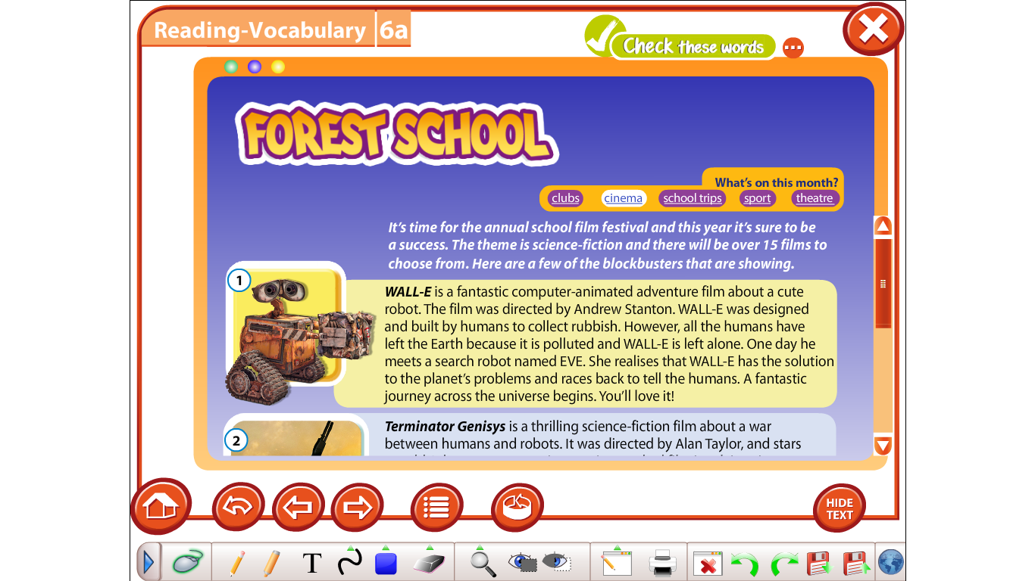  Descriptor: students read the sentences and choose the right answer True or False, DS  Task 3. Reading card game. (group work)  Students will read film review and find out it from picture cards.  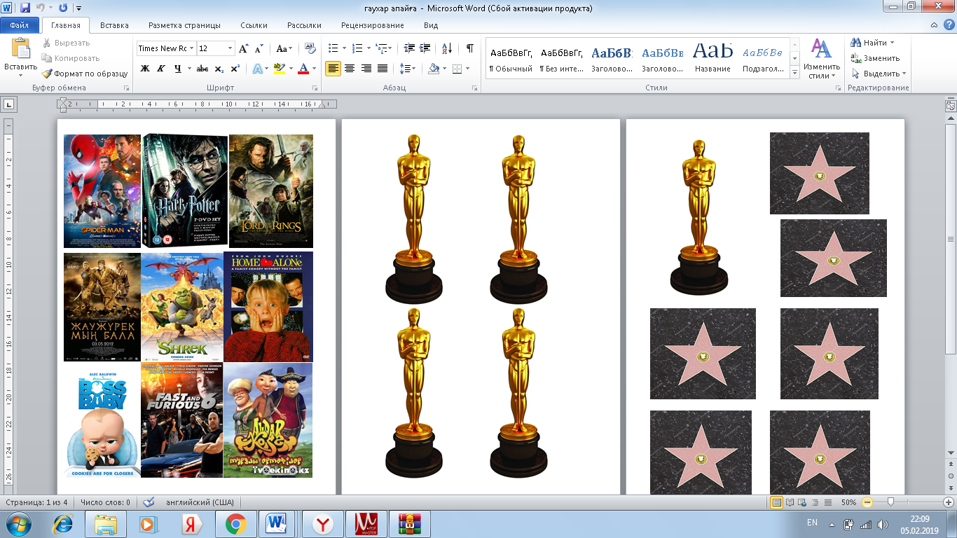  Descriptor  All learners will be able to:  Read, understand and guess 3-4 films  Most learners will be able to:  Read, understand and guess 5-6 films  Some learners will be able to:  Read, understand and guess 8-9 films  Warm-up. Let’s have a rest.  Task 4. Freeze frame (group work)  Task. You have 1 minute to create a Freeze frame, a photograph to capture the moment when all members of your group are watching  Criteria:  Use all body language signs and gestures!  Don’t forget about facial expression!  Don’t use any sounds and words!  Don’t move! |  |  | Cards  A3 poster  Smart board  Cards  Excel 7th grade  Cards  https://www.youtube.com/watch?v=UJUIns7ssqg
End  4min | Assessment  Teacher gives to the students assessment paper  Feedback “clapping hands”  -I understand everything (clap above your head)  -I have some questions. (clap in front of you)  - I don’t understand (clap below your knees)  Reflection  Students will write answers on the leaf and stick it on the tree  Name 1-2 things you have learned today  What activities were the most interesting?  What activities were the most challenging? |  |  | Assessment paper  stickers
Additional information
Differentiation – how do you plan to give more support? How do you plan to challenge the more able learners? |  | Assessment – how are you planning to check learners’ learning? | Health and safety check
Differentiationcan be achievedthroughtheselectionofactivities, identification of learning outcomes for a certain student, provision of individual support to learners,selection of learning materials and resources based on the individual abilities of leaners (Theory of Multiple Intelligences by Gardner). |  | Use this section to record the techniques that you will use to assess what the learners have learned during the lesson. | Health saving technologies.  Using physical exercises and active activities.  Rules from the Safety Rules book which can be appliedin this lesson.
Reflection  Were the lesson objectives/learning objectives realistic?  Did all the learners achieve the  lesson objectives/ learning objectives? If not, why?  Did my planned differentiation work well?  Did I stick to timings?  What changes did I make from my plan and why? | Use the space below to reflect on your lesson. Answer the most relevant questions from the box on the left about your lesson.
Summary evaluation
What two things went really well (consider both teaching and learning)?

1:

2:

What two things would have improved the lesson (consider both teaching and learning)?

1:

2:

