Қысқа мерзімді жоспар
Сабақтың тақырыбы: |  | Shapes and colors
Бөлім: | Unit:All about me
Педагогтың аты-жөні:
Күні:
Сынып: | Қатысқандар: |  |  |  | Қатыспағандар:
Сабақтың тақырыбы: |  | Shapes and colors
Оқу бағдарламасына сәйкес оқу мақсаты: | 2.L1 understand a range of short basic supported classroom instructions  2.L2 recognise with considerable support an increasing range of common personal questions  2.S2 ask questions in order to satisfy basic needs and find information on familiar topics and classroom routines
Сабақтың мақсаты: | Names new words, matches the words with pictures, makes sentences with using new words.Introduce yourself.
Сабақ барысы:
Сабақтың кезеңі: | Педагогтің іс-әрекеті |  | Оқушының іс-әрекеті |  |  | Бағалау | Ресурстар
Beginning  10 m | Teacher greets the learners: Speech drill.  Good morning, good morning,  Good morning to you.  Good morning, good morning  We are glad to see you  How are you today? |  | Students respond to the teacher |  |  | Orally  Good | Posters
 | Teacher asks students to revise the words from previous unit  Descriptor:  - Names the pictures [1]  - Matches the words with pictures[1]  - Spells the words [1] |  | Students revise the words from previous units  Ex: square, triangle, circle etc. |  |  | FA board – 3 points | Sheets of paper  Pictures
Middle  30 m  (IPW) | Teacher introduces students with new words on the topic “Shapes”  star  rectangle  triangle  circle |  | Students listen, point to the pictures and repeat the words.  Students repeat, chorally and/or individually. |  |  | Orally  Good  Well done | Sheets of paper  Posters  Pictures  Video
Teacher introduces students with new grammar theme
What is this?
This is circle.
 | Task 1  Teacher shows learners the pictures of weather and sheets with their names and asks students to match the pictures with the words.  Descriptor:  - Reads words clearly [1]  - Matches the words with the pictures [1] |  | Students read the words and matches them with the pictures |  |  | FA board – 2 points  Pair assessment | Sheets of paper
 | Task 2  Teacher give the cards and leaners write the name of shapes and color them  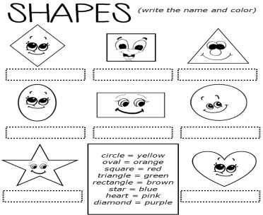  Descriptor:  - Identify at least 2 sentences [1]  - Identify all sentences[1] |  | Students write the name of shapes and color them |  |  | FA board – 2 points  Orally:  Well done!  Super!  Great! | Pictures of body parts  True /False cards
End  5 m | Teacher asks students to give feedback to each other. This might be done in oral form. |  | Learners reflect on their learning:  - What has been learned  - What remained unclear  What is necessary to work on |  |  | FA board
Home work | To learn by heart new words, write the words into copybook
Differentiation task | 