Short term plan

Before beginning, refer to your medium term plan. Your lesson plans should be developed from this, making any adjustments necessary in the light of recent teaching and learning.

Unit of a long term plan Unit 1. Animals |  | School: T. Zhanuzakov
Date: |  | Teacher name: Duisenbai A
Grade: 3 |  | Number present: 10 | absent:
The theme | Animal types
Learning objectives | 3.1.5.1 distinguish between phonemically distinct words;  3.2.1.1 make basic statements which provide personal information on a limited range of general topics;  3.5.14.1 use prepositions of location and position: in, near, behind, on, between describe where people and things.
Level of thinking skills | knowledge of comprehension, application
Lesson objectives | - to guess, point, and name what animal it is  - to describe their favorite animals using the vocabulary  - use prepositions to tell about the location

Stages / Time | Tasks, forms, Activities and methods of teaching | Teaching notes | Assessment | Resources
Beginning  5 min  Middle  30 min  5 min | Greeting & Objectives  New words.  with Grammar Preposition:  The cow in the Farmhouse.  The dog near the house.  The duck behind the house.  The cat on the trees.  The chicken between the trees and house.  Differentiation:  -Good for practical subjects where students may be working on the same task.  -Could be as simple as giving a number line to a group of students in English  -Allows all students to achieve & progress  Listen to text.  Context.  Text  My Farm house  Hello! My name is Lily. This is my grandmother’s farmhouse. There I saw so many animals they are so cute and funny. Let me introduce them. It's a dog Daisy. It is near the house. See, it is Charlie chicken. Charlie is between the trees and the house. And behind the chicken we see Duffy the chicken. And I love them all.  Content.  Concept Checking Questions.  1. Is Grandma Lily's farmhouse? Yes, it is Grandma Lily’s farmhouse.  2. Is cow’s naming Daisy? Yes, cow’s name Daisy.  3. Is dog near the house? Yes, dog near the house.  4. Is chicken’s naming Charlie? Yes, chicken’s name Charlie.  Restate “Yes”  1. Is dog’s naming Daisy? No, isn’t.  2. Is cow near the house? No, isn’t.  3. Is chicken next to the trees? No, isn’t.  4. Isn’t Lily love animals? No, isn’t.  Restate “No”.  Task. “Word Fill” method.  Fill in the missing words can include the words underneath in the wrong order of course -for differentiation.  - The dog near the house.  - The cow in the Farmhouse.  - The chicken between the trees and house  - The cat on the trees.  Differentiation:  -Allows all students to make progress  -Promotes engagement  -Can tailor lessons to the strengths of individuals  Descriptor:  Put the name of the animals with prepositions  Divided into two group: Method of “Puzzle”  Game: “Say me answer!”  In this game, students choose two group leaders and place them on the board, the rest of the students sit down and show the group leader where the animals are, and the group leader says a sentence.  For example: The cat in the house. | The teacher greets the students  I will show pictures according the theme using pictures.  I teach prepositions with new words.  Teacher shows total physical respond TPR  Pre-listening with audio.  The text is displayed with a picture.  I teach the text to students through pictures  I say and show the preposition in the text  Planning activity prior knowledge of students.  Ask questions using preposition  Students will be asked a text-related concept checking question  Pre-Listening.  Teacher understand the pupils tasks  Students are given a task using the “Word Fill” method.  In the task, students should place a picture of an animal in the appropriate place, using a preposition.  Teacher support: Pre-prepared sentences are given.  Task about the new words and preposition  Teacher support is demonstrated by saying a sentence and acting as an example.  In this game, students select group leaders from two groups and place them on the board. The rest of the students show the sentence to the group leader in action and the group leader says the action in sentence.  Pre-speaking (pair work)  Divide students into two groups using the puzzle method, play an interesting game on the topic as a confirmation of the lesson. | Self- assessment  Verbal  Evaluation  Individual evaluation  Mutual evaluation | ICT  Audio  Didactic material  Book “Smile”  Jenny Dooley, Series Consultant: Bob Obee, Translations by N. Mukhamedjanova  Сards
The end of the lesson 5 min | The conclusion:  Feedback  “Positive Feedback”:  Not bad  I like it  Excellent  Home task: Draw picture domestic animals with preposition.  Saying goodbye | Teacher gives feedback for attend the lesson.  Reflection:  The teacher give 3 colour stickers and put the trees  Green colour: I understand.  Yellow colour: I understand little.  Red colour: I don’t understand. | Self-assessment

Pictures: News words with preposition | 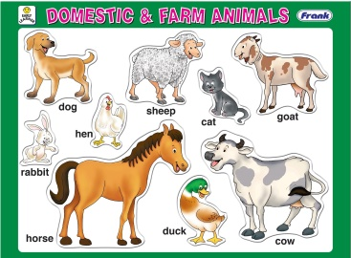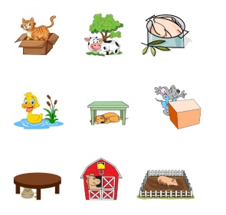
Listen to text.  Context. | Text  My 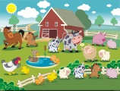  Hello! My name is Lily 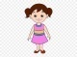This is my  farmhouse. There I saw so many 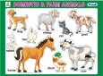 they are so cute and funny. Let me introduce them. It's a  Daisy. It is near the . See, it is Charlie 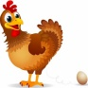 . Charlie is between the trees and the . And next to the 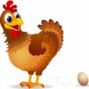 we see Duffy the . And I love them all.
Task 1. “Word Fill” method. Put each animal in the right box  Picture prepositions places. | 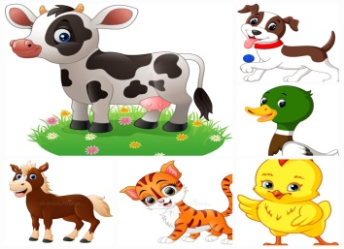  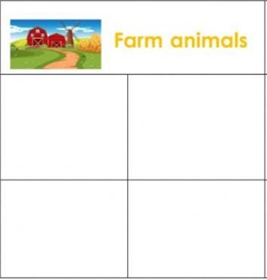
   | 
   | 

Divided into two groups: Method of “Puzzle”.  “Positive Feedback” | 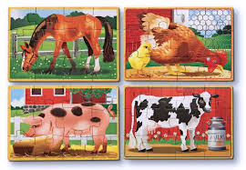  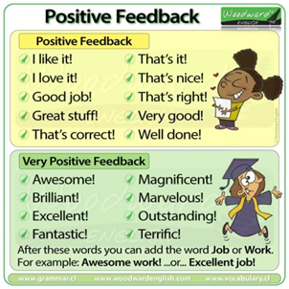
Positive feedback | 