Қазақстан Республикасының Білім және ғылым министрлігі
School №204 after I.Altynsarin
(білім беру ұйымының атауы)
Қысқа мерзімді (сабақ) жоспары
Parks around the world
(сабақтың тақырыбы)
Бөлім: | Module 6 Travel and holidays
Педагогтің Т.А.Ә. (болған жағдайда) | Bozayeva A.
Күні: | 22.02.2022
Сынып: 6 B | Қатысушылар саны: 11 | Қатыспағандар саны:
Сабақтың тақырыбы | Parks around the world
Оқу бағдарламасына сәйкес оқыту мақсаттары | 6.2.8.1- understand supported narratives including some extended talk, on a range of general and curricular topics  6.1.6.1- organize and present information clearly to others  6.5.7.1- use with some support appropriate layout at text level for a growing range of written genres on familiar general topics and some curricular topics;
Сабақтың мақсаты | All learners will be able to:  use some language from the module to express views and write some relevant questions accurately  Most learners will be able to:  use a range of language from the module to express views and write a range of relevant questions accurately  Some learners will be able to:  use a wide range of language from the module to express views and write a range of relevant questions accurately
Сабақтың барысы
Сабақтың кезеңі/ уақыт | Педагогтің әрекеті | Оқушының әрекеті | Бағалау | Ресурстар
Beginning of the lesson | Organization moment  Teacher greets students; students respond to greeting and take their places.  To check the home task  Students change notebooks and check works of their partners  Draw Ss’ attention to the pictures and ask what they see. Ss to say which subject is shown in each picture.  Ss’ should begin with “I see…”  Regrouping : students are divided into two groups with the help of parts of cards from the picture. Each of them take one card and they complete the full picture. At the end they should form 2 groups.  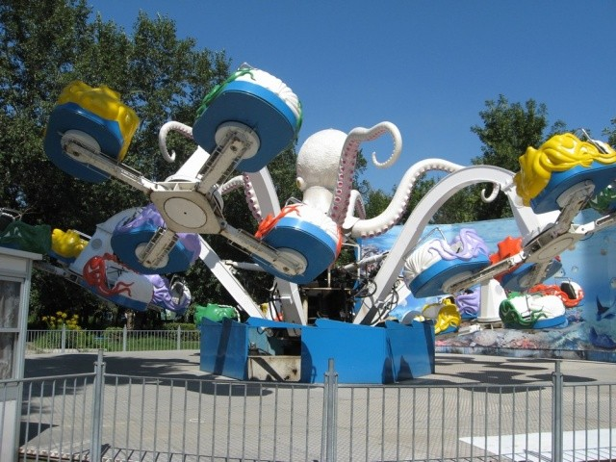  1st group – Attraction  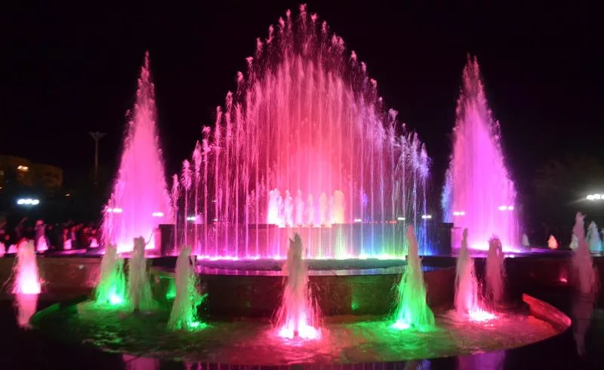  2nd group - Fountain | (Ss’ own answers)  (Ss’ own answers) | Emotions  Verbal evaluation | Presentation  Handouts with task
Main activirties | New vocabulary  Amusement park – ойын-сауық саябағы  Arrangement – уағдаластық  Attraction – аттракцион  Fairground – жәрменке алаңы  Hidden – жасырылған  Landmark – көрікті жерлер  Light up – жану, тұтану  Miniature – шағын  Ride – қыдыру  Tiny – кіп-кішкентай  Treasure – қазына  Task 1.To introduce the topic and predict the content of a text  Direct Ss’ attention to the pictures and the title and elicit guesses to the question in the rubric.  Play the recording. Ss listen and follow the text in their books and check.  Ask Ss to look up the meanings of the words in the  Check these words box in the Word List.  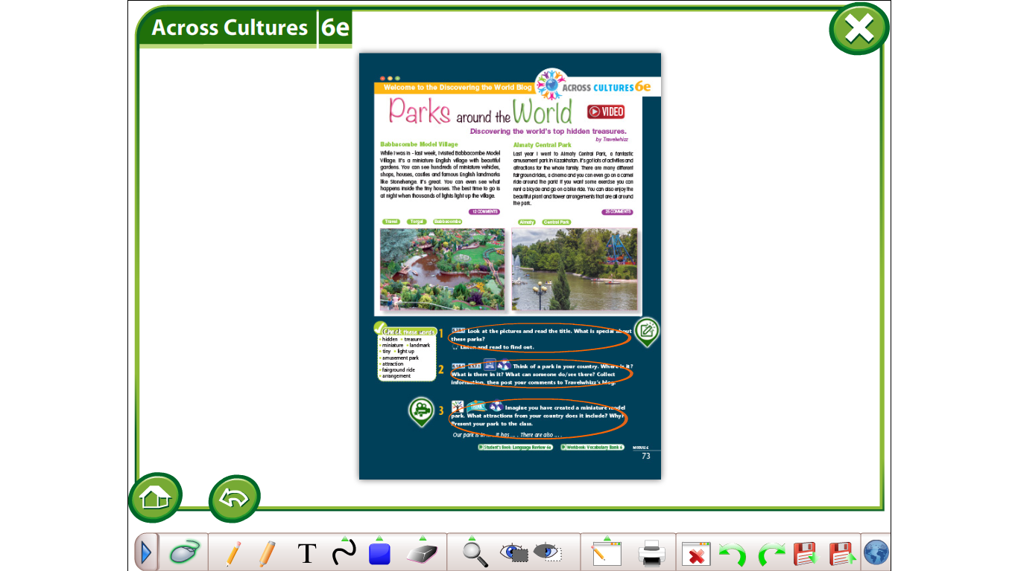  Task 2. Mark the following statements with a B(Babbacombe) or A(Almaty)  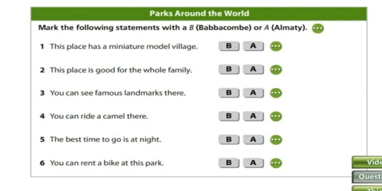  Task 3. To read for specific information  Give Ss time to read the text and complete the sentences with the given words. Check Ss’ answers around the class.  Babbocombe Model Village  While I was in – last week, I visited Babbacombe Model Village. It’s a miniature English village with beautiful gardens. You can see hundreds of miniature 1)__________, shops, houses, castles and famous English 2)__________ like Stonehenge. It’s great. You can even see what happens inside the 3)_________houses. The best time to go is at night when thousands of lights light up the village.  Almaty Central Park.  Last year I went to Almaty Central Park, a fantastic 1)__________park in Kazakhstan. It’s got lot;s of activities and attractions for the whole family. There are many different fairground 2)__________, a cinema and you can even go on a camel ride a bicycle and go on a bike ride. You can also enjoy beautiful plant and flower arrangements that are all 3)_________the park.  Task 4 Learners write a cinquain poem about world.  “Cinquain”  1. World  2. two adjectives  3. three verbs  4. one sentence  5. synonym | (Ss’listen and repeat chorally new vocabulary)  Students complete the information.  Ss ’ complete the task  Ss ’ complete the sentences | Emotions  Individual  evaluation | https://youtu.be/MD8a1lZclKM  https://youtu.be/1Do6Ex838ws
Ending the lesson | Reflection:  Learners are given sticky papers to write their opinion on the lesson  Hometask  To write about a park in your country  Find and write information about a park in their country. | Learners write their opinion on the lesson | Self-assessment | https://youtu.be/hdcTmpvDO0I

