Unit 5: Art&Music |  |  | School:Maibalyk secondary school
Date: 17.11.2022 |  |  | Teacher name:Gabdulina Zarina Serikbaevna
Grade: 3 |  |  | Number present: |  |  | Number absent:
Theme of the lesson: |  | Drawing chairs
Learning objectives |  | 3.1.3.1 understand the main points of short, slow, carefully articulated talk on a limited range of general and some curricular topics;  3.3.4.1 use with some support a simple picture dictionary;
Lesson objectives |  | All learners will be able to:  -revise the names of musical instruments  -practice topic related vocabulary  -do the puzzle  Most learners will be able to:  -answer the question  -read the description  Some learners will be able to:  -to do different tasks  -describe the picture
Criteria |  | - participate actively in discussion;t  - talk about warm and cool coloursusing given vocabulary  - complete most of tasks correctly about warm and cool colours
Previouslearning |  | Art and Music
Lesson plan
Plannedtimings | Teacher’s action |  |  | Pupil’saction | Assessment |  | Resources
Begining  3m  2m  3m  4m | I.Organization moment.  Greeting.  -Good afternoon!  -How are you?  -Ok! Sit down!  -Who is on duty today?  -Who is absent today?  -What weather like today?  -Well, Sit down!  -What date is it today?  What day is it today?  II. Phonetic drill  -Now, stand up all of you! And repeat the words and actions after me!  It’s time to think,  It’s time to speak,  It’s time to show,  Ready, study, go.  -Very well!  -Are you ready to start our English lesson?  Evaluate:  -Today I’ll evaluate you for each correct answer,  you’ll get different coloured circles.  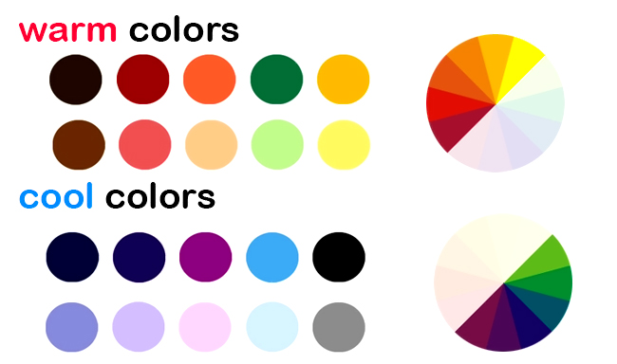    Divide into the groups:  -I’ll divide you into two groups. Children, I have different coloured pencils. You’ll choose one of pencil.  -Ok! What colour is it?  -Yes, It’s a red, a blue, a yellow …  If you chose red, yellow, orange, pink, brown, light red, you sit in the group of warm colours.  If you chose blue, purple, green, dark green, dark blue, you sit in the group of cool colours.  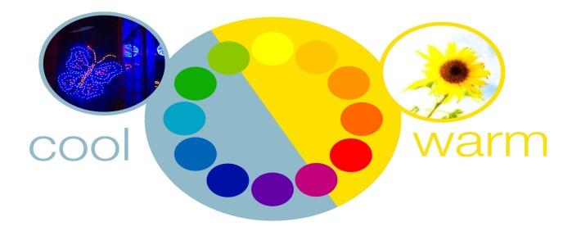  III. Check-up the home task:  “Wonderful circle” method  -Now, I’ll spin the drum. The drum is spinning if it gets into any name it will choose an envelope. And answer the question.  -Have you understood me?  1. пианино 4. гитара  2. домбыра 5. барабан  3. скрипка 6. саксофон |  |  | Pupils respond the greeting and take their places  Pupils repeat phonetic drill after teacher.  Pupils divide into two groups.  Pupils choose the envelope and answer the question.  Answer key:  Piano, dombra, violin, guitar, drum, saxophone | With wordsExcellent / Very good / Right.  With coloured circle |  | ppt  Coloured circles  coloured pencils, group’s names  ppt  https://ru.piliapp.com/random/wheel/  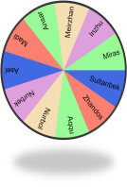
Middle  5 m  3 m  5 m  2 m  5 m  7 m | Main Part  IV. New theme.  -Children, look at the interactive board.  -What is it?  -Yes, it’s chair.  -What colour is it?  -Is it a big or a small?  -Excellent!  -Our new theme is “Drawing chairs”.  -Open your copybooks and write the topic.  -You will be able to :  -to know about warm and cool colours  -to do group, couple and individually tasks.  Explain the topic:  -What are the cool and warmcolours?  The colour may be warm colours and cool colours.  Cool colours is in Kazakh “қою түстер”and warm colour is in Kazakh “жылы түстер”.  Warm colours are red, orange, yellow, pink, brown.  Cool colours are blue, green, purple.  New words:  -Now, look at the new words and repeat after me!  draw – [drɔː] – суретсалу  colour – [ˈkʌlə] – түс  pencil – [ˈpɛnsl] – қарындаш  paint – [peɪnt] – бояу  Task:1. Writing.  Complete the sentences with the words in the box.  sun, favourite, blue, brown, t-shirt  - My ___________colour is black.  - Warm colours relate to the _______.  - Cool colour is ________.  - Aset wears red ________.  - Bear’s colour is ________.  Refreshing moment:  -Stand up all of you! Now, let’s dance the song “aram-zam-zam”  Task:2. Work with group.  -Our next task is to work with your group members.  “Puzzle” method  -I’ll give you puzzle. You should do the puzzle and paint group name’s colours.  For example, Warm colour’s group should paint red, yellow, brown, orange or pink.  Cool colour’s group should paint blue, green, purple or dark blue.  Task:3. Reading. Couple work.  -Now, you should work with your neighbour.  “Picture description” method.  -Read the description. And match chairs according to the description.  1. This seat has got four legs, two arms and a back. It is long. Many people can sit on it.  2. This seat has a long back. It is for an importantperson, like a king.  3. This seat has got four legs, a back and small table. This chair is for a child to help him/her eat  4. This seat hasn’t got a back or arms, but it has gotthree or four legs.  5. This seat is for one person. It is very comfortable and soft.  It has 4 legs, 2 arms and a back.  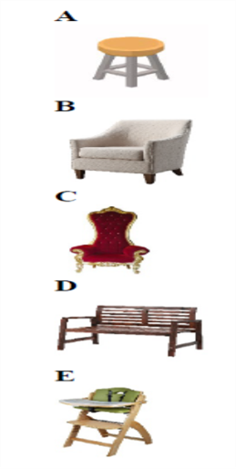 |  |  | Pupils answer the question and write the topic in their copybook.  Pupils repeat new words after teacher and write in their dictionary copybook.  Pupils complete the sentence with the words in the box.  Answer key:  1.favourite  2.Sun  3.blue  4. t-shirt  5.brown  Pupils dance the song “aram-zam-zam”  Pupils work with their group members. And do the puzzle then paint the picture.  Pupils work with their neighbour. Read the description. And match chairs according to the description.  1.D  2. C  3. E  4. A  5. B | Verbal evaluation  With words Excellent / Very well / Right.  With coloured circle  With words Excellent / Very well / Right.  With coloured circle  With coloured circle |  | Ppt  Chairs’s picture,  warm and cool colours picture  Dictionary copy book  Ppt  https://youtu.be/wXU9KHKB47w  two puzzles, coloured pencils,  Different chairs pictures
End  3 m  3 m | V. Conclusion.  “Rainbow” method  -I’ll give you stickers, you should write your opinion about today’s lesson. Then put your stickers on the rainbow.    VI. Marking.  -Children, how many circles have you got?  VII. Home work.  -Your home work is to learn by heart new words  The lesson is over! Good Bye! |  |  | Pupils should write their opinion about today’s lesson.  Pupils count their circles. | Feedback |  | Stickers,  Rainbow’s picture

