«БЕКІТЕМІН» «Тексерілді»
Мектеп директоры м.у.а Оқу ісі меңгерушісі
___________Н.Айтмуханов ____________Б.Избергенова
«__» _____________2022жыл «___» ____________2022жыл

ҚР Білім және ғылым министрлігінің 16.09.2021 №472 бұйрығы
Қазақстан Республикасының Білім және ғылым министрлігінің 2020 жылғы 6 сәуірдегі №130 бұйрығына
2 – қосымша
Қазақстан Республикасының Білім және ғылым министрлігі
«Атамекен жалпы білім беретін мектеп» КММ
Қысқа мерзімді жоспары

Unit: 7 Lesson 6 |  |  | Journey into Space
Date: 19.04.2022y. |  |  | Teacher name: Aitzhanova Aidana
Grade: 4 «В» |  |  | Number present: |  | Number absent:
Theme of the lesson: |  | Aliens 1
Learning objectives |  | 4.L5 identify initial, middle and final phonemes and blends  4.R6 understand with some support, some specific information and detail in short, simple texts on a growing range of general and some curricular topics  4.W7 spell most familiar high-frequency words accurately when writing independently  4.UE16 use conjunctions and, or, but, because to link words and phrases
Lesson objectives |  | All learners will be able to:  To revise holidays and planets; to write a blog entry about your dream holiday; to develop the pupils' listening skills through a song.  Most learners will be able to:  To revise holidays and planets; to write a blog entry about your dream holiday; to develop the pupils' listening skills through a song.  Some learners will be able to:  To revise holidays and planets; to write a blog entry about your dream holiday; to develop the pupils' listening skills through a song.
Previous learning |  | Planets 2
Plan
Planned timings | Planned activities |  |  | Learners’ activities |  | Evaluation | Resources
Begining  5 min  “traffic light”  “Mozaika” | 1. Organization moment:  - Good afternoon, children.  - How are you?  - Nice to meet you!  - Thank you, everybody! Take your sits!  Request homework using the “traffic light” method  Divide students into two groups using the “Mozaika”.  І group: “Astronauts”  II group: “Aliens” |  |  | Greeting  Pupils answer questions |  | Verbal evaluation
Middle  35 min | MAIN PART  Let’s start new theme.  Our new topic today: ‘Aliens”  New words: The teacher reads the new words, the students repeat and write them down.  Dream holiday- армандағы демалыс  Underwater – су астында  Glass - шыны  Shark - акула  Whale - кит  Seashells - бақалшықтар  Ex 20. Complete. Then listen and check  Explain the activity. Allow the pupils some time to read and complete the texts.  Answer key:  - Sea  - Windows  - Fish  - Planet  - Aliens  - Spacesuit  Grammar  Read and understand the grammar theme. Then do exercise in the picture.  Choose the correct article a/ an.  Ex 21. Read and circle.  Explain the activity. Go through the text and elicit\explain any unknown words. Allow the pupils some time to complete it.  Answer key:  - and 5. a  - – 6. -  - any 7. the  - but 8. An  Refreshing moment  Ex22. Let’s sing!  Ex23. Thinking cap: Read the song again and choose the best title.  Answer key:  B. Future Holidays!  GROUP WORK  Ex24. Read and write the aliens' names.  - The alien friends are going to the beach. Bango's excited because he likes swimming underwater, but Dalo isn't very happy because he gets very hot! Nonta's got her swimsuit and some sunscreen. Floogle is wearing sunglasses and she's ready to take lots of photos from their trip to the beach.  Answer key:  - Dalo 3. Floogle  - Bango 4. Yonta  PORTFOLIO:Talk with your friends. Then write a blog entry about your dream holiday  2 sentences.  Where would you like to go?  (Куда бы вам хотелось пойти или поехать?)  What do you want to do there?  (Что вы хотите там делать?) |  |  | Learners listen and pronounce  Play the CD. The pupils listen and check their answers  Learners choose the correct article  Pupils will be refreshed  The pupils complete the activity. Check their answers.  Learners complete the sentences  Learners write about your dream holiday |  | Mutual evaluation  Individual evaluation  Verbal evaluation  Mutual evaluation | Pupils book  Words  Notebooks  Track 35 CD2  Grammar  Pupils book  Notebooks  Refreshing moment  Track 36 CD2  Pupils book  GROUP WORK  Pair work  Pupils book
End  5 min | REFLECTION  Well what did we do in our lesson?  Did you enjoy the lesson?  Evaluation of the lesson  Blob tree  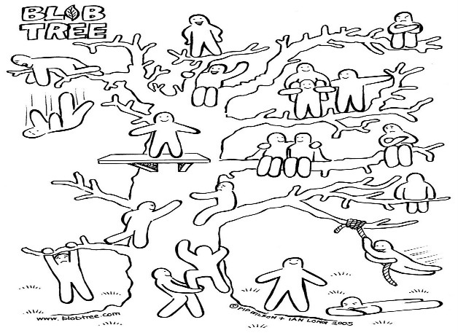  Home task: Exercise 22.  Saying goodbye |  |  | Pupils provide feedback on the lesson |  | Self-assessment | 