Teacher name: | Karabaeva Indira Aibarovna
Date: | 07.09.2022
Grade: | 5 | Number present: 21 | absent:
Theme of the lesson | Silent and double letters
Lesson objectives | Formation of general professional competencies based on knowledge of theoretical and practical phonetics of modern English
Lesson action
Lesson period / time | Teacher's action | Student action | Evaluation | Resources
The beginning of the lesson  10 min | Greeting learners.  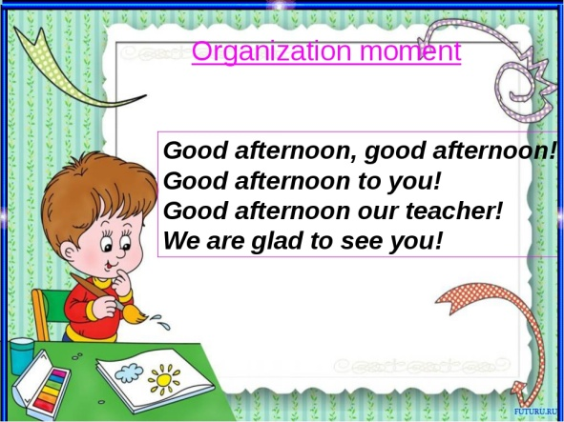 | - the mood will rise  - will be ready for the lesson. answer questions | The method of "verbal encouragement"
The middle of the lesson  30min | Perform the task by looking at the picture  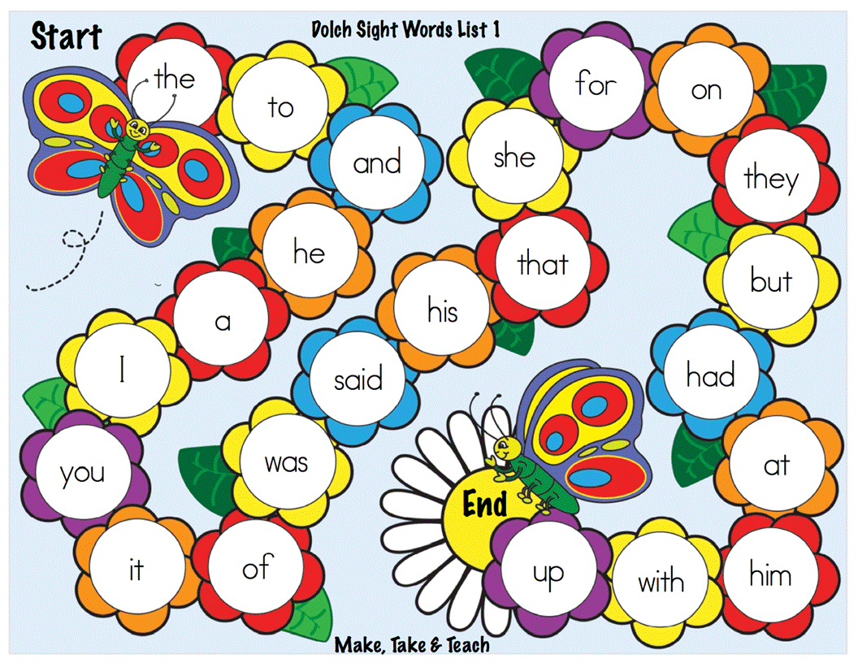  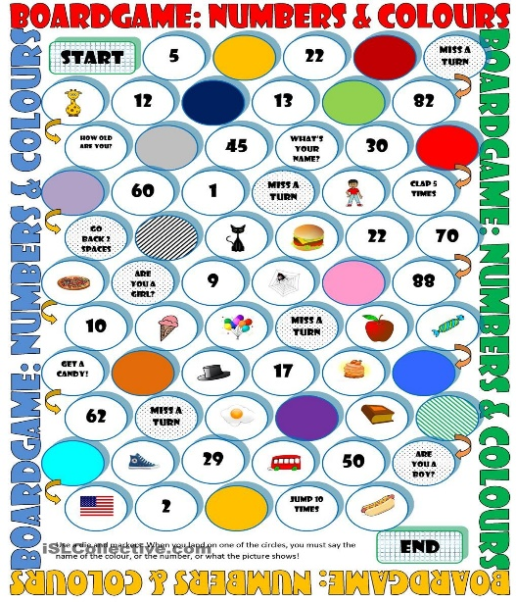  Perform the task by looking at the picture. Watch the cartoon and retell the story  https://www.youtube.com/watch?v=iM2Fws06bFY  Task 2. Many English words also include silent letters in their spelling, as we suggested above. Words like ‘knight’ have a silent and start with the same sound as ‘Nan’, rather than with the same sound as ‘king’. Words like ‘psychology’ and ‘pterodactyl’ have a silent  at the start, and many other letters can be silent. In addition, many English words contain double letters, and we will now think about how these are pronounced. Exercise 1 Let us think about the following words that contain double letters. Say each of the words below. When you come to the part of each word represented by the double letters, listen carefully and work out if you hear two of the same sound. You may like to practise this with someone else and try to work out what you hear. UNIT 1 The difference between speech and writing 5 letter summer winner apple rubber offer  Task 3. Learn by heart the tongue twister  Betty Botta bought some butter,  "But", she said, "this butter’s bitter,  If I put it in my batter  It will make my batter bitter,  But a bit of better butter will make my batter better".  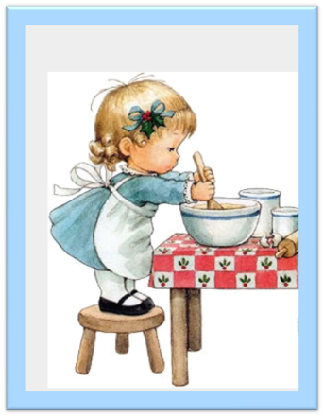 | Performs exercises  Performs exercises  Тапсырманы орындайды | Стикрелер арқылы,  Түрлі түсті жалаушалар арқылы,  «Бес саусақ» әдісі арқылы  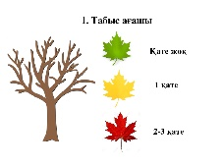  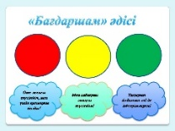  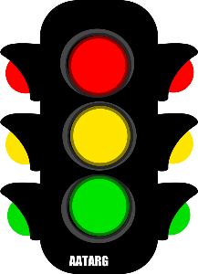 | Интернет, моноблок, электронды тақта      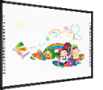
End of lesson  5 min | 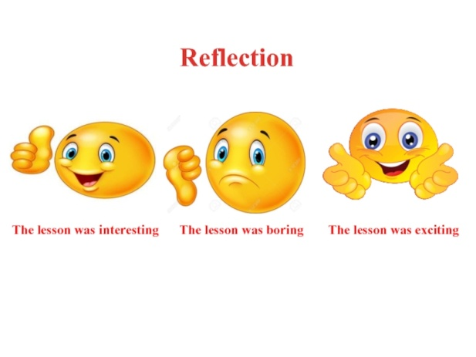 | Creates feedback

