Long-term plan  Unit: Creativity |  | School:
Date: |  | Teacher’s name:
Grade: 5 |  | Number of presents:  Absents:
Theme of the lesson: |  | Planning a visit to Astana
Learning objectives: | 5.L.5.1Understand most specific information and detailof short, supported talk on a wide range of familiar topics  5.S.3.1 Give an opinion at sentence level on a limited range of general and curricular topics  5.R.2.1 Understand with little support specific information and detail in short , simple texts on a limited range of general and curricular topics
Lesson objectives: | All learners will be able to know about Astana, recognize the famous landmarks of Astana.  Most learners will be able to answer to open questions, match the sentences with the pictures, guess the crossword.  Some learners will be able to retell about Astana,to find the simularity and the difference between the landmarks.
Assessment criteria | Read the given short text and identify the general information.  Express thoughts about the given topic.
Cross-curricular link | Geography, Literature, History
Value | Friendship, respect, independence, internationalism
Previous learning | The objects connected to landmarks. F.ex. tower, shopping, entertainmentcentre, palace, theatre, mosque,marqueeetc.

Plan
Planned timings | Planned activities | Resources
Start  8 min | Greeting  Brainstorming  Teacher elicit learners by questions  - How do you think , what city does he come to?  - To Astana.  Teacher: Let’s continue our lesson.  Watch please the video. | Photo on PPT  Video “One day in Astana”  https://www.youtube.com/watch?v=40yEGpz6X0g
Teacher uses the open questions
- What famous places of Astana do you know?
-Have you ever been to Astana?
-Where is it situated?

Middle  10 min | Teacher divides learners into two groups.  Teacher : My dear learners come here and I have some pictures that are cut into several sheets. You must collect them in right order.  Teacher: Who collects first the picture?  1gr: We. It’s the picture of Baiterek.  Teacher: If so your group’s name is “Baiterek”.  Teacher: The second group , what picture have you collect?  2 gr: “Khan shatyr”  Task  Now, listen to the text about Astana  Teacher gives to 2groups text about two famous landmarks of Astana.  Read the text and write their similarity and differences between of these buildings  Text “Bayterek Tower”  Kazakh legends have it that on the World River bank , there grows the Tree of Life , called Bayterek. Samruk the holy bird of happiness is flying to it to lay a golden egg in the nest, located on its top. The egg symbolizes the Sun, granting life and hope. But beneath , there is Aydakhar , a wicked dragon, hiding among the roots, and wishing to eat the egg. This is a Kazakh version of the universe. Quite recently ,Bayterek , a folklore symbol, was embodied in a beautiful tower, resembling the ever –lasting fight of good and evil. The Bayterek monumental structure was opened in the very center of Kazakhstan capital in 2002. It ushered in a new stage in the people’s life , becoming a symbol not only of Astana,but also of the whole country.  Text Khan Shatyr  Khan –Shatyris one of the most famous eco-buildings in the world . Khan-Shatyr is the largest marquee with shopping and entertainment facilities.  The Khan Shatyr , another bright attraction of Astana modern architecture, at the same time, a huge city’s shopping and entertainment centre.  It’s the world’s largest marquee: its height along the spire is 150 metres , and total area is 127,000 sq.m.  Opened in 2010 , the Khan Shatyr is a spire with a special transparent curtain, supported by strained steel lines. Special chemical lining of the curtain protects the marquee space from temperature drop and helps to maintain special microclimate.  Owing to these and other technologies , the Khan Shatyr is inside the top ten of the world’s eco-buildings. The architect of this unique structure is Norman Foster, who is the author several architectural miracles of Astana.    Descriptor A learner :  - Read the text;  - Write similarities and differences;  - Complete the diagram | https://www.advantour.com/kazakhstan/astana/bayterek.htm  https://www.advantour.com/kazakhstan/astana/khan-shatyr.htm  Venn diagram
6 min | Task for 1st group:  Match the words with the pictures  Khan Shatyr mosque Pictures  Duman tower  Bayterek palace  …of Peace andReconcillition entert. and shopping centre  EXPO ocean centre  Hazret Sultan ice palace  Alau Exhibition  Task for 2nd group  Guess the crossword  Task for crossword  1.The capital of Kazakhstan is …. (Astana)  2.In Astana grows the Tree of Life, called … (Bayterek)  3. …. is the largest marquee with shopping and entertainment facilities. (Khan Shatyr)  4. What was in 2017 in Astana? (EXPO)  5. The biggest mosque in Astana. (Hazret Sultan)  6.The biggest ocean centre in Astana. (Duman) | https://avatars.mds.yandex.net/get-pdb/1515288/31a752fa-3f17-417a-b0e0-49f2a897b798/s1200?webp=false  http://zaleskiy.com/wp-content/gallery/2017/08/IMG_8889_1200.jpg  https://happyfrogtravels.com/wp-content/uploads/2016/09/Astana-02-730x730.jpg  http://www.mfa.gov.kz/mobile/demos/resources/C9_ASTANA/c9p3/02.jpg  https://astanatimes.com/wp-content/uploads/2016/03/Hazret-Sultan-mosque-Astana-Kazakhstan-5.jpg  https://www.alau.info/data/nws/eng/_thumbs/img_145_227_889x480.jpg
 |  | Flashcards
11min | Work with vocabulary  Polyglot  Say these words in three languages  English Русский Қазақ  Ғимарат  Резиденция  Ойын-сауық орталығы  Театр  Монумент  Халық саны  Мешіт  Кітапхана т.б
End  5 min | Feedback  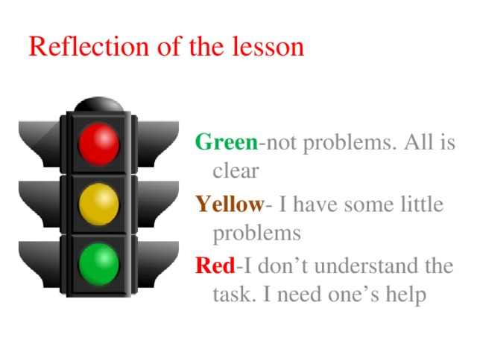

Home task
Learners identify the Astana’s landmarks and retell about it.

