 | Short term plan: Unit 7. The natural environment |  |  |  | School- lyceum: 10
 | Date:12.04.2019 |  |  |  | Teacher’s name: Auezkhan Z
 | Grade: 2a |  |  |  | Number present: |  |  | absent:
 | Theme of the lesson: |  | Changing season
 | Learning objectives(s) |  | 2.R3 read and follow with considerable support simple, words, phrases and sentences on familiar topics  2.S3 use a limited range of basic words, phrases and short sentences to describe objects, activities and classroom routines  2.L4 recognize with support short basic questions relating to features such as seasons and weather
 | Lesson  objectives |  | All learners will be able to:  -know the new words;  Most learners will be able to:  -write the words;  -use seasons in their speech.  Some learners will be able to:  -say all the words correctly;  - make all the tasks correctly.
 | Assessment criteria |  | -make with support short simple sentences on  the theme  -describe season using of basic words and short sentences
 | Value links |  | -National unity, peace and harmony in our society
 | Cross curricular links |  | Kazakh and Russian languages, science
 | ICT skills |  | Picture, video, project
 | Previous learning |  | Changing seasons
 | Plan
 | Planned timings | Planned activities |  |  |  | Resources
 | Beginning  2 min  5 min  1 min  2 min  5 min  3 min | Org. moment  I. Greeting.  -Good afternoon children  -How are you?  The rules are: All for one,  One for all.  Good luck  Thank you.  -Who is on duty today?  -Who is absent today?  -What day is it today?  II. Check-up home work  Let’s say the poem and show with doing actions.  I can jump,  I can run,  I can climb out in the sun…  III. Dividing into groups by choosing pictures of seasons.  1st group is winter  2nd group is summer  IV. Brain storming.You see in your cards that you choose, seasons of the year. What kind of season do you see?  Look at the window, children.  What season is it now?  What is the weather like today?  How many seasons in the year?  What kind of season do you like?  V. New theme:  Children, today we are going to speak about seasons.You see new words and you should listen and repeat.  • season [si:zn] – маусым  • spring [ spriŋ]– көктем  • summer [ sʌmə] – жаз  • autumn [ͻ:təm] – күз  • winter [wintə] – қыс  V. Individual work: Ex 9 p 92. Listen and draw lines  “Four pictures and one word” method  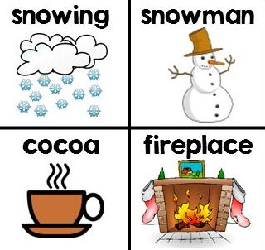  Winter  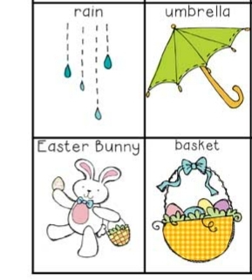  Spring  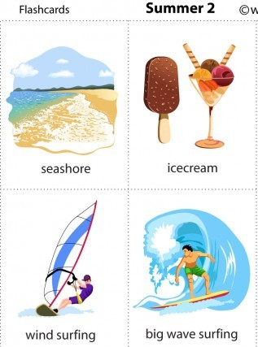  Summer  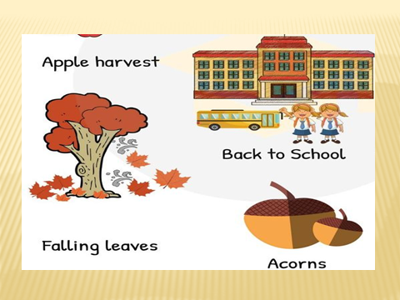  Autumn  Assessment :teacher’s assess with smile |  |  |  | PPT  PPT  Cards, pictures  PPT, Pictures  Pictures, active board
 | 1 min  6 min  7 min  5 min | VI. Relaxing time  Look at the video and repeat the moving.  VII. Group work.  Ex 11 p 93. Read and match.  To put pictures in right place.  Assessment with point  VIII. Work in pairs. Make a dialogue using words.  Ex 10 p 92. Talk with your friend.  What’s your favourite season?  My favourite season is summer.  Why?  Because I like swimming, etc.  Assessment with stickers  Individual work. Listening. Ex 9 p 91. Listen and draw lines.  Children must to find Berik’s, Dana’s, Assel’s, Kairat’s favourite season.  Teacher’s assessment. |  |  |  | video  poster, glue, pictures  book  Audio 24 CD1
 | End  3 min | IX. Home task: learn by heart the new words  Feedback. How many seasons in the year?  What kind of season do you like?  Can you name four seasons?  Reflection. If you understand put your stickers on the sun.  If you understand not well put your stickers on the sun and cloud  If you don’t understand put your smiles on the cloud |  |  |  | Pictures: sun cloud
 | Additional information
 | Differentiation – how do you plan to give more support? How do you plan to challenge the more able learners?  By tasks  More talented learners will be able to make words and to read and translate them.  Less able students will make words with mixed lettersTeacher will support to some learners by showing the picture. |  |  |  | Assessment – how are you planning to check learners’ learning?  Checking the task  Self assessment  “Well done,good”  With stickers |  | Health and safety check  Health promoting techniques  Breaks and physical activities used.  Points from Safety rules used at this lesson.
Reflection
Were the lesson objectives/learning objectives realistic? Did all learners achieve the LO?
If not, why?
Did my planned differentiation work well?
What changes did I make from my plan and why?
Summary evaluation
What two things went really well (consider both teaching and learning)?
1:

2:
What two things would have improved the lesson (consider both teaching and learning)?
1:

2:
What have I learned from this lesson about the class orachievements/difficulties of individuals that will inform my next lesson?

