LESSON 64  Unit : 8 Travel |  |  | School:3 secondary school
Date:11.05.22 |  |  | Teacher name: Turlibaeva A
Grade: 2”a” form |  |  | Number present: 19 |  |  | Number absent:-
Theme of the lesson: |  | My plane
Learning objectives |  | 2.R3 Read and follow with considerable support simple, words, phrases and sentences on familiar topics  2.S4 Respond to basic supported questions giving personal and factual information
Lesson objectives |  | Use and follow with considerable support words,  phrases, sentences in reading familiar topics  Answer basic questions with support  Provide personal information and facts
Previous learning |  | Types of vehicle
Plan
Planned timings | Planned activities |  |  | Learners’ activities | Evaluation |  | Resources
Begining  5 min | ORGANIZATIONAL MOMENT  Teacher greets students; students respond to greeting and take their places. Teacher asks a couple of familiar questions to make sts think in English:  How are you?  What day is it today?  What is the weather like today? |  |  | Greeting  Learners answer the questions
Middle  10 min | Step 1 POSTER Listen, point and repeat.  Pupils’ books closed. Put up the My Weather poster on the board, and present the weather. Then mime a weather condition and ask: What’s the weather like? Elicit: It’s hot. Follow the same procedure for the remaining weather conditions.  The pupils repeat, chorally and/or individually.  Step 2 Listen and do. Listen and number. (activity 5)  Say as you mime: It’s hot. Encourage the pupils to copy your mime. Repeat with the rest of the weather conditions.  Explain the activity. Refer the pupils to the picture.  Say: This is a magic island! Look! It’s sunny and it’s hot. Elicit the rest of the weather conditions. Play the CD again. |  |  | Learners listen, point to the pictures, and repeat the sentences.  The pupils listen to different types of weather conditions and mime an appropriate action.  Learners listen and number. | Verbal evaluation  Mutual avaluation |  | My Weather Poster
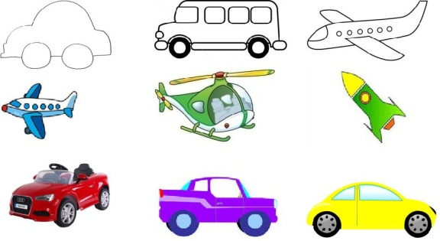  FA  20 min | READING  Task 1. Read and follow the instructions.  I like to play with a car.  We go to Astana by train.  He can’t ride a bike.  She plays with a plane.  Task 2. Read and follow the instructions.  Colour the bus into yellow.  Cross the plane.  Circle the red car.  Task 3. Listen to the teacher and answer the questions.  What is your name?  Can you ride a bike?  Do you go to school by bus?  What types of vehicles do you know?  Do you fly by plane? |  |  | Learners read and do the tasks  Learners answer the questions | Individual avaluation
End  5 min | FEEDBACK  Teacher gives feedback for learners. This might be done in oral form. Learners reflect on their learning:  Ask each learner to name 3 words they remember.  Home task: to revise vocabulary  Saying goodbye |  |  |  | Self-assessment

