Teacher name: | Torebek Aisulu
Date: | 21.10.2021
Grade: 4 | Number present: | Number absent:
Theme of the lesson: | Spelling Bee
Learning objectives(s) that this lesson is contributing to | Improving the communicative competence of students in oral speech.  Creating conditions for students to realize the need for self-expression and self-realization, social recognition, by joining an international spelling competition in English.
Lesson objectives | - increase interest in learning English;  - to expand of vocabulary;  - to develop of spelling skills.

Lesson plan
Planned timings | Teacher's actions | Pupils` actions | Assessment | Resources
10 minutes | ORGANISATION MOMENT:  Teacher greets students. | Students respond to greeting and take their places
 | MAIN PART  Warm-up  “Introduce yourself”  - Teacher ask the pupils introduce yourself use adjectives. They may use the first letter of their name.  For example: I’m Aisulu – attentive.  Active, clever, calm, perfect, great, nice, beautiful, optimist, lucky, lovely, important, rich, quit, quickly, proud, successful, happy, best, cool, gentle, friendly  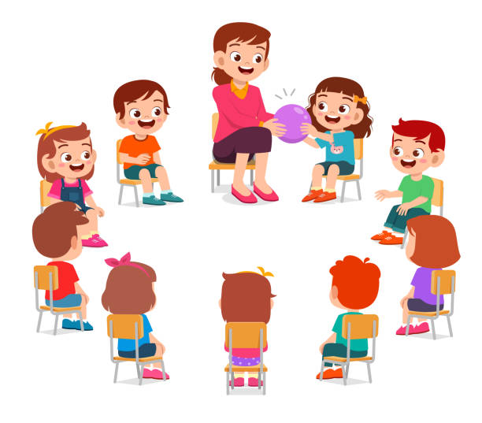  - Pupils, What season is it now? (It’s Autumn)  - Yes, you are right. Oh, look at the tree. That is beautifully, let’s take a leaf.  - Divide into two groups: “Vowels” and “Consonants”    - Pupils, please tell me, “How many letters in English alphabet? (26)  - Great! Look at the whiteboard, watch the video and revise the Alphabet!  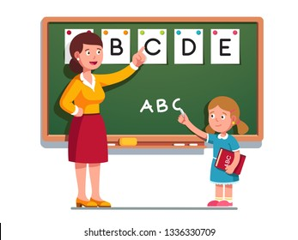  - So, let’s start our contest and find out who will win?  1st round: “Sudoku”  - The teams are given cards with hidden word. Pupils should be find, what words are hidden? The numbers are link in alphabetical order.  For example: 3/1/20 – CAT  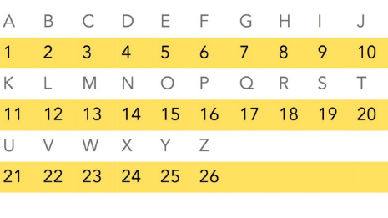  2nd round: “Who is the faster?”  - Pupils should look at the picture, then write the words and spell.  For example:   - DOG  3rd round: “The cleverest”  - Teacher gives task. Look at the sentences and point out that they are incorrect. Teacher gives few minutes. Pupils write the correct versions. Check their answers.  4th round: “Even smarter”  - Teacher gives cards with riddles. The teams should find correct answers and then receive a point for the correct answer.  Riddle 1  It has words,  But never speaks.  If we read it,  We known everything.  (a book)  Riddle 2  I am in a purple,  I am not in a yellow.  I am in a pink too,  But I’m not in red and green  (the letter “p”)  Riddle 3  You see me once in June,  Twice in November  and not at all in May.  What am I?  (the letter “e”)  Riddle 4  Two in a Brother,  One in a Father,  Zero in a Family,  But one in a Mother. What is it?  (the letter “r”)  Riddle 5  What is the start of good?  What is the end of everything?  (the letter “g”)  Riddle 6  Look at words,  Double in a book  Twice in o’clock  One in a block  And not at all in black.  What am I?  (the letter “o”) | Pupils introduce themself use adjectives  Pupils answer the question, then take a leaf.  Pupils answer the question, then sing a song.  Pupils find a hidden words  Pupils write words and spell them  Pupils write the correct versions. Check their answers.  Pupils answer riddles | comments | Tree with leaves  Video  Cards  Pictures  Cards  Cards
10 minutes | ENDING THE LESSON:  Well what did we do in our lesson?  - Evaluation of the lesson  Good bye | Children says Good bye | Feedback

